1. **EPCC使用docker**

如果是centos就很卡，如果是ubuntu就好多了。能连上网，而且可以作为sudo权限。（不需要写sudo，而是直接作为sudo用户。）

1. **如何在VScode上连接远程服务器，并进入远程服务器的docker？**

首先在VScode上安装remote - SSH插件。

然后点击左下角的><按钮，在上方搜索框会出现connect to Host remote - SSH的选项，点击！

然后如果是第一次连接，可以选择config SSH hosts

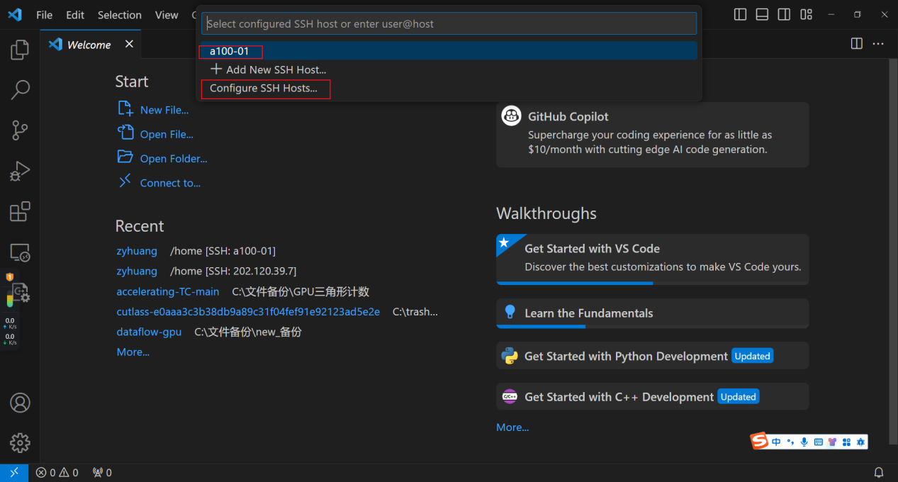

然后选一个文件去修改。其实这里点进去和去C盘文件地址修改是一样的。

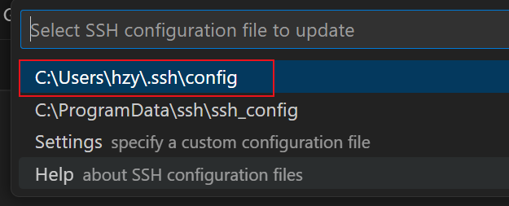

这里我的文件写法有点独特，因为我们是直接登录进去是a40，然后再ssh a100-01，所以我需要跳转一下。所以写成这样：

Host a100-01

    HostName a100-01

    User zyhuang

    ProxyJump zyhuang@202.120.39.7:8482

那么编辑好之后回到上一步，就会出现刚才那个a100-01选项。就需要输入两次密码（都一样啦）

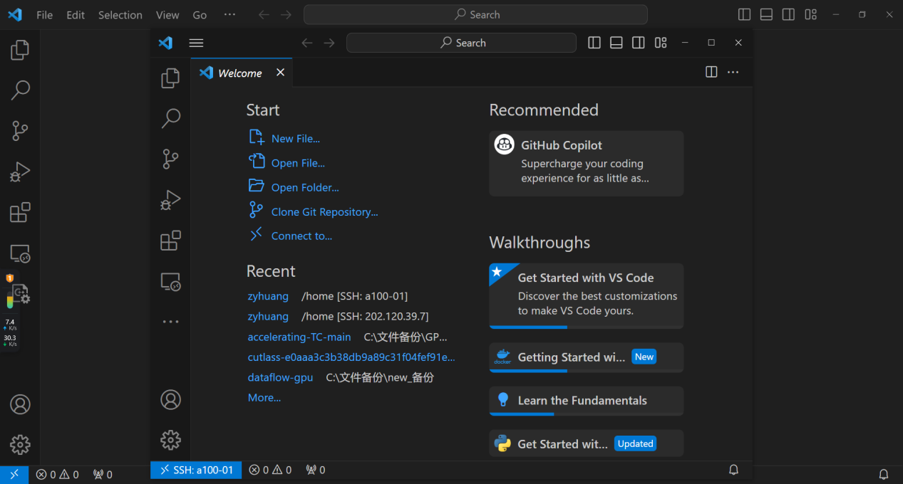

然后在这个远程服务器的连接页面上安装extension：docker。

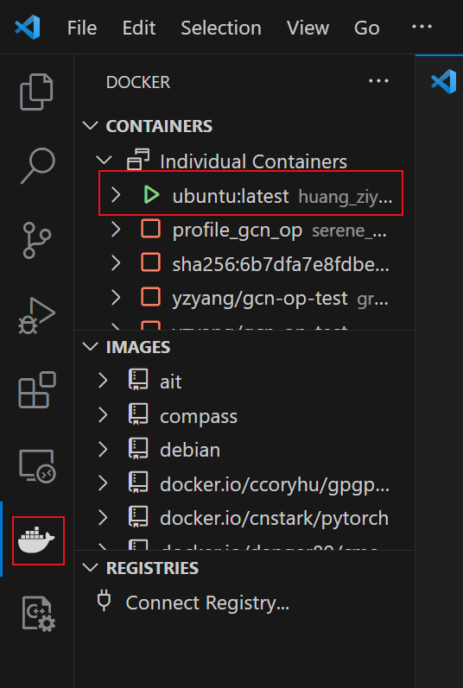

在mobaxterm登录的地方，连接a100之后创建docker。名字叫huang_ziyu_docker，然后此处就能显示出来！然后选择attach shell。那么就进去了。

为了使用GPU，需要使用nvidia-docker。那么方法是：

**~~docker run --name huang_ziyu_docker_nvidia --privileged -v /home/zyhuang/:/home/zyhuang_in_docker/ -it --gpus all nvidia/cuda:latest /bin/bash~~**

docker run --name zyhuang_docker_2 --privileged -v /home/zyhuang/:/home/zyhuang/ -it nvcr.io/nvidia/pytorch:23.09-py3 /bin/bash

chmod 777 /home/zyhuang/flash-CUDA

首先，需要在宿主机上用上面这个777命令来给全部的权限。

然后，在docker内，如果是root创建或者下载或者修改的文件呢，那就是root身份，那么在宿主机上肯定就不是root了，就改不了。如果此时是用mobaxterm，也改不了（默认是用宿主机的身份来修改？）所以为了修改文件方便，需要在docker内创建另一个user，和外部宿主机的group_ID和user_ID一致，命令如下：

addgroup --gid 2084 zyhuang

adduser --disabled-password --uid 2084 --gid 2084 zyhuang （这里不需要有密码。。。所以disable了）

然后输入su zyhuang就可以激活

然后可以输入exit，这样就退出了zyhuang这个用户，就回到了root。如果再输入exit，就退出了docker。

--name huang_ziyu_docker_nvidia 这个是命名。

--privileged加了这个，进去才能使用nvidia-smi。否则不行。

-v /home/zyhuang/:/home/zyhuang_in_docker/ 这个是为了挂载文件目录。

Bug记录：

有一次遇到这个报错

The following error occurred while trying to add or remove files in the

installation directory:

[Errno 13] Permission denied: '/usr/local/lib/python3.10/dist-packages/test-easy-install-2491.write-test'

The installation directory you specified (via --install-dir, --prefix, or

the distutils default setting) was:

/usr/local/lib/python3.10/dist-packages/

Perhaps your account does not have write access to this directory? If the

installation directory is a system-owned directory, you may need to sign in

as the administrator or "root" account. If you do not have administrative

access to this machine, you may wish to choose a different installation

directory, preferably one that is listed in your PYTHONPATH environment

variable.

然后可以加--user来指定安装位置以避免问题：

MAX_JOBS=16 python setup.py install --user

MAX_JOBS=16 pip install --user -e . 据说这个能够及时反映出代码的最新变化，有助于debug。。。。

为了让每次的值都是最新的，就是能够根据最新的代码来编译，我觉得应该删掉旧的文件：

rm -rf build/ dist/ *.egg-info

MAX_JOBS=16 python setup.py install --user

这样就不会有旧的代码的内容了。

或者放到一起执行：

rm -rf build/ dist/ *.egg-info && MAX_JOBS=16 python setup.py install --user

==================*******************==============*********************

上面记录的方法是很有用的。下面是后来我又一次，为了使用cuda12.3的版本，在EPCC上的事情。自己是没办法在裸机上安装cuda的，需要使用docker。GPT截图如下：

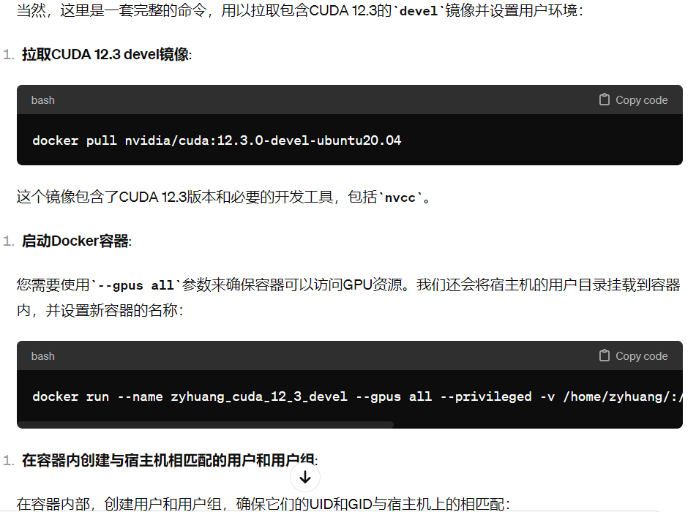

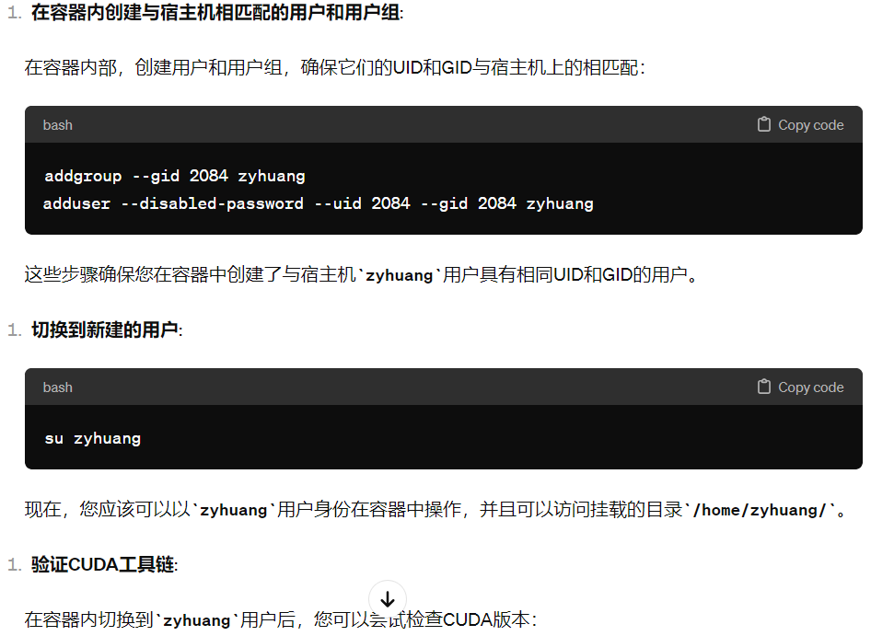

docker pull nvidia/cuda:12.3.0-devel-ubuntu20.04

docker run --name zyhuang_cuda_12_3_devel --gpus all --privileged -v /home/zyhuang/:/home/zyhuang/ -it nvidia/cuda:12.3.0-devel-ubuntu20.04 /bin/bash

addgroup --gid 2084 zyhuang

adduser --disabled-password --uid 2084 --gid 2084 zyhuang

su zyhuang

其中，使用docker的base版本是没有cuda toolkit的，得用devel。以及还需要export PATH=/usr/local/cuda/bin:$PATH

这一句。然后就OK了，甚至还包含了ncu。

未经完全证实的，**给zyhuang用户赋予sudo权限**，以能够使用apt install等命令的方法：

总结一下，您现在应该在 Docker 容器的 root 用户下依次执行以下命令：

# 在 Docker 容器中作为 root 用户执行:

groupadd --gid 2084 zyhuang

useradd --uid 2084 --gid 2084 --create-home --shell /bin/bash zyhuang

usermod -aG sudo zyhuang

echo "zyhuang ALL=(ALL) NOPASSWD: ALL" >> /etc/sudoers

执行完这些之后，您可以用 su - zyhuang 来切换到 zyhuang 用户。

1. **学习安培架构的无寄存器读写。**

When this pattern occurs within an iterative algorithm, each thread block needs to synchronize after the shared[local_idx] = global[global_idx] assignment, to ensure all writes to shared memory have completed before the compute phase can begin. The thread block also needs to synchronize again after the compute phase, to prevent overwriting shared memory before all threads have completed their computations. This pattern is illustrated in the following code snippet.

这里说的第二种sync，意思应该是，写入共享内存，写完之后再同步，之后再读。避免有的还没写完，后面就开始读了。（写后需要同步）

第一种是全局内存读到共享内存，也是写完后同步。

1. **ncu-cli如何使用**

首先在远程服务器上建立nvidia-docker，然后下载compute。从宿主机修改权限（chmod +x）然后在docker里安装。至于如何运行文件：

<https://forums.developer.nvidia.com/t/nsight-profiling-crashes-with-error-code-9/230094/6>

ncu --set full --replay-mode application --app-replay-match grid --app-replay-buffer file -f --export output-file-full.nsight-cuprof-report ./a.out

sudo /usr/local/cuda-11.7/bin/ncu --set full --replay-mode application --app-replay-match grid --app-replay-buffer file -f --export output-file-full.nsight-cuprof-report ./delete

ncu --devices 0 --set roofline --replay-mode application --app-replay-match grid --app-replay-buffer file --app-replay-mode relaxed -f --export output-file-full.nsight-cuprof-report ./sgemm_1（好像在多张卡上做测试需要加--devices 0这样。但是还没完全搞成功）

sudo /usr/local/cuda-12.2/nsight-compute-2023.2.2/ncu --set full --replay-mode application --app-replay-match grid --app-replay-buffer file -f --export output-file-full.nsight-cuprof-report ./sgemm3

如果想要更丰富的roofline图，可以把**--set full**改成**--set roofline**.

上面是普通执行文件（好像--app-replay-mode relaxed这个容易出问题）

ncu --set full --replay-mode application --app-replay-match grid --app-replay-buffer file --app-replay-mode relaxed -f --export output-file-full.nsight-cuprof-report python test_delete.py

在SQZ上需要指明python具体位置：

sudo /usr/local/cuda-12.2/nsight-compute-2023.2.2/ncu --set roofline --replay-mode application --app-replay-match grid --app-replay-buffer file --app-replay-mode relaxed -f --export output-file-full.nsight-cuprof-report /home/zyhuang/anaconda3/bin/python blog_test.py

上面是**python**代码里的kernel如何运行

--replay-mode application 避免RAM占用过高。

--app-replay-match grid --app-replay-buffer file --app-replay-mode relaxed 都很重要。否则就跑不起来。

a.out是之前编译得到的输出结果

然后把整个文件夹都下载下来，包括上delete.cu这个文件。否则查看source的时候PTX和source对应不上。

为了能对应上 ，在nvcc编译的时候加上-G。即：nvcc -G delete.cu -std=c++17 -arch sm_80

如何使用PmSampling：：

ncu --section PmSampling --replay-mode application --app-replay-match grid --app-replay-buffer file -f --export output-file-full.nsight-cuprof-report --pm-sampling-interval 100 --pm-sampling-buffer-size 0 --pm-sampling-max-passes 100 C:\Users\hzy\anaconda3\envs\new_torch\python.exe softmax.py

可以

1. **Ncu的lock-file如何解决**

==ERROR== Failed to open/create lock file /tmp/nsight-compute-lock. Please check that this process has write permissions on this file. See https://docs.nvidia.com/nsight-compute/ProfilingGuide/index.html#faq for more details.

遇到上面这样的报错，怎么办？：

可以export TMPDIR=/tmp/other_folder/ 来设置temp目录的地址，这样ncu会把临时文件放到新的temp 目录里。

export TMPDIR=/home/zyhuang/temp_can/test_FFN/new_tmp

ncu --set detailed --replay-mode application --target-processes all -f --export output-file-full.nsight-cuprof-report /home/zyhuang/miniconda3/envs/py_hzy_new/bin/python /home/zyhuang/temp_can/test_FFN/pure_FFN.py

遇到这个问题，先建立一个tmpdir，然后注意要制定完全的python和py文件地址。

1. **本地NCU如何执行python脚本**

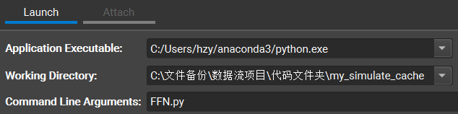

1. **如何根据所需创建定制的NCU report**

ncu --section SpeedOfLight_HierarchicalTensorRooflineChart --section MemoryWorkloadAnalysis_Chart --section MemoryWorkloadAnalysis_Tables --replay-mode application --target-processes all --clock-control=base --cache-control=all -f --export output-file-full.nsight-cuprof-report /home/zyhuang/miniconda3/envs/py_hzy_new/bin/python /home/zyhuang/temp_can/test_FFN/delete4.py

比如说这里，只选取我需要的section来测。

ncu --section SpeedOfLight_HierarchicalTensorRooflineChart --section MemoryWorkloadAnalysis_Chart --section MemoryWorkloadAnalysis_Tables --replay-mode application --target-processes all **--clock-control=base --cache-control=all** -f --export /home/zyhuang/delete/47-GemmIdentityThreadblockSwizzle /home/zyhuang/cutlass/build/examples/47_ampere_gemm_universal_streamk/47_ampere_gemm_universal_streamk

1. **阅读李少侠矩阵乘法计算记录**

“Titan V L2 cache 带宽约 1.9TB/s，那么最乐观的结果即使 L2 cache 100% 命中，此方案的理论上限也只有 1.9T * 0.48 = 0.912 tflops，远低于 14.9 tflops 的硬件算力。”

TB/s * OP/byte = OP/s （byte和TB能约掉，flops就是OP/s）

“假设M_tile，N_tile都取 64，依上述表达式可得计算访存比为16，代入 Titan V FFMA 算力可得: 14.9tflops / 16 = 931GB/s，即对于 64*64 大小的 thread block tile，平均访存带宽超过 931GB/s 后性能瓶颈就不在内存上了。”

OP/s / OP/byte = byte/s （就是当前计算访存比下最大能达到的最大内存流量，也就是说给更多的内存，计算也计算不过来。）

**对于计算访存比，一个是乘，一个是除，注意区分。**

1. **提高L2 Cache命中率**

前面提到Block分块问题，假如Block分块已完成，那么在实际计算时这些Block分块的计算顺序该如何设计。最直接的方式是按行计算，这种计算方式会带来一个问题，显著降低L2 Cache命中率。

一般来说，对于同一行的C矩阵Block分块，其所需要的A矩阵的分块数据是相同的，同理对于同一列的C矩阵Block分块，其所需要的B矩阵的分块数据是相同的。如果按行计算，对于A矩阵来说，数据相同，L2 Cache命中率很高，但是对于B矩阵来说，数据都不相同，L2 Cache命中率很低，综合来看，考虑到L2 Cache的容量，L2 Cache命中率不会太高。

因此，可以采取如下图所示Swizzle计算方式，即“牛耕式”计算，兼顾A矩阵和B矩阵的L2 Cache命中率，提高整体的L2 Cache命中率。同时可以结合Block分块大小和L2 Cache容量，调整“牛耕”步长，获取最高的L2 Cache命中率。



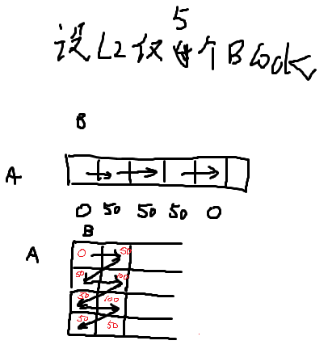

我画了图来理解，确实是swizzle更好。假设每次只有一个block在计算。。。上面是A保有，但是B每次都是新的值，但是下面有可能爆出100%的命中率，以及哪怕L2占满了，丢失旧的，也有可能存在50%的命中率。

！！！而且，这个是控制block计算的精确顺序吗！！？？怎么做到的？？

1. **Mma如何用寄存器输入值**

<https://forums.developer.nvidia.com/t/can-we-directly-use-register-value-for-tensor-core-calculation/269808?u=202476410arsmart>

<https://forums.developer.nvidia.com/t/can-we-directly-use-register-value-for-tensor-core-calculation/269808?u=202476410arsmart>

__global__ void mma_fp16_acc_fp32(float *out) {

    float c[4] = {0., 0., 0., 0.};

    float d[4] = {0., 0., 0., 0.};

    half a[4] = {1., 1., 1., 1.};

    half b[2] = {1., 1.};

    // the above would set our input matrices to all 1

    // now lets modify some values

    if (threadIdx.x%4 == 0) {

    // set the first column of A to be 0, 1, 2, 3, ... 15

      a[0] = threadIdx.x/4; a[2] = threadIdx.x/4 + 8;

    // set the second row of B to 3,3,3, ... 3

      b[1] = 3;}

    unsigned const *A = reinterpret_cast<unsigned const *>(&a);

    unsigned const *B = reinterpret_cast<unsigned const *>(&b);

    float const *C = reinterpret_cast<float const *>(&c);

    float *D = reinterpret_cast<float *>(&d);

    asm(

      "mma.sync.aligned.m16n8k8.row.col.f32.f16.f16.f32 "

      "{%0,%1,%2,%3}, {%4,%5}, {%6}, {%7,%8,%9,%10};\n"

      : "=f"(D[0]), "=f"(D[1]), "=f"(D[2]), "=f"(D[3])

      :

        "r"(A[0]), "r"(A[1]),

        "r"(B[0]),

        "f"(C[0]), "f"(C[1]), "f"(C[2]), "f"(C[3])

    );

    memcpy(out+threadIdx.x*2, D, 8);

    memcpy(out+8*8+threadIdx.x*2, D+2, 8);

}

这里为什么是a b c d每个寄存器只有4个或者2个值？因为总尺寸是A=16*8, B=8*8，又只有一个warp，所以平均下来，每个线程需要4个A的值，2个B的值。

为什么在asm里只有两个A：A[0], A[1]？ 因为这里都是32位的寄存器，而A是half，两个A才占一个寄存器。

为什么最后要memcpy两次？因为根据文档：

<https://docs.nvidia.com/cuda/parallel-thread-execution/index.html#matrix-fragments-for-mma-m16n8k8>

这里的C是分两部分的，直接写一个表达式没法表示两段位置。（同理也可根据文档的标注理解  if (threadIdx.x%4 == 0) {

    // set the first column of A to be 0, 1, 2, 3, ... 15

      a[0] = threadIdx.x/4; a[2] = threadIdx.x/4 + 8;这一部分的逻辑。）

1. **如何跑GPU-dataflow**

首先我修改了，建了一个新的GPU-dataflow-new。里面似乎有很多原先代码跑不了的问题。。。各种import和cutlass-home的问题。。现在是改好了。然后进bert_ffn去make，之后就可以运行。

1. **看258有感**

这里面的queue。比如后面几个案例，有多个mlp的，会第一个mlp读q1，写入q2，然后下一个mlp读q2，写入q3.。。能不能这时候写入q1呢？也许是因为q1还没算完。。。

这里还存在的问题是，分配block，有的block去算layer1，有的去算layer2，而有依赖关系先算layer1，结果要给layer2。那万一调度的时候block先去算layer2了，结果发现没有输入，然而layer1也没人去算，这不就死锁了吗？似乎可以用atomic的方法确定计算先后顺序。（去试试看！）

一个问题就是，所有的block的大小必须是一样的。哪怕可能算的是不同的功能。这一点可以通过更大的block来局部缓解，内部分配warp即可。不过前提是block数目足够多。

我的代码和258的不太一样。我的需要切分区域的每一行为界，探测到每个block都存好了，才能继续，但是也只需要负责自己的这一行。Acquire和release还得要。而且写出最好是能够按行来写出。

1. **如何使用tmux**

创建对话：

tmux new -s my_session

重回对话：

tmux attach -t my_session

上下滚动：

同时按住ctrl B（这里必须是大写的B哦！），然后再按[键。就可以了。要退出就按q键。

1. **树状和环状通信**

“当然,我们这里的通信时间只考虑传输带宽,而没有考虑每次传输都包含的延迟(latency)。当数据量V比较大时,延迟项可以忽略,上文的分析就是成立的。当V特别小,或者设备数p特别大时,带宽β就变得不重要了,反而是延迟比较关键,这时更好地实现就不是环状算法了,而应该使用树状通信。”

为什么？因为，环状需要的延迟是p-1个（总共p个处理器），每个之间通信都需要一个延迟，而树状是log2 P，一层需要一次。那么当P很大，环状的延迟p-1就远大于log2 P了。

1. **Roofline介绍与分析**

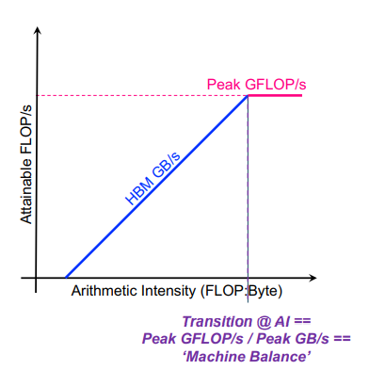

1. 为什么不可能超过蓝色线？

因为横坐标是FLOP/BYTE，纵坐标是FLOP/S，那么斜率就是BYTE/S，这个是由内存读取速度决定的，有上限。纵坐标显然是有上限的，这是硬件执行计算的极限速度，而横坐标是无上限的，那比如读进来两个数，我们反反复复的加减加减，也是可以的。

1. 为什么纵坐标一样：
2. 看起来不论是L1 L2还是DRAM，计算方式似乎都是用PE的计算量，除以本级缓存的时间（纵坐标）或者流过的数据量（横坐标）。因为PE计算量对大家都是一样的，所以纵坐标肯定是一样的。而本级缓存流过的数据量大家是不一样的，所以横坐标各有不同。
3. 那比如本图的L1和L2的横坐标也一样，那就说明所有L1的值都流过了L2。但是有些L2没有流回DRAM（L2更靠左，说明byte更大），说明L2对不同block起到了缓存的作用，有些直接在L2命中就走了，没有继续去DRAM。

FLOP是"Floating Point Operation"的缩写，意思是"浮点运算"。

FLOPS是"FLoating-point Operations Per Second"的缩写，意味着"每秒浮点运算次数"。

1. **在推理中，单GPU的显存不够用，是选择TP还是PP？**

TP能加速计算，但是需要更高的互联带宽，PP只需要低互联带宽，但是逐层计算带来的减速很明显。

从roofline角度来看，如果batch增大，那么同样多的矩阵乘法参数就能够执行更多的计算，那么在roofline上就会向右移动。但是推理常常batch很小，那么就会靠近memory bound

1. **If(thread==0)之后的sync的作用**

*// Synchronize to make sure that each thread reads* *// the correct value of isLastBlockDone.* __syncthreads();

**if** (isLastBlockDone) {

首先有if(thread==0)的执行，然后在这个外面再sync一下，这样能够确保if内部写到全局内存的值能够被所有的线程都看到。这个操作的价值尤其在于，这个值在后续操作还要立刻用。

如果内存访问高度分散并且仅由单个线程访问，则执行未缓存的全局加载可能会节省带宽。可以使用内联 PTX 按指令控制缓存。还可以使用编译选项 -dlcm 禁用 L1 缓存。

1. **VScode里的环境变量和外部不同怎么办**

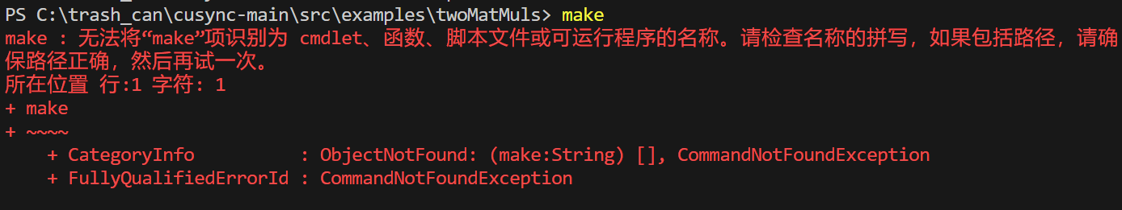

根据GPT的建议成功了：

尝试在 VSCode 中 手动设置终端的环境变量。你可以创建一个 .vscode 文件夹（如果它还不存在的话）在你的项目根目录下，然后在该文件夹中创建一个 settings.json 文件。在这个文件中，你可以添加以下设置：

{

"terminal.integrated.env.windows": {

"PATH": "${env:PATH};C:\\cygwin64\\bin"

}

}

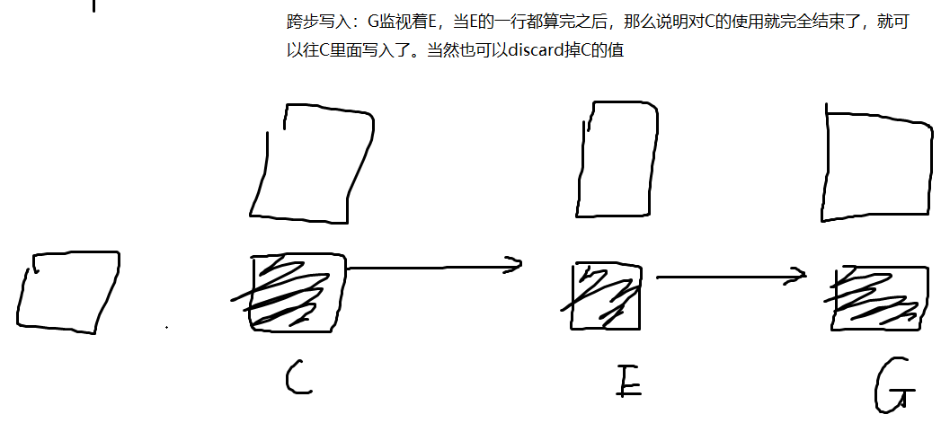

感觉好像是连续一整块比较好啊。。分立很多个不方便吧。。

1. **怎么用github进行版本回退**

首先将别人的github repo下载到自己的目录下。

然后git init

然后 git remote remove origin

然后在github自己的页面下创建一个私密的repo

git remote add origin https://github.com/ziyuhuang123/my_cusync.git

然后就可以修改文件了。

然后就是

git add .

git commit -m "描述您的更改"

git push origin main

这里面很可能会要求输入用户名和密码。额。。。为了方便，密码最好记住：git config --global credential.helper store

然后密码一般是需要去生成一个的，PAT。。。有点麻烦。最好记下来。

/usr/local/cuda-11.7/bin/ncu --cache-control none --metrics lts__t_request_hit_rate.pct ./matrixMul

这个命令可以直接输出L2命中率。

1. **EPCC服务器反连本地VPN**

<https://www.cnblogs.com/hanX3/p/15834301.html>

问题描述：

  服务器用的是学校教育网，屏蔽了 github，但是笔记本连接热点或者挂 VPN 是可以访问 github 的。想要在笔记本上远程服务器时，可以访问 github。

解决：

  首先在笔记本设置中查看自己的网络代理转发端口，然后用 ssh -R 2080:127.0.0.1:10809 name@ipaddress，这里 127.0.0.1 是笔记本的地址，10809 是笔记本转发

2080" 和  export https_proxy="127.0.0.1:2080" 来指定远程转发端口。如此，便可以访问 github.

我本地使用的是pigcha的VPN，进入“菜单”，“复制代理环境变量”，然后就得知了15732这个是本地的端口。然后登录我的EPCC的服务器：-p 8474 [zyhuang@202.120.39.7](mailto:zyhuang@202.120.39.7)

期智是：ssh -R 2080:127.0.0.1:15732 zyhuang@10.200.5.156

ssh -R 2080:127.0.0.1:15732 -p 30824 [root@10.210.22.155](mailto:zyhuang@202.120.39.7)

(base) C:\Windows\system32>**ssh -R 2080:127.0.0.1:15732 -p 8474 [zyhuang@202.120.39.7](mailto:zyhuang@202.120.39.7)**

**export http_proxy="127.0.0.1:2080"**

**export https_proxy="127.0.0.1:2080"**

**curl -I <https://www.google.com>**

zyhuang@202.120.39.7's password:

Welcome to Ubuntu 20.04.6 LTS (GNU/Linux 5.15.0-88-generic x86_64)

* Documentation: https://help.ubuntu.com

* Management: https://landscape.canonical.com

* Support: https://ubuntu.com/advantage

* Introducing Expanded Security Maintenance for Applications.

Receive updates to over 25,000 software packages with your

Ubuntu Pro subscription. Free for personal use.

https://ubuntu.com/pro

Expanded Security Maintenance for Applications is not enabled.

54 updates can be applied immediately.

1 of these updates is a standard security update.

To see these additional updates run: apt list --upgradable

Enable ESM Apps to receive additional future security updates.

See https://ubuntu.com/esm or run: sudo pro status

The list of available updates is more than a week old.

To check for new updates run: sudo apt update

New release '22.04.3 LTS' available.

Run 'do-release-upgrade' to upgrade to it.

Your Hardware Enablement Stack (HWE) is supported until April 2025.

Web console: https://a100-04:9090/

Last login: Fri Jan 19 10:33:59 2024 from 10.2.0.1

(base) a100-04% **export http_proxy="127.0.0.1:2080"**

(base) a100-04% **export https_proxy="127.0.0.1:2080"**

(base) a100-04% **curl -I <https://www.google.com>**

**下面这个命令要输入的！否则不行的！**

**export http_proxy="127.0.0.1:2080"**

**export https_proxy="127.0.0.1:2080"**

HTTP/1.0 200 Connection established

HTTP/2 200

content-type: text/html; charset=ISO-8859-1

content-security-policy-report-only: object-src 'none';base-uri 'self';script-src 'nonce-PU8xU1L_MoUz22XnqNNu9w' 'strict-dynamic' 'report-sample' 'unsafe-eval' 'unsafe-inline' https: http:;report-uri https://csp.withgoogle.com/csp/gws/other-hp

p3p: CP="This is not a P3P policy! See g.co/p3phelp for more info."

date: Fri, 19 Jan 2024 03:06:19 GMT

server: gws

x-xss-protection: 0

x-frame-options: SAMEORIGIN

expires: Fri, 19 Jan 2024 03:06:19 GMT

cache-control: private

set-cookie: 1P_JAR=2024-01-19-03; expires=Sun, 18-Feb-2024 03:06:19 GMT; path=/; domain=.google.com; Secure

set-cookie: AEC=Ae3NU9N2aUZ_WHE7f2C7wVJ9xM00ShDvXxKSQnR5QTqV8_NTDx5WvYrrsw; expires=Wed, 17-Jul-2024 03:06:19 GMT; path=/; domain=.google.com; Secure; HttpOnly; SameSite=lax

set-cookie: NID=511=pWumJkJRhckHpYPvu7IJI3ol5HNx10G1_wbruzP0KhFZ6KLaPBWRpxeZTw0XBkQRPTaRHnr7AA1vuGdBUQFHh1TSvJRV6pSrCZGLuO8T3WdrpeXaym4z1_OzpPJgoO4VlrgDoiGnzl7BeDldDp6B3tENZ7uddYQmQgzicJtnlDk; expires=Sat, 20-Jul-2024 03:06:19 GMT; path=/; domain=.google.com; HttpOnly

alt-svc: h3=":443"; ma=2592000,h3-29=":443"; ma=2592000

(base) a100-04% **curl -I https://www.github.com**

HTTP/1.0 200 Connection established

HTTP/2 301

content-length: 0

location: <https://github.com/>

1. **Cuda-gdb怎么用**

退出后用这个去查看多余的进程ps aux | grep cuda-gdb，然后kill -9 ....(进程号）

首先在编译的时候要在nvcc ..... 后面加上-g -G

然后就cuda-gdb delete1 （这里是编译完成的可执行文件）

有可能这里找不到cuda-gdb，那就去找。常见是在ls /usr/local/cuda/bin/cuda-gdb

那如果在，刚才这个命令会显示出具体地址。那然后加入path：

export PATH=/usr/local/cuda/bin/:$PATH && source ~/.zshrc

然后就进入了cuda-gdb。这时候要开始打断点了：break delete1.cu:30（第30行。这里是具体的.cu文件。）

然后就run，就会到断点处。

有可能到某个函数，想进去，上溯看看到底上层是哪里，那就step，或者s。

如果是想向下一行，就是next。简写是n

关于 finish 命令，它的用途是继续运行程序直到当前函数完成执行并返回。当您在函数内部调试并且想快速跳出该函数时，finish 非常有用。简写是fin

关于条件断点。可以写成break delete1.cu if threadIdx.x==0这样。虽然在主机端肯定还是会报错一堆，就是刚刚写完这个break之后。但是真的运行下去，还是OK的。不过注意条件要加在断点上。要是后面到地方了，比如print，再if，那就不行了。

向下运行直到某一行：until delete1.cu:60

1. **如何使用cmake？**

首先使用makefile会需要手动link很多库，如果用cmake，可以自动的寻找很多的库，会方便一点。我现在正在写libtorch（cpp版本的torch），这个拿makefile特别难写，用cmakelist就方便的多了。

文件结构一般是

---folder

|-----Cmakelist.txt

|-----folder.cpp

然后cd folder

mkdir build

cd build

Cmake ..

cmake --build . --config Release -- -j 48

-j 48这个是多线程编译。总共有48个CPU内核，一般一个内核可以两个线程一起跑，似乎最大值是96。然后每次修改了代码之后的新的编译的时候不需要删掉旧的build，只需要cmake --build . --config Release -- -j 48

这一行就够了。

1. **为什么git add .失败？**

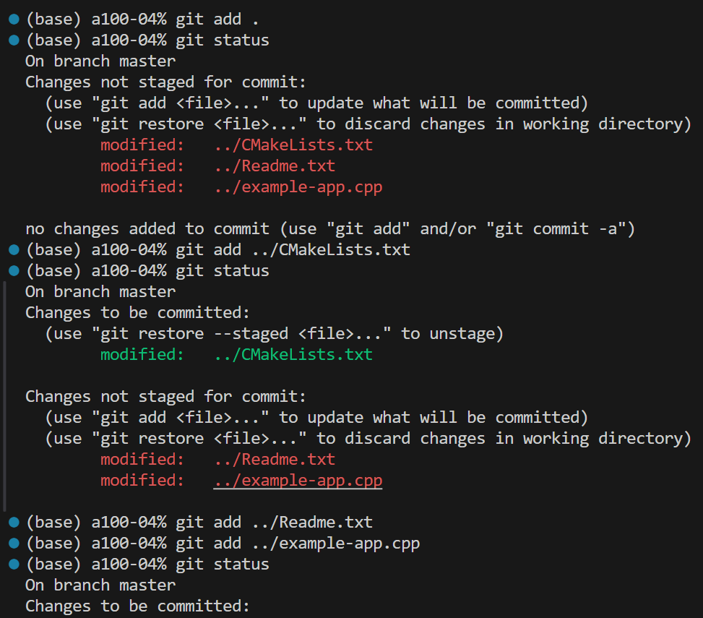

为什么这里git add .总失败？但是可以手动一个一个git add ../......这样？因为此时不在git仓库的根目录。

(base) a100-04% pwd

/home/zyhuang/temp_can/example-app/**build**

1. **如何设置cutlass的环境变量？（否则flash attention报错了）**

**报错：**

In file included from /home/zyhuang/temp_can/extract_cpp_of_flash/src/flash_fwd_launch_template.h:11,

from /home/zyhuang/temp_can/extract_cpp_of_flash/src/flash_fwd_split_hdim256_fp16_sm80.cu:5:

/home/zyhuang/temp_can/extract_cpp_of_flash/src/flash_fwd_kernel.h:7:10: fatal error: cute/algorithm/copy.hpp: No such file or directory

7 | #include <cute/algorithm/copy.hpp>

| ^~~~~~~~~~~~~~~~~~~~~~~~~

compilation terminated.

In file included from /home/zyhuang/temp_can/extract_cpp_of_flash/src/flash_fwd_launch_template.h:11,

from /home/zyhuang/temp_can/extract_cpp_of_flash/src/flash_fwd_split_hdim96_fp16_sm80.cu:5:

/home/zyhuang/temp_can/extract_cpp_of_flash/src/flash_fwd_kernel.h:7:10: fatal error: cute/algorithm/copy.hpp: No such file or directory

7 | #include <cute/algorithm/copy.hpp>

| ^~~~~~~~~~~~~~~~~~~~~~~~~

**解决办法：**

nano ~/.zshrc

export CPLUS_INCLUDE_PATH=$CPLUS_INCLUDE_PATH:/home/zyhuang/cutlass/include

export CUTLASS_DIR=/home/zyhuang/cutlass

source ~/.zshrc

学长教我什么是矩阵乘法的multi-stage：就是

memcpy_async(....)

memcpy_async(....)

compute()

这样写两次读取，当然也得分配更多的shared memory，然后计算一次，这就算stage=3了。

1. **Flash attention学习日记**

新来的flash attention用python setup.py install编译，一堆报错，尤其是cute:....一堆的东西。就怀疑是cutlass版本不对，然后去删掉cutlass。更新环境变量（这些内容都是GPT教的）。然后就跑起来了。

再一次，遇到了cute等的版本错误。就是因为自己的cutlass太新了，一看flash支持的是3.4.1的@ bbe579a版本。然后使用该方法在cutlass文件夹下面更换到@ bbe579a：

git checkout bbe579a

然后注意自己的extract....文件夹的内容也得保持一致，和flash一样才行。

1. **如何在SQZ上连接外网**

export https_proxy=http://127.0.0.1:7990 http_proxy=http://127.0.0.1:7990 all_proxy=socks5://127.0.0.1:7991

然后取消掉用：

unset http_proxy

unset https_proxy

unset all_proxy

1. **让SQZ使用CUDA12.3**

export PATH=/usr/local/cuda-12.2/bin:$PATH

export LD_LIBRARY_PATH=/usr/local/cuda-12.2/lib64:$LD_LIBRARY_PATH

source ~/.bashrc

nvcc --version

1. **如何给华为项目发邮件**

收件人：huguipeng@huawei.com, jialiancheng@huawei.com, junsongwang@huawei.com, huangjiangle@huawei.com, hutianchi1@huawei.com

抄送: leng-jw@sjtu.edu.cn, altair.liu@sjtu.edu.cn, h.y.zhang-zdy@sjtu.edu.cn, [weiminghu@sjtu.edu.cn](mailto:weiminghu@sjtu.edu.cn)

1. **如何使用TileFlow**

首先需要在docker里用。按照本文档部分1介绍那样创建docker后，执行TileFlow的md文件介绍的初始化过程

如果没有gdb，可能需要在docker里安装一下gdb。

然后cd tutorials/00-GEMM

gdb ../../build/bin/tileflow 注意这里要能够补全出来tileflow，就是说从当前位置去寻找到tileflow可执行文件，路径要对。

break /home/zyhuang/temp_can/TileFlow/src/application/main.cpp:169 这里没法被识别自动补全。。。但是后续也是可以的。。。

run arch/arch.yaml prob/prob.yaml map/map.yaml macro.yaml 然后这一行就会执行，并且停在上面所设置的break的位置。

1. **KV cache的执行细节**

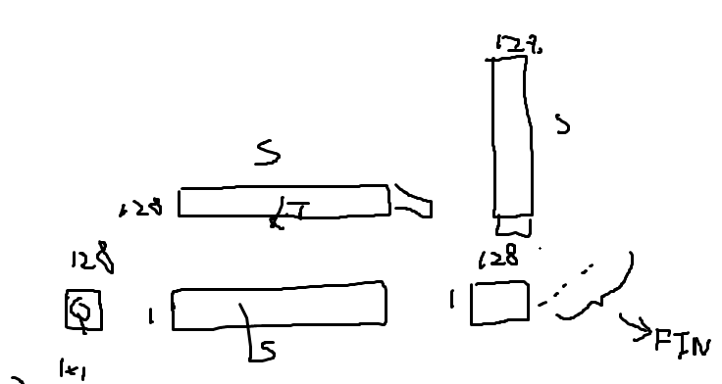

M的宽度是1，但是长度是head-dim，然后多个attention拼接到一起。之后的FFN也是seq=1。

然后每次input*W_Q K V的时候，只生成一个很小的块，每次拼接到K和V上面，如上图最旁边的小块所示。

1. **Cutlass如何用tensor core和cuda core**

/home/zyhuang/cutlass/examples/21_quaternion_gemm--->cuda core

47_ampere_gemm_universal_streamk-->tensor core

上述两个代码可以执行。

以防以后找不到，打包压缩放到了my_simulation_cache文件夹里面

1. **学习cusync**

现在在学习cusync的cutlass是怎么写的。然后进行修改。

1. 研究cusync，这里面的cutlass是怎么实现的？怎么插入到里面去控制？

2. 基于这一套方法，我怎么消除掉其中的avoid_kernel？

首先，**cusync是如何使用cutlass的**？我先研究了ml-bench的代码。跑起来之后再抽丝剥茧的删去无用部分。现在地址在/home/zyhuang/temp_can/cusync/src/ml-bench/transformer下。

make build/mlp-eval-rowsync

build/mlp-eval-rowsync --batch 256 --check true --model gpt3 --split-k1 1 --split-k2 1 --policy cusync

CUDA_LAUNCH_BLOCKING=1 build/mlp-eval-rowsync --batch 128 --check true --model gpt3 --split-k1 1 --split-k2 1 --policy cusync --order-line 1 --file-path "/home/zyhuang/temp_can/dataflow_code/block_swizzle/gen_order/new_gen_order/orders_512.txt"

build/mlp-eval-rowsync --batch 256 --check true --model gpt3 --split-k1 1 --split-k2 1 --policy cusync --order-line 1 --file-path "/home/zyhuang/temp_can/dataflow_code/block_swizzle/gen_two_order/order_256.txt"

swizzle duration(us) L2%

1 15,120 73.11 --->15712 73.54

2 9484 81.49 --->9007 85.03

4 9326 89.59 --->8993 86.70

8 9384 84.33 --->9117 82.26

16 9367 90.55 --->9067 83.90

terminate called after throwing an instance of 'cutlass_cutlass::cuda_exception'

what(): std::exception

遇到过这样的错误。然后nvidia-smi发现是GPU-0的内存被占满了。

然后用export CUDA_VISIBLE_DEVICES=1指定了使用GPU1，就可以跑起来了。

1. **如何用SQZ的GPU**

见管仁阳的聊天记录

我的密码都设为了123456

每次结束后都要在网页上点击备份。

开启前在网页上选终端，然后passwd

然后更新密码（好像每次都要重来一次）

备份的时候，要关掉其他VPN，否则会影响。即使不关VPN，也可以点击按钮，但是不会弹出状态栏，其实是没有备份成功。

1. **如何独占GPU做测试**

（首先需要将自己先设为root）

**将GPU设置为独占模式**

sudo nvidia-smi -i 7 -c EXCLUSIVE_PROCESS

**设置GPU可见性**

export CUDA_VISIBLE_DEVICES=7

**恢复为共享模式**

sudo nvidia-smi -i 7 -c DEFAULT

**检查GPU模式**

nvidia-smi

1. **Github如何个性化搜索**

repo:NVIDIA/cutlass path:/^include\/cutlass\/epilogue\/collective\// content:/\bstore\b/

content:/\b \b/

在这个中间插入想要精确搜索的内容。

content:的意思是，只搜索内容，而不搜索标题。

/\b \b/的意思是前后不能带其他东西。比如我搜索store，那storeAdd就不行

/\bTmaWarpSpecialized\b/

1. **H100连接及复制**

跳转机：访问：ssh clouduser@125.76.110.14 -p 1203 密码：6aaW6YO95Zyo57

H100：访问：ssh root@10.0.2.109 密码：@Testing456

每个用户：访问 ssh zyhuang@10.0.2.109 密码：112358

如何传输文件：

在本地机器上：scp -P 1203 -r ./gpu-arch-microbenchmark [clouduser@125.76.110.14:/home/clouduser/Downloads/zyhuang/](mailto:clouduser@125.76.110.14:/home/clouduser/Downloads/zyhuang/)

在跳板机上：scp -r /home/clouduser/Downloads/zyhuang/py_hzy_new.tar.gz [zyhuang@10.0.2.109:/home/zyhuang/temp_can](mailto:zyhuang@10.0.2.109:/home/zyhuang/temp_can)

scp -r /home/clouduser/Downloads/zyhuang/cutlass-main.zip [zyhuang@10.0.2.109:/home/zyhuang/temp_can](mailto:zyhuang@10.0.2.109:/home/zyhuang/temp_can)

scp -P 1203 -r ./cutlass-main.zip [clouduser@125.76.110.14:/home/clouduser/Downloads/zyhuang/](mailto:clouduser@125.76.110.14:/home/clouduser/Downloads/zyhuang/)

1. **cutlass如何安装/编译**

首先git clone cutlass的文件夹。然后进入cutlass文件夹内。

export CUDACXX=${CUDA_INSTALL_PATH}/bin/nvcc ---->这地方需要根据自己的CUDA位置稍微改改。

mkdir build && cd build

cmake .. -DCUTLASS_NVCC_ARCHS=90a ---->根据自己的cc改 （这里遇到必须cmake --version》=3.19，不过其实安装cmake可以用.sh，而且是不需要sudo权限的。）

make ----->很慢！这会编译全部的文件

我们往往需要运行example文件夹里的具体某一个文件，如何编译呢？如果像上面那样make，会编译所有的文件，是非常非常慢的，可能要1小时以上。现在以编译./examples/cute/tutorial/sgemm_1.cu这个文件为例。首先，虽然这里是有CMakelist的，但是不可以在本地直接make或者cmake。否则会出现：

**Unknown CMake command "cutlass_example_add_executable".**

正确的方法是回到**cutlsss主目录**下，

mkdir build

cd build

然后执行cmake ..

然后此时应该make，但是具体make谁呢？可以make help。这样会列出所有可以make的目标。其实tutorial下面有很多个想make的，不过可能需要一个一个make吧。那我们现在就：make sgemm_1

然后等个3分钟就差不多好了。生成的文件是在cutlass/build/examples/cute/tutorial下面的。不是在原先的cutlass/examples/cute/tutorial下面。

有时间去试试看ncu：docker挂载一个tmp，然后自己创建一个tmp，然后

touch /tmp/nsight-compute-lock

chmod 666 /tmp/nsight-compute-lock

这样是不是不需要root了？是不是也不需要docker了？好像是的）

**H100上googletest无法下载googletest**

在H100上没法联网，在cmake .. -DCUTLASS_NVCC_ARCHS=90a的时候会报错：googletest无法下载。解决办法是：

* 下载googletest并上传到服务器，比如此时放到位置：

/home/zyhuang/temp_can/googletest

找到cutlass/cmake/googletest.cmake，将下面内容：

FetchContent_Declare(

googletest

GIT_REPOSITORY https://github.com/google/googletest.git

GIT_TAG v1.14.0

)

更换为：

FetchContent_Declare(

googletest

SOURCE_DIR /home/zyhuang/temp_can/googletest

)

再执行cmake .. -DCUTLASS_NVCC_ARCHS=90a即可成功。

1. **cutlass如何用nvcc单独编译**

nvcc ampere_gemm.cu -o ampere_gemm -arch=sm_80 -std=c++17 -I ../cutlass/include -I ../cutlass/tools/util/include

用上述命令可以。代码是

https://github.com/NVIDIA/cutlass/tree/922fb5108b61c909ea3170d656f89ce151a246fd/examples/14_ampere_tf32_tensorop_gemm

往往会出现缺少helper.h的报错。那么从cutlass里面找到helper.h文件，放到当前同一目录下依然叫helper.h，然后编译就可以过了。

**另一个例子**：

zyhuang@ljwA100:~/cutlass/examples/cute/tutorial$ **nvcc -o sgemm_nt_1 sgemm_nt_1.cu -arch=sm_80 -std=c++17 -I ../../../include -I ../../../tools/util/include --expt-relaxed-constexpr**

zyhuang@ljwA100:~/cutlass/examples/cute/tutorial$ ls

CMakeLists.txt sgemm_nt_1 sgemm_nt_1.cu

zyhuang@ljwA100:~/cutlass/examples/cute/tutorial$ ./sgemm_nt_1

Using device 0: NVIDIA A100 80GB PCIe (SM80, 108 SMs)

M = 5120

N = 5120

K = 4096

Verification by comparison with cuBLAS is disabled, either because the CMake option CUTLASS_ENABLE_CUBLAS was explicitly set to OFF, or because CMake could not find cuBLAS. If you would like to enable verification with cuBLAS, please set the CMake option CUTLASS_ENABLE_CUBLAS to ON, rerun CMake, and recompile this example.

CUTE_GEMM: [16347.1]GFlop/s (13.1368)ms

这个代码是位于/cutlass/examples/cute/tutorial/sgemm_nt_1.cu，如果直接写cmake或者make之类的不能编译会报错，搞不明白为什么虽然。然后就研究自己写编译代码。

由于代码开头有#include <cute/tensor.hpp>，所以需要寻找到它的位置：./include/cute/tensor.hpp，然后就需要-I ../../../include

由于代码开头有

"cutlass/util/print_error.hpp"

"cutlass/util/GPU_Clock.hpp"

"cutlass/util/cublas_wrappers.hpp"（如果定义了CUTLASS_ENABLE_CUBLAS）

"cutlass/util/helper_cuda.hpp"

所以就需要-I ../../../tools/util/include

额，反正，这里的include是相对路径，也可以写成

nvcc -o sgemm_nt_1 sgemm_nt_1.cu -arch=sm_80 -std=c++17 -I ../cutlass/include -I ../cutlass/tools/util/include --expt-relaxed-constexpr

1. **Cute学习日记**

什么是local_tile和local_partition？





  using T = cute::half_t;

  using namespace cute;

  // 假设 self_defined_value 数组的维度为 16x16。

  int dim1 = 6;

  int dim2 = 6;

  T *self_defined_value;

  self_defined_value = (T*)malloc(sizeof(T) * dim1 * dim2);

  // 初始化 self_defined_value 数组

  for(int i = 0; i < dim1; ++i) {

      for(int j = 0; j < dim2; ++j) {

          self_defined_value[i * dim2 + j] = i * 10 + j / 10.0; // 根据给定公式赋值

      }

  }

  // 在打印时，将 half_t 转换为 float

  for (int ii = 0; ii < dim1; ii++) {

      for (int jj = 0; jj < dim2; jj++) {

          // 将 half_t 类型的值转换为 float 来打印

          printf("%2.3f\t", static_cast<float>(self_defined_value[ii * dim2 + jj]));

      }

      printf("\n");

  }

  printf("\n");

  // 现在可以使用 self_defined_value 来创建和操作 Tensor 对象

  Tensor tensor_modified = make_tensor(self_defined_value, make_shape(dim1, dim2), make_stride(dim2, 1));

  auto tile_modified = make_tile(2, 2);

  auto coor_modified = make_coord(1, 0);

  // Tensor tc1_modified = local_tile(tensor_modified, tile_modified, coor_modified);

  auto tA = make_layout(make_shape(Int<3>{}, Int<3>{}), LayoutRight{});

  Tensor tc1_modified = local_partition(tensor_modified, tA, 3);

  print_tensor(tc1_modified);

  // 注意tA的LayoutRight，这是行主序的意思，所以这里打印出来的就是第四个值，10.0。

  Tensor tc2_modified = local_partition(tensor_modified, tA, 4); // 很明显了，实验表明，起码对于tA二维的情况，是列主序的，就是后面的index是优先沿着列往下走的。这是因为，默认的make_layout创建出来就是列优先的。如https://github.com/NVIDIA/cutlass/blob/8f7d2789b8b04418ac01e515019dc3b74b249070/media/docs/cute/01_layout.md这里所示。

  print_tensor(tc2_modified);

local_tile是取一整块出来。而local_partition是根据index，先按tA来切ptr，然后在每个tile里取第index个值（会按照列主序来取，除非tA写了是layoutright就是行主序）。并且注意这里的index只能是一个标量，哪怕你给了数组对，也会按某种方式理解为一个标量。

上面的输出如下：

tensor_modified

0.000 0.100 0.200 0.300 0.400 0.500

10.000 10.102 10.203 10.297 10.398 10.500

20.000 20.094 20.203 20.297 20.406 20.500

30.000 30.094 30.203 30.297 30.406 30.500

40.000 40.094 40.188 40.312 40.406 40.500

50.000 50.094 50.188 50.312 50.406 50.500

ptr[16b](0x55bc83f628bc) o (2,2):(18,3): tc1_modified

10.00 10.30

40.00 40.31

ptr[16b](0x55bc83f628be) o (2,2):(18,3): tc2_modified

10.10 10.40

40.09 40.41

  using mma_op = SM80_16x8x8_F16F16F16F16_TN;

  using mma_traits = MMA_Traits<mma_op>;

  using mma_atom = MMA_Atom<mma_traits>;

using MMA = decltype(make_tiled_mma(mma_atom{},

                      make_layout(Shape<_2, _2, _1>{}),

                      make_layout(Shape<_1, _2, _1>{})));

这个写法和下面是差不多的：

  using MMA = decltype(make_tiled_mma(mma_atom{},

                      make_layout(Shape<_2, _2, _1>{}),

                      Tile<_32,_32,_16>{}));

上面的写法是：mma_atom{}, Layout, val_layout，含义和reed的写法一致，第一个Layout影响线程数，在main函数中，我们选择使用Ampere架构提供的16x8x16的Tensor Core矩阵乘法指令，数据精度和计算精度都为fp16。然后通过MMA_Traits得到mma_traits，继续将traits转换成MMA_Atom。我们知道SM80的Tensor Core执行是warp level的，也就是说这个MMA_Atom是32个线程，我们对MMA_Atom能力通过增加线程的方式进行M、N方向的重复，**同时我们让B矩阵C矩阵使用更多寄存器在N方向扩展2次**，得到main函数中的MMA类型。这样，我们便可以得到TiledMMA需要32x2x2 = 128线程，其能处理的矩阵的大小: M = 16 x 2 x 1 = 32, N = 8 x 2 x 2 = 32, K = 16 x 1 x 1 = 16, 即TiledMMA能处理的MNK为32x32x16。

下面的tile是新写法，直接可以指定尺寸为32,32,16。

上面加粗的，更多寄存器，与事实测试不符！很奇怪。甚至当用1,2,1相比于1,1,1还更少寄存器。

如上图所示，纵向是K=2，横向是N=3，而kTileK=32，我们这里的tile上面说了，在K维度上是16，所以这里的MMA_K是2。

（MMA_M=2, MMA_N=3）这三个维度虽然没有明说，不过估计是在cute::gemm内部会进行迭代。显式迭代的只有大tile外侧的k，就是对128*32这里的总K除以32得到的K_num

local_tile的用法

  // Represent the full tensors

  Tensor mA = make_tensor(make_gmem_ptr(A), select<0,2>(shape_MNK), dA); // (M,K)

  Tensor mB = make_tensor(make_gmem_ptr(B), select<1,2>(shape_MNK), dB); // (N,K)

  Tensor mC = make_tensor(make_gmem_ptr(C), select<0,1>(shape_MNK), dC); // (M,N)

  // Get the appropriate blocks for this thread block

  auto cta_coord = make_coord(blockIdx.x, blockIdx.y, _);              // (m,n,k)

  Tensor gA = local_tile(mA, cta_tiler, cta_coord, Step<_1, X,_1>{});  // (BLK_M,BLK_K,k)

  Tensor gB = local_tile(mB, cta_tiler, cta_coord, Step<X,_1,_1>{});  // (BLK_N,BLK_K,k)

  auto cta_tiler1 = Shape<_32, _64, _4>{};

  auto cta_coord1 = make_coord(blockIdx.x, blockIdx.y, _);

  Tensor ctaA = local_tile(mA, cta_tiler1, cta_coord1, Step<_1, X,_1>{});  // (_32,_4,k)

  Tensor ctaB = local_tile(mA, cta_tiler1, cta_coord1, Step< X,_1,_1>{});  // (_64,_4,k)

  Tensor ctaC = local_tile(mA, cta_tiler1, cta_coord1, Step<_1,_1, X>{});  // (_32,_64)

  if(blockIdx.x==0&&blockIdx.y==0&&threadIdx.x==0&&threadIdx.y==0){

    print(mA);

    printf("\nmA shape\n");

    print(gA);

    printf("\ngA shape\n");

    print(mB);

    printf("\nmB shape\n");

    print(gB);

    printf("\ngB shape\n");

    print(ctaA);

    printf("\nctaA shape\n");

    print(ctaB);

    printf("\nctaB shape\n");

    print(ctaC);

    printf("\nctaC shape\n");

  }

gmem_ptr[32b](0x7f83a0000000) o (5120,4096):(_1,5120)

mA shape

gmem_ptr[32b](0x7f83a0000000) o (_128,_8,512):(_1,5120,40960)

gA shape

gmem_ptr[32b](0x7f839e000000) o (2048,4096):(_1,2048)

mB shape

gmem_ptr[32b](0x7f839e000000) o (_256,_8,512):(_1,2048,16384)

gB shape

gmem_ptr[32b](0x7f83a0000000) o (_32,_4,1024):(_1,5120,20480)

ctaA shape

gmem_ptr[32b](0x7f83a0000000) o (_64,_4,1024):(_1,5120,20480)

ctaB shape

gmem_ptr[32b](0x7f83a0000000) o (_32,_64):(_1,5120)

ctaC shape

先分析这里从原始的mA到local_tile的gA是怎么回事。

mA是(5120,4096):(_1,5120)

gA是(_128,_8,512):(_1,5120,40960)

下图解释了40960的来历。

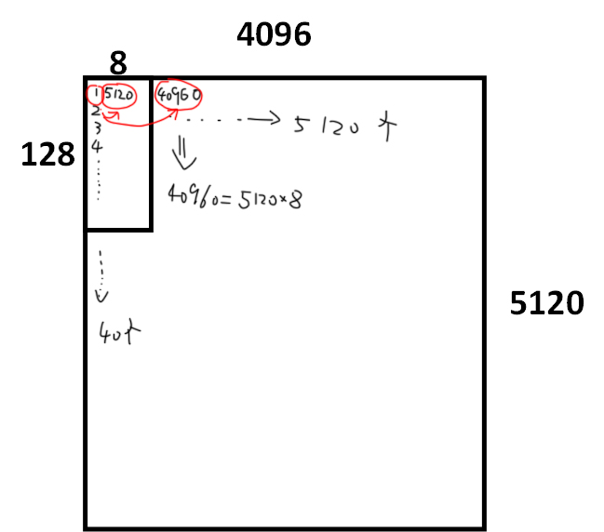

然后解释Step<X>是什么用法：

<https://github.com/NVIDIA/cutlass/blob/f7b19de32c5d1f3cedfc735c2849f12b537522ee/include/cute/tensor_impl.hpp#L985C1-L995C92>

来历是上面这里。

要想理解，就需要看懂源代码：

template <class Tensor, class Tiler, class Coord, class Proj,

          __CUTE_REQUIRES(is_tensor<remove_cvref_t<Tensor>>::value)>

CUTE_HOST_DEVICE

auto

local_tile(Tensor    && tensor,

           Tiler const& tiler,   // tiler to apply

           Coord const& coord,   // coord to slice into "remainder"

           Proj  const& proj)    // projection to apply to tiler and coord

{

  return local_tile(static_cast<Tensor&&>(tensor),

                    dice(proj, tiler),

                    dice(proj, coord));

}

这里的tiler就诸如（128,256,64），coord就诸如（blockIdx.x, blockIdx.y, _）然后使用Step对这两者都执行切片。X就是省略。可以通过实验证实，

  Tensor ctaA = local_tile(mA, cta_tiler1, cta_coord1, Step<_1, X,_1>{});  // (_32,_4,1024):(_1,5120,20480)

  Tensor ctaA1 = local_tile(mA, make_coord(32,4), make_coord(blockIdx.x,_));

这两种写法是一样的。就是跳过cta_tiler和cta_coord的对应位置。

然后我们进入

  return local_tile(static_cast<Tensor&&>(tensor),

                    dice(proj, tiler),

                    dice(proj, coord));

也就是：

template <class Tensor, class Tiler, class Coord,

          __CUTE_REQUIRES(is_tensor<remove_cvref_t<Tensor>>::value)>

CUTE_HOST_DEVICE constexpr

auto

local_tile(Tensor    && tensor,

           Tiler const& tiler,   // tiler to apply

           Coord const& coord)   // coord to slice into "remainder"

{

  return inner_partition(static_cast<Tensor&&>(tensor),

                         tiler,

                         coord);

}

我们进入inner_partition看看：

template <class Tensor, class Tiler, class Coord,

          __CUTE_REQUIRES(is_tensor<remove_cvref_t<Tensor>>::value)>

CUTE_HOST_DEVICE constexpr

auto

inner_partition(Tensor    && tensor,

                Tiler const& tiler,

                Coord const& coord)

{

  auto tensor_tiled = zipped_divide(static_cast<Tensor&&>(tensor), tiler);

  constexpr int R0 = decltype(rank<0>(tensor_tiled))::value;

  if(blockIdx.x==5&&blockIdx.y==2&&threadIdx.x==0&&threadIdx.y==0){

    print(tensor_tiled);

    printf("\ncute 000\n");

  }

  // The coord slices into the second mode (the "rest" mode), flatten the first

  if constexpr (is_tuple<Coord>::value) {

    // Append trailing modes if coord is tuple

    constexpr int R1 = decltype(rank<1>(tensor_tiled))::value;

    if(blockIdx.x==5&&blockIdx.y==2&&threadIdx.x==0&&threadIdx.y==0){

      // printf("\ncute 111, R0=%d, R1=%d\n", R0, R1);

      auto repeated = repeat<R0>(_); // 因为这里的R0打印出来是2，所以这里就是(_,_)

      auto appended = append<R1>(coord, _); // 这里的R1打印出来是4，比如原先的coord是(5,_)这个是根据blockidx.x .y那些来的。然后这里就是append延展到R1（4）那么长，然后补的内容都补_，就比如成为(5,_,_,_)

      // print(coord); // 诸如(5, _)，因为都是(blockIdx.x, blockIdx.y, _)跳过第一维或者第二维。

      // printf("\n");

      print(repeated);

      printf("\n");

      print(appended);

      printf("\n");

      print(tensor_tiled(repeat<R0>(_), append<R1>(coord,_)));

      printf("\n");

      // 对((32,4),(32,128,1,10))执行((_,_),(5,_,_,_))，就得到(32,4,128,1,10)。一来是这是tensor的切片，不会拆分出((32,4),(12,,1,10)，二来这里是对(32,128,1,10)那个32进行选择5，就消掉了这个5。选择了第五个位置，这里一般是A嘛，就对于A的列是无所谓的，要完全遍历，对于行则要选择具体一行。

    }

    return tensor_tiled(repeat<R0>(_), append<R1>(coord,_));

  } else {

    if(blockIdx.x==0&&blockIdx.y==0&&threadIdx.x==0&&threadIdx.y==0){

      printf("\ncute 222\n");

    }

    // Flat indexing if coord is not tuple

    return tensor_tiled(repeat<R0>(_), coord);

  }

}

这个图对理解inner_partition也有帮助。

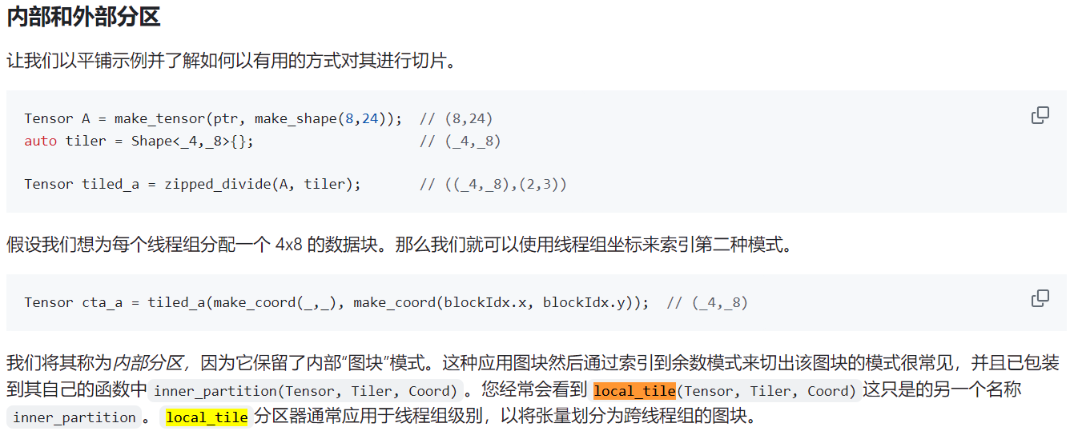

1. **如何使用DSM**

<https://docs.nvidia.com/cuda/cuda-c-programming-guide/index.html#distributed-shared-memory>

}

// cluster synchronization ensures that shared memory is initialized to zero in

// all thread blocks in the cluster. It also ensures that all thread blocks

// have started executing and they exist concurrently.

**cluster.sync(); <<<<-------要有这一步！在开始工作前就要有！**

for (int i = tid; i < array_size; i += blockDim.x * gridDim.x)

{

int ldata = input[i];

为了设置cluster尺寸，需要使用cudaLaunchKernelEx。如果使用传统的<<<>>>方式，则必须写死cluster尺寸，（此时可以以变量来调整gridDim和blockDim），如下：

__global__ void myKernel() __cluster_dims__(2, 1, 1) {

// kernel code

}

// Launch kernel

myKernel<<<gridDim, blockDim>>>();

但是使用cudaLaunchKernelEx，就可以动态调整三个值，如下：

__global__ void myKernel() {

// kernel code

}

cudaLaunchConfig_t config = {0};

config.gridDim = gridDim;

config.blockDim = blockDim;

cudaLaunchAttribute attribute[1];

attribute[0].id = cudaLaunchAttributeClusterDimension;

attribute[0].val.clusterDim.x = variableX; // 这里可以使用变量

attribute[0].val.clusterDim.y = variableY;

attribute[0].val.clusterDim.z = variableZ;

config.numAttrs = 1;

config.attrs = attribute;

cudaLaunchKernelEx(&config, myKernel, args...);

1. **如何使用TMA**

如何用cute来写TMA：

<https://research.colfax-intl.com/tutorial-hopper-tma/>

TMA的PTX页面：<https://docs.nvidia.com/cuda/parallel-thread-execution/index.html#data-movement-and-conversion-instructions-cp-async-bulk>

3. TMA的cuda API页面：https://docs.nvidia.com/cuda/cuda-c-programming-guide/index.html#using-tma-to-transfer-one-dimensional-arrays（要用memcpy_async加一些mbarrier的PTX）

TMA和mbarrier等非常相关！虽然我不熟悉这块。

可以从上面第三点提供的代码开始。我暂时还没跑通。

1. **研究cutlass/example/48**

**KernelScheduleAuto到底调用的是谁？**

首先要找到KernelScheduleAuto到底底层调用的是谁。现在找到其位置在：<https://github.com/NVIDIA/cutlass/blob/5b283c872cae5f858ab682847181ca9d54d97377/include/cutlass/gemm/collective/builders/sm90_gmma_builder.inl>

最终目标是获得KernelSchedule，根据cutlass代码，得到下面这样的判断树：

1. 判断是否支持TMA：

如果 IsTmaCompatible 为真，进入下一步判断；

否则，使用 KernelCpAsyncWarpSpecializedSchedule。

1. 判断CUDA版本是否>=12.1：

如果 CUDA 版本>=12.1，进入下一步判断；

否则，使用 KernelTmaWarpSpecialized。

1. 判断是否为Mixed Width Input：

如果 IsMixedWidthInput 为真，进入Mixed Width Input路径；

否则，进入Same Width Input路径。

3.1 Mixed Width Input路径：

判断 TileShape_M 是否为64：

如果 TileShape_M 为64，使用 KernelTmaWarpSpecializedPingpongMixedInput；

否则，使用 KernelTmaWarpSpecializedCooperativeMixedInput。

3.2 Same Width Input路径：

判断 TileShape_M 是否为64：

如果 TileShape_M 为64，使用 KernelTmaWarpSpecializedPingpong；

否则，使用 KernelTmaWarpSpecializedCooperative。

最终我们是使用KernelTmaWarpSpecializedCooperative

然后具体进入同一个文件的上面寻找，能找到最后可以是

// GMMA_TMA_WS_RS

// GMMA_TMA_WS_SS

这两者之一。。。暂时先研究GMMA_TMA_WS_SS。

里面和TMA和warp specialization相关的是MainloopSm90ArrayTmaGmmaWarpSpecialized

GMMA_TMA_WS_SS最底下定义了：

  using CollectiveOp = CollectiveMma<

      DispatchPolicy,

      TileShape_MNK,

      ElementA,

      TagToStrideA_t<GmemLayoutATag>,

      ElementB,

      TagToStrideB_t<GmemLayoutBTag>,

      TiledMma,

      GmemTiledCopyA,

      SmemLayoutAtomA,

      SmemCopyAtomA,

      cute::identity,

      GmemTiledCopyB,

      SmemLayoutAtomB,

      SmemCopyAtomB,

      cute::identity

    >;

在外部cutlass/example里面调用的是

using CollectiveMainloop = typename cutlass::gemm::collective::CollectiveBuilder<

    ArchTag, OperatorClass,

    ElementA, LayoutA, AlignmentA,

    ElementB, LayoutB, AlignmentB,

    ElementAccumulator,

    TileShape, ClusterShape,

    cutlass::gemm::collective::StageCountAutoCarveout<

      static_cast<int>(sizeof(typename CollectiveEpilogue::SharedStorage))>,

    cutlass::gemm::collective::KernelScheduleAuto

  >::CollectiveOp;

所以我们要进入CollectiveMma里面查看：

// WarpSpecialized Mainloop

template <

  int Stages,

  class ClusterShape,

  class KernelSchedule,

  class TileShape_,

  class ElementA_,

  class StrideA_,

  class ElementB_,

  class StrideB_,

  class TiledMma_,

  class GmemTiledCopyA_,

  class SmemLayoutAtomA_,

  class SmemCopyAtomA_,

  class TransformA_,

  class GmemTiledCopyB_,

  class SmemLayoutAtomB_,

  class SmemCopyAtomB_,

  class TransformB_>

struct CollectiveMma<

    MainloopSm90TmaGmmaWarpSpecialized<Stages, ClusterShape, KernelSchedule>,

    TileShape_,

    ElementA_,

    StrideA_,

    ElementB_,

    StrideB_,

    TiledMma_,

    GmemTiledCopyA_,

    SmemLayoutAtomA_,

    SmemCopyAtomA_,

    TransformA_,

    GmemTiledCopyB_,

    SmemLayoutAtomB_,

    SmemCopyAtomB_,

    TransformB_>

这里面有很多个不同的文件定义了CollectiveMma，依靠的是

MainloopSm90TmaGmmaWarpSpecialized来判断是否进入当前结构体。

为了确定进入的到底是哪个collectivemainloop，在这里插入：

/// Initialize operands to be used in the GEMM and reference GEMM

void initialize(const Options &options) {

  CollectiveMainloop op;

  op.print_template_name();

相应地，在sm90_mma_tma_gmma_ss_warpspecialized.hpp这里插入：

  //

  // Methods

  //

  void print_template_name() const {

    printf("Enter sm90_mma_tma_gmma_ss_warpspecialized\n");

  }

然后验证得知进入的确实是sm90_mma_tma_gmma_ss_warpspecialized。这里区别的是rs和ss。判断标准在：

// We need to handle the tuples in this function since it is used in SFINAE dispatch in the CollectiveBuilder.

// At that point, it is not guaranteed that the tuples have been split out into the required parts.

template <class MaybeTupleElementA, class LayoutA, class MaybeTupleElementB, class LayoutB>

constexpr bool

is_use_rmem_A() {

  using ElementA = detail::deduce_mixed_width_dtype_t<0, MaybeTupleElementA>;

  using ElementB = detail::deduce_mixed_width_dtype_t<0, MaybeTupleElementB>;

  constexpr bool IsABDifferentWidth = cute::sizeof_bits_v<ElementA> != cute::sizeof_bits_v<ElementB>;

  constexpr bool HasScales = cute::is_tuple<MaybeTupleElementA>::value ^ cute::is_tuple<MaybeTupleElementB>::value;

  constexpr bool IsInputSizeTwoBytes = is_input_size_two_bytes<ElementA, ElementB>();

  constexpr bool IsLayoutAkBk = cutlass::gemm::detail::is_k_major_A<LayoutA>() &&

                                cutlass::gemm::detail::is_k_major_B<LayoutB>();

  constexpr bool IsUseRmemA = (!IsInputSizeTwoBytes && !IsLayoutAkBk) || IsABDifferentWidth || HasScales;

  return IsUseRmemA;

}

综合所有条件，判断是否使用寄存器内存：

* 如果输入数据类型不是 2 字节宽且布局不是 k-major，则为真。
* 如果 A 和 B 的数据类型宽度不同，则为真。
* 如果 A 或 B 包含缩放因子，则为真。

似乎rs是一种新的优化方法，不过我暂时先不管。

在example48文件里面最重要的是这一行：

using GemmKernel = cutlass::gemm::kernel::GemmUniversal<

    Shape<int,int,int>, // Indicates ProblemShape

    CollectiveMainloop,

    CollectiveEpilogue

>;

这里的GemmUniversal决定了最内层的kernel到底是怎么写的。

这些GemmUniversal广泛的存在于

sm90_gemm_tma_warpspecialized_cooperative.hpp/sm90_gemm_tma_warpspecialized_pingpong.hpp等等之中。在每个文件开头处有判断，比如：

template <

  class ProblemShape_,

  class CollectiveMainloop_,

  class CollectiveEpilogue_,

  class TileScheduler_

>

class GemmUniversal<

  ProblemShape_,

  CollectiveMainloop_,

  CollectiveEpilogue_,

  TileScheduler_,

  cute::enable_if_t<cute::is_base_of_v<KernelTmaWarpSpecializedCooperative, typename CollectiveMainloop_::DispatchPolicy::Schedule>>>

{

我们这里的输入就是KernelTmaWarpSpecializedCooperative，所以就进入到了sm90_gemm_tma_warpspecialized_cooperative.hpp，打印结果也证实了这一点。

**kernel函数到底在哪？**

在include/cutlass/device_kernel.h，里面调用了operator。所以在sm90_gemm_tma_warpspecialized_cooperative.hpp里面真正被执行的是里面的operator。

/// Generic CUTLASS kernel template.

template <typename Operator>

CUTLASS_GLOBAL

#ifdef __CUDACC__

// Enclosing this in __CUDACC__ suppresses MSVC warnings.

__launch_bounds__(Operator::MaxThreadsPerBlock, Operator::MinBlocksPerMultiprocessor)

#endif // __CUDACC__

void device_kernel(CUTLASS_GRID_CONSTANT typename Operator::Params const params)

{

  // Dynamic shared memory base pointer

  extern __shared__ char smem[];

  Operator op;

  op(params, smem);

}

这里的operator是什么？为什么不需要写成op.operator，就相当于调用了里面的operator函数呢？解释如下：

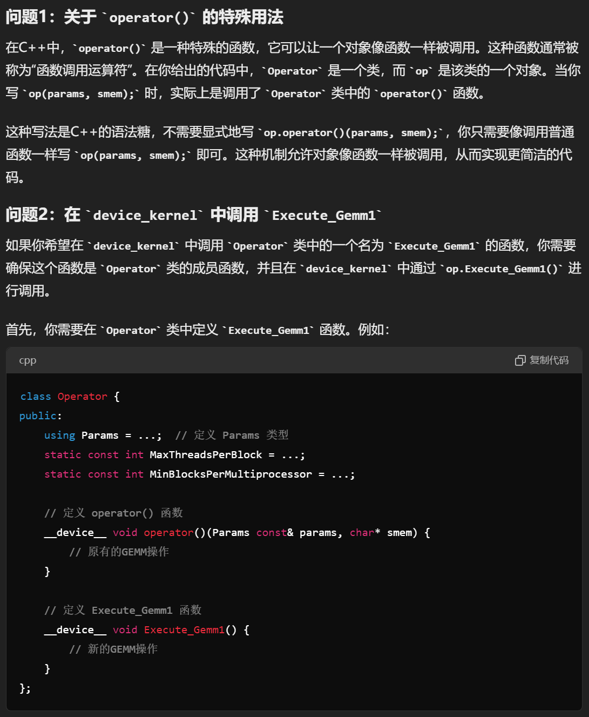

**研究Operator的细节**

CUTE_DEVICE void cluster_arrive_relaxed()

{

#if defined(CUTE_ARCH_CLUSTER_SM90_ENABLED)

asm volatile("barrier.cluster.arrive.relaxed.aligned;\n" : : );

#else

CUTE_INVALID_CONTROL_PATH("CUTE_ARCH_CLUSTER_SM90_ENABLED is not defined");

#endif

}

CUTE_DEVICE void cluster_arrive()

{

#if defined(CUTE_ARCH_CLUSTER_SM90_ENABLED)

asm volatile("barrier.cluster.arrive.aligned;\n" : : );

#else

CUTE_INVALID_CONTROL_PATH("CUTE_ARCH_CLUSTER_SM90_ENABLED is not defined");

#endif

}

CUTE_DEVICE void cluster_wait()

{

#if defined(CUTE_ARCH_CLUSTER_SM90_ENABLED)

asm volatile("barrier.cluster.wait.aligned;\n" : : );

#else

CUTE_INVALID_CONTROL_PATH("CUTE_ARCH_CLUSTER_SM90_ENABLED is not defined");

#endif

}

等等，这些的区别是什么？我自己怎么用？

ChatGPT的答案：（我也将信将疑。。。。）

· 初始化阶段：在集群中的所有线程开始执行主要任务之前，需要进行一些初始化操作。cluster_arrive_relaxed可以在这个阶段使用，以通知其他线程已经准备好，但不必等待所有线程都到达。

· · 主循环阶段：在集群中的所有线程都需要在某个关键点同步。使用cluster_arrive和cluster_wait确保所有线程都到达同步点，然后再继续执行。这通常用于确保数据一致性和正确性。

    auto cluster_wait_fn = [] () {

      // We need this to guarantee that the Pipeline init is visible

      // To all producers and consumer thread blocks in the Cluster

      if constexpr (size(ClusterShape{}) > 1) {

        cute::cluster_arrive_relaxed();

        return [] () { cute::cluster_wait(); };

      }

      else {

        __syncthreads();

        return [] () {}; // do nothing

      }

    } ();

假设 ClusterShape 的大小大于1，则执行流程如下：

定义 cluster_wait_fn：

立即执行 cute::cluster_arrive_relaxed()。

返回一个包含 cute::cluster_wait() 的 lambda 表达式。

稍后调用 cluster_wait_fn：

执行返回的 lambda 表达式，也就是 cute::cluster_wait()。

**共享内存使用量是多少？**

在文件

/home/zyhuang/cutlass/include/cutlass/gemm/kernel/sm90_gemm_tma_warpspecialized_cooperative.hpp里有

  struct SharedStorage {

    struct PipelineStorage : cute::aligned_struct<16> {

      using MainloopPipelineStorage = typename CollectiveMainloop::PipelineStorage;

      using EpiLoadPipelineStorage = typename CollectiveEpilogue::PipelineStorage;

      alignas(16) MainloopPipelineStorage mainloop;

      alignas(16) EpiLoadPipelineStorage epi_load;

      alignas(16) typename LoadWarpOrderBarrier::SharedStorage load_order;

    } pipelines;

    struct TensorStorage : cute::aligned_struct<128> {

      using MainloopTensorStorage = typename CollectiveMainloop::TensorStorage;

      using EpilogueTensorStorage = typename CollectiveEpilogue::TensorStorage;

      EpilogueTensorStorage epilogue;

      MainloopTensorStorage mainloop;

    } tensors;

  };

这里的尺寸由下式求出：

static constexpr int SharedStorageSize = sizeof(SharedStorage);

在operator里输出SharedStorageSize可知是196864byte。Ncu测试也一样。（注意ncu的结果是kbyte，即1e3byte，而不是1024byte，那个是kb，不等同于kbyte）

每一项详细测出来是：

**PipelineStorage**

PipelineStorageSize=96:

PipelineStorage的总大小。这部分包括主循环管道存储、EpiLoad管道存储和LoadWarpOrderBarrier的共享存储。

**TensorStorage**

TensorStorageSize=196736:

TensorStorage的总大小。这部分包括主循环张量存储和Epilogue张量存储。

* MainloopPipelineStorage

MainloopPipelineStorageSize=64:

主循环管道存储的大小。这部分存储用于在主循环（Mainloop）中存储需要在不同线程之间共享的数据。

* EpiLoadPipelineStorage

EpiLoadPipelineStorageSize=2:

EpiLoadPipelineStorage的大小。这部分存储用于在Epilogue加载阶段存储需要在不同线程之间共享的数据。

* LoadWarpOrderBarrierSharedStorage

LoadWarpOrderBarrierSharedStorageSize=16:

LoadWarpOrderBarrier的共享存储大小。这部分存储用于协调不同线程之间的加载顺序。

* MainloopTensorStorage

**MainloopTensorStorageSize=196608:**

主循环张量存储的大小。这部分存储用于在主循环（Mainloop）中存储需要在不同线程之间共享的张量数据。（192KB）（smem_A=64KB, smem_B=128KB）

* EpilogueTensorStorage

EpilogueTensorStorageSize=1:

Epilogue张量存储的大小。这部分存储用于在Epilogue阶段存储需要在不同线程之间共享的张量数据。

/home/zyhuang/cutlass/include/cutlass/gemm/collective/sm90_mma_tma_gmma_ss_warpspecialized.hpp

  // Tile along modes in a way that maximizes the TMA box size.

  using SmemLayoutA = decltype(tile_to_shape(

      SmemLayoutAtomA{},

      make_shape(shape<0>(TileShape{}), shape<2>(TileShape{}), Int<DispatchPolicy::Stages>{}),

      cute::conditional_t< ::cutlass::gemm::detail::is_major<0,StrideA>(), Step<_2,_1,_3>, Step<_1,_2,_3>>{}));

打印出这里的SmemLayoutA和B来检查数值。方法是将其插入到同一个文件瞎的SharedStorage结构体里，然后去

/home/zyhuang/cutlass/include/cutlass/gemm/kernel/sm90_gemm_tma_warpspecialized_cooperative.hpp的operator里printf出来。得到以下结果：

TileShape=(128, 256, 64)

stages_value=4

SmemLayoutAtomA=(8, 64)

SmemLayoutA=(128, 64, 4)

和之前得到的结果相比，结果一致：

MNK=128,256,64

A矩阵是128(M)*64(K)*2/1024*4(stage_count)=64KB

B矩阵是256(N)*64(K)*2/1024*4(stage_count)=128KB

SmemLayoutAtomA是由ss_smem_selector得到的，底层是GMMA::Layout_MN_SW128_Atom或者类似的东西，暂时不管。

**stage_count是怎么得到的？**

因为SmemlayoutA是由SmemLayoutAtomA组合而得：

  // Tile along modes in a way that maximizes the TMA box size.

  using SmemLayoutA = decltype(tile_to_shape(

      SmemLayoutAtomA{},

      make_shape(shape<0>(TileShape{}), shape<2>(TileShape{}), Int<DispatchPolicy::Stages>{}),

      cute::conditional_t< ::cutlass::gemm::detail::is_major<0,StrideA>(), Step<_2,_1,_3>, Step<_1,_2,_3>>{}));

所以需要上溯stage_count的由来。可见我们需要的是DispatchPolicy::Stages，那么需要上溯DispatchPolicy。using DispatchPolicy = MainloopSm90TmaGmmaWarpSpecialized<Stages, ClusterShape, KernelSchedule>;让我们上溯MainloopSm90TmaGmmaWarpSpecialized

由此上溯

/home/zyhuang/cutlass/include/cutlass/gemm/collective/builders/sm90_gmma_builder.inl。

在此文件下找到

  using DispatchPolicy = cute::conditional_t<IsArrayOfPointersGemm,

      MainloopSm90ArrayTmaGmmaWarpSpecialized<PipelineStages, ClusterShape_MNK, KernelScheduleType>,

      /* For FP8 use a separate mainloop compared to other datatypes */

      cute::conditional_t<IsFP8Input,

          MainloopSm90TmaGmmaWarpSpecializedFP8<PipelineStages, ClusterShape_MNK, KernelScheduleType>,

          MainloopSm90TmaGmmaWarpSpecialized<PipelineStages, ClusterShape_MNK, KernelScheduleType>>>;

也就是找到PipelineStages，也就是

  static constexpr int PipelineStages = detail::compute_stage_count_or_override<detail::sm90_smem_capacity_bytes,

      ElementAMma, ElementBMma, TileShape_MNK>(StageCountType{});

compute_stage_count_or_override定义在同一个路径下，有三个override函数，区别在于输入参数，这里我们用到：

// Returns the maximum number of smem tiles that can be used with a given smem capacity, or overrides with manual count.

template<int CapacityBytes, class ElementA, class ElementB, class TileShapeMNK, int carveout_bytes>

constexpr int

compute_stage_count_or_override(StageCountAutoCarveout<carveout_bytes> stage_count) {

  constexpr auto mainloop_pipeline_bytes = sizeof(typename cutlass::PipelineTmaAsync<1>::SharedStorage);

  constexpr auto a_bits = cute::sizeof_bits_v<ElementA>;

  constexpr auto b_bits = cute::sizeof_bits_v<ElementB>;

  constexpr int stage_bytes =

    cutlass::bits_to_bytes(a_bits * size<0>(TileShapeMNK{}) * size<2>(TileShapeMNK{})) +

    cutlass::bits_to_bytes(b_bits * size<1>(TileShapeMNK{}) * size<2>(TileShapeMNK{})) +

    static_cast<int>(mainloop_pipeline_bytes);

  return (CapacityBytes - carveout_bytes) / stage_bytes;

}

在operator里打印出计算需要的参数，分别是：

mainloop_pipeline_bytes: 16 bytes

a_bits: 16 bits

b_bits: 16 bits

TileShapeMNK = {128, 256, 64}

carveout_bytes: 1 byte

a_bits * size<0>(TileShapeMNK{}) * size<2>(TileShapeMNK{})

= 16 bits * 128 * 64

= 16 * 128 * 64

= 131072 bits=131072 / 8 = 16384 bytes

b_bits * size<1>(TileShapeMNK{}) * size<2>(TileShapeMNK{})

= 16 bits * 256 * 64

= 16 * 256 * 64

= 262144 bits=262144 / 8 = 32768 bytes

stage_bytes = 16384 + 32768 + 16

= 49168 bytes

return (232448 - 1) / 49168

= 232447 / 49168

≈ 4.728 所以取4。

1. **Setmaxnreg的特性**

the number of register is determined by:

code shared by different warp (A registers per thread)

code snippet for warp(i, i+1…, i+K) (B registers per thread)------code snippet for warp(j, j+1, …, j+T)(C registers per thread)

In part 2, the register is num_2 = (KB+CT)/(B+C)

So overall register number is max(A, num_2)

如何获知producer和consumer的寄存器数量？可以用ncu的source code来看。找到最大寄存器数量即可。（有时间亲自试试看！）

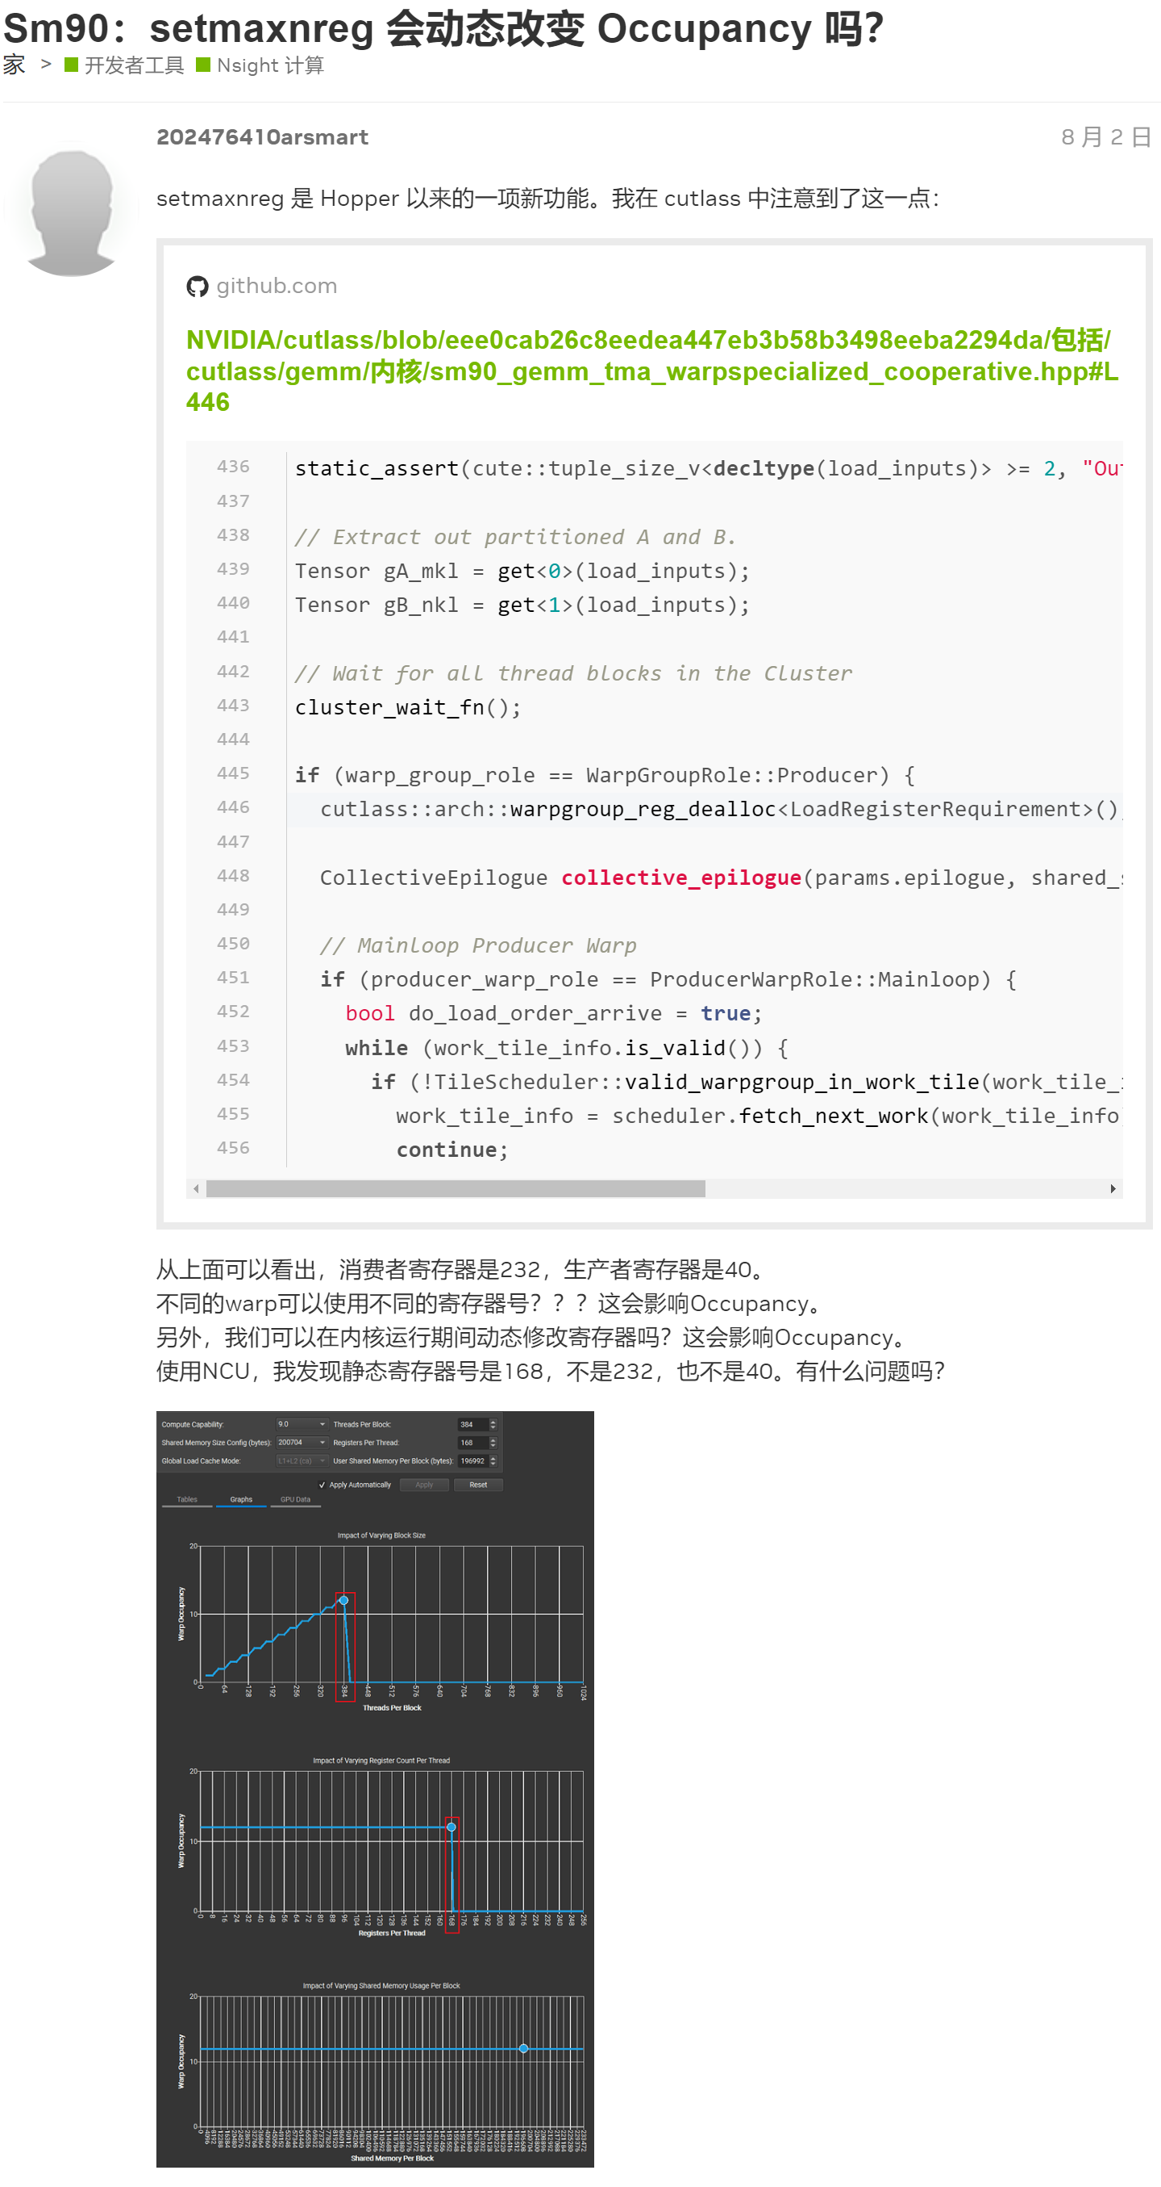

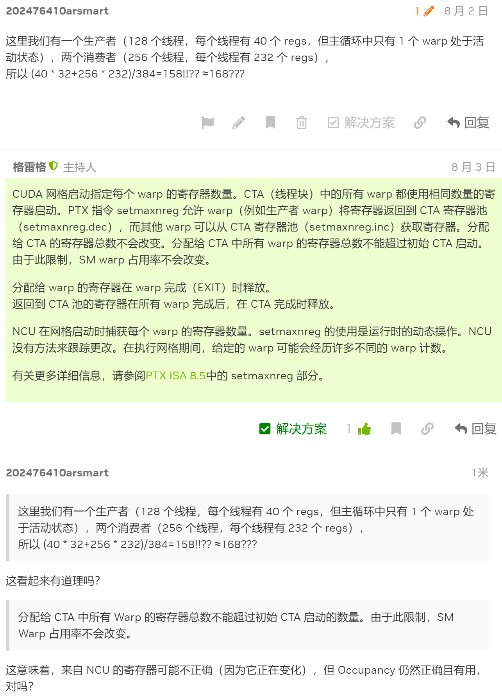

1. **TileSchedulerSelector是怎么被调用的？**

首先是我们跑example48，从

/home/zyhuang/cutlass/include/cutlass/gemm/kernel/sm90_gemm_warpspecialized.hpp里看到scheduler.fetch_next_work，然后去找fetch_next_work，在include/cutlass/gemm/kernel/下面有三个tilescheduler文件：

/home/zyhuang/cutlass/include/cutlass/gemm/kernel/sm90_tile_scheduler.hpp

/home/zyhuang/cutlass/include/cutlass/gemm/kernel/sm90_tile_scheduler_stream_k.hpp

/home/zyhuang/cutlass/include/cutlass/gemm/kernel/sm90_tile_scheduler_group.hpp

在其中都有fetch_next_work，在每个里面加打印函数，最后发现是进入了sm90_tile_scheduler。

所以去寻找该文件的类：class PersistentTileSchedulerSm90。搜索代码发现：

// Default (void) for Sm90 maps to PersistentTileSchedulerSm90

template <

  class ArchTag,

  class TileShape,

  class ClusterShape

>

struct TileSchedulerSelector<

  void,

  ArchTag,

  TileShape,

  ClusterShape

  > {

  using Scheduler = typename TileSchedulerSelector<

    PersistentScheduler,

    ArchTag,

    TileShape,

    ClusterShape

  >::Scheduler;

};

这里最关键的是TileSchedulerSelector后面紧跟着的是void。然后去寻找TileSchedulerSelector。

在include/cutlass/gemm/kernel/sm90_gemm_tma_warpspecialized_cooperative.hpp里找到了

using TileScheduler = typename detail::TileSchedulerSelector<

    TileScheduler_, ArchTag, TileShape, ClusterShape>::Scheduler;

再上溯去找TileScheduler_

template <

  class ProblemShape_,

  class CollectiveMainloop_,

  class CollectiveEpilogue_,

  class TileScheduler_

>

class GemmUniversal<

  ProblemShape_,

  CollectiveMainloop_,

  CollectiveEpilogue_,

  TileScheduler_,

  cute::enable_if_t<cute::is_base_of_v<KernelTmaWarpSpecializedCooperative, typename CollectiveMainloop_::DispatchPolicy::Schedule>>>

这一点，在

/home/zyhuang/cutlass/examples/48_hopper_warp_specialized_gemm/48_hopper_warp_specialized_gemm.cu里没有直接体现：

using GemmKernel = cutlass::gemm::kernel::GemmUniversal<

    Shape<int,int,int>, // Indicates ProblemShape

    CollectiveMainloop,

    CollectiveEpilogue

>;

缺失了。然后去找GemmUniversal的定义函数：

/home/zyhuang/cutlass/include/cutlass/gemm/kernel/gemm_universal_decl.h

template <

  class ProblemShapeOrThreadblockMma_, // (m, n, k) or (m, n, k, l)

  class CollectiveMainloopOrEpilogue_,

  class CollectiveEpilogueOrThreadblockSwizzle_,

  class TileScheduler_ = void,

  class Enable = void

>

class GemmUniversal;

得知如果不写，就默认是void。然后最终使用PersistentTileSchedulerSm90。

1. **Template是怎么用的？**

// WarpSpecialized Mainloop

template <

  int Stages,

  class ClusterShape,

  class KernelSchedule,

  class TileShape_,

  class ElementA_,

  class StrideA_,

  class ElementB_,

  class StrideB_,

  class TiledMma_,

  class GmemTiledCopyA_,

  class SmemLayoutAtomA_,

  class SmemCopyAtomA_,

  class TransformA_,

  class GmemTiledCopyB_,

  class SmemLayoutAtomB_,

  class SmemCopyAtomB_,

  class TransformB_>

struct CollectiveMma<

    MainloopSm90TmaGmmaWarpSpecialized<Stages, ClusterShape, KernelSchedule>,

    TileShape_,

    ElementA_,

    StrideA_,

    ElementB_,

    StrideB_,

    ElementB_gemm1_weight_,

    Stride_gemm1_weight_,

    TiledMma_,

    GmemTiledCopyA_,

    SmemLayoutAtomA_,

    SmemCopyAtomA_,

    TransformA_,

    GmemTiledCopyB_,

    SmemLayoutAtomB_,

    SmemCopyAtomB_,

    TransformB_>

{

比如这里就报错说ElementB_gemm1_weight_未定义。可见，外部初始化的时候，是根据struct后面的列表顺序来初始化的。但是这些初始化的内里面，每个都要再前面的template里面出现一次，除非说是int那种内置类型。因为cpp内部是没有定义诸如TransformA_这种类型的。

1. **Sm90上的block执行顺序是什么？**

首先sm90必然使用persistent策略。所以一个CTA就会计算多个128*256的block位置。到底计算哪些？

其次，每次都是以cluster为集体来计算的。一个cluster是怎么排布的？

首先由41确定下来，我们用的是PersistentTileSchedulerSm90，位于/home/zyhuang/cutlass/include/cutlass/gemm/kernel/sm90_tile_scheduler.hpp

然后这里面计算当前cluster/CTA具体负责的block的函数是get_work_idx_m_and_n，这将被/home/zyhuang/cutlass/include/cutlass/gemm/kernel/static_tile_scheduler.hpp调用。每次在operator里scheduler.fetch_next_work的时候，底层都会调用到get_work_idx_m_and_n。要调整每个cluster/CTA的计算位置，也只需要修改get_work_idx_m_and_n即可。

一个测试结果是，在代码中，限定blockIdx.x=.y=0时，输出当前CTA负责的block_coord：

|  |  |  |
| --- | --- | --- |
| blk_M | blk_N | blk_K |
| 128 | 256 | 64 |
| cluster0 | cluster1 | cluster2 |
| 1 | 2 | 1 |

|  |  |  |  |
| --- | --- | --- | --- |
| 4096-4096-256 |  |  |  |
| M | N | M*16+N | 上下差值 |
| 0 | 0 | 0 |  |
| 8 | 4 | 132 | 132 |
| 16 | 8 | 264 | 132 |
| 24 | 12 | 396 | 132 |

（16是4096/256）

|  |  |  |  |
| --- | --- | --- | --- |
| 4096-8192-256 |  |  |  |
| M | N | M*32+N | 上下差值 |
| 0 | 0 | 0 |  |
| 4 | 4 | 132 | 132 |
| 8 | 8 | 264 | 132 |
| 12 | 12 | 396 | 132 |
| 16 | 16 | 528 | 132 |
| 20 | 20 | 660 | 132 |
| 24 | 24 | 792 | 132 |
| 28 | 28 | 924 | 132 |

（32是8192/256）

暂未破译132是什么。。。后来查明了，在

cutlass/include/cutlass/gemm/kernel/static_tile_scheduler.hpp的advance_to_next_work，每次block的增量是total_block_size，也就是gridDim.x*gridDim.y*gridDim.z。所以这里如果是132，那就是cluster_size=1或者2，就是总共能发射132个block（因为SM也是132个）。不过我测过，当cluster_size=4，最大block_per_wave是116，cluster_size=16, max_block_per_wave是112。

当我们深入/home/zyhuang/cutlass/include/cutlass/gemm/kernel/static_tile_scheduler.hpp，会看到scheduler_params后面附带很多参数，不知道具体是在哪里定义的，下面去寻找具体定义的位置。

    auto [work_idx_m, work_idx_n] = Subclass::get_work_idx_m_and_n(blk_per_grid_dim, scheduler_params.divmod_cluster_shape_major_, scheduler_params.divmod_cluster_shape_minor_, scheduler_params.divmod_cluster_blk_major_, scheduler_params.log_swizzle_size_, scheduler_params.raster_order_);

在/home/zyhuang/cutlass/include/cutlass/gemm/kernel/sm90_gemm_tma_warpspecialized_cooperative.hpp里面有：

  // Convert to underlying arguments. In this case, a simple copy for the aliased type.

  static

  Params

  to_underlying_arguments(Arguments const& args, void* workspace) {

    CUTLASS_TRACE_HOST("to_underlying_arguments():");

    auto problem_shape = args.problem_shape;

    if constexpr (detail::Has_SwapAB_v<CollectiveMainloop>) {

      // swap M/N

      get<0>(problem_shape) = get<1>(args.problem_shape);

      get<1>(problem_shape) = get<0>(args.problem_shape);

    }

    auto problem_shape_MNKL = append<4>(problem_shape, 1);

    // Get SM count if needed, otherwise use user supplied SM count

    int sm_count = args.hw_info.sm_count;

    if (sm_count <= 0) {

      CUTLASS_TRACE_HOST("  WARNING: Arguments do not include a valid SM count.\n"

          "  For optimal performance, populate the arguments KernelHardwareInfo struct with the SM count.");

      sm_count = KernelHardwareInfo::query_device_multiprocessor_count(args.hw_info.device_id);

    }

    CUTLASS_TRACE_HOST("to_underlying_arguments(): Setting persistent grid SM count to " << sm_count);

    KernelHardwareInfo hw_info{args.hw_info.device_id, sm_count};

    // Calculate workspace pointers

    uint8_t* workspace_ptr = reinterpret_cast<uint8_t*>(workspace);

    size_t workspace_offset = 0;

    void* scheduler_workspace = workspace_ptr;

    workspace_offset += TileScheduler::template get_workspace_size<ProblemShape, ElementAccumulator>(

      args.scheduler, args.problem_shape, args.hw_info, NumMmaWarpGroups);

    workspace_offset = round_nearest(workspace_offset,  MinWorkspaceAlignment);

    void* epilogue_workspace = workspace_ptr + workspace_offset;

    workspace_offset += CollectiveEpilogue::get_workspace_size(args.problem_shape, args.epilogue);

    workspace_offset = round_nearest(workspace_offset,  MinWorkspaceAlignment);

    void* mainloop_workspace = nullptr;

    // Precompute the sub tiles numbers in epilogue, pass into tile scheduler.  Therefore it will be used

    // in separate reduction scheme for streamk case, NumEpilogueSubTiles default value is 1, which means

    // subtile will not be used, therefore separate reduction will not be enabled.

    constexpr uint32_t NumEpilogueSubTiles = CollectiveEpilogue::get_store_pipe_increment(TileShape{});

    TileSchedulerParams scheduler = TileScheduler::to_underlying_arguments(

      problem_shape_MNKL, TileShape{}, ClusterShape{}, hw_info, args.scheduler, scheduler_workspace, NumEpilogueSubTiles);

    return {

      args.mode,

      problem_shape,

      CollectiveMainloop::to_underlying_arguments(args.problem_shape, args.mainloop, mainloop_workspace),

      CollectiveEpilogue::to_underlying_arguments(args.problem_shape, args.epilogue, epilogue_workspace),

      hw_info,

      scheduler,

      workspace

    };

  }

注意这里：

    TileSchedulerParams scheduler = TileScheduler::to_underlying_arguments(

      problem_shape_MNKL, TileShape{}, ClusterShape{}, hw_info, args.scheduler, scheduler_workspace, NumEpilogueSubTiles);

TileScheduler::to_underlying_arguments是cutlass/include/cutlass/gemm/kernel/static_tile_scheduler.hpp里面的：

  template <class ProblemShapeMNKL, class TileShape, class ClusterShape>

  static Params

  to_underlying_arguments(

    ProblemShapeMNKL problem_shape_mnkl,

    TileShape tile_shape,

    ClusterShape cluster_shape,

    [[maybe_unused]] KernelHardwareInfo const& hw_info,

    Arguments const& arguments,

    [[maybe_unused]] void* workspace=nullptr,

    [[maybe_unused]] const uint32_t epilogue_subtile = 1) {

    // We only need the tile and cluster shape during scheduler setup, so let FTAD do the magic

    static_assert(cute::is_static<TileShape>::value);

    static_assert(cute::is_static<ClusterShape>::value);

    dim3 problem_blocks = get_tiled_cta_shape_mnl(problem_shape_mnkl, tile_shape, cluster_shape);

    Params params;

    params.initialize(

      problem_blocks,

      to_gemm_coord(cluster_shape),

      hw_info,

      arguments.max_swizzle_size,

      arguments.raster_order

    );

    return params;

  }

注意这里的Params是PersistentTileSchedulerSm90Params，这定义在：cutlass/include/cutlass/gemm/kernel/tile_scheduler_params.h

这里面定义了很多很多东西。这就完全找到最底层了。

      int cta_per_device = sm_count;

      /*

      * Optimal grid size calculation is based on

      * GH100: 8 GPCs, 72 TPCs (9 TPCs/GPC), 2 SMs/TPC, 144 SMs per full GPU

      * Hence, maximum SMs per GPC = 18

      */

      constexpr int max_sm_per_gpc = 18;

      // Provided SM count could possibly be less than the assumed maximum SMs per GPC

      auto cluster_size = cluster_shape.m() * cluster_shape.n();

      int const min_num_gpc = sm_count < max_sm_per_gpc ? 1 : sm_count / max_sm_per_gpc;

      int const max_cta_occupancy_per_gpc = max_sm_per_gpc - (max_sm_per_gpc % cluster_size);

      cta_per_device = min_num_gpc * max_cta_occupancy_per_gpc;

回到block的执行顺序上。在cutlass/include/cutlass/gemm/kernel/sm90_tile_scheduler.hpp里这个函数是开始：

  // Kernel helper function to get next work tile

  CUTLASS_DEVICE

  auto

  fetch_next_work(WorkTileInfo work_tile_info) {

    if (continue_current_work(work_tile_info)) {

      return work_tile_info; // 在static_tile_scheduler里定义了continue_current_work函数必然返回false。所以是绝对不会进入这里的。

    }

    advance_to_next_work();

    return get_current_work();

  }

也就是advance_to_next_work()和get_current_work()。

advance_to_next_work()是对current_work_linear_idx_（private变量）每次进行增加一个wave的block数量（假设是112个）。

get_current_work()是调用get_work_idx_m_and_n，对current_work_linear_idx_进行计算，比如假如是100，那么就除以problem_shape<1>，比如是横向有15个block每行，那么第100位置对应的就是第六行的第十个位置。

然后下次advance_to_next_work()再增加到212，也就是14行第二列。

直到https://github.com/NVIDIA/cutlass/blob/7192f4ab230bb721fa8d4d3df33886dbe86cdc59/include/cutlass/gemm/kernel/static_tile_scheduler.hpp#L169-L172

  get_current_work_for_linear_idx(uint64_t linear_idx) const {

    if (linear_idx >= scheduler_params.blocks_per_problem_) {

      return WorkTileInfo::invalid_work_tile();

    }

这里结束外层的循环https://github.com/NVIDIA/cutlass/blob/7192f4ab230bb721fa8d4d3df33886dbe86cdc59/include/cutlass/gemm/kernel/sm90_gemm_tma_warpspecialized_cooperative.hpp#L453。

注意现在因为我只改写了raster=N的情况。所以要想跑通，得写全，类似于：

./48_hopper_warp_specialized_gemm --m=4096 --n=20480 --k=5120 --raster=N

1. **计算结果是怎么存出到global的？**

首先看到在producer里面有epilogue。怀疑是不是在这里存出。但是第一，producer并不拥有每次的计算结果。其次是每个warp_group算完后就应该存出去，因为共享内存也没有分配地方来存这些中间结果（也没必要）。所以存出不可能放在producer。

其次看到consumer里面有epilogue_store，注明了是存到global。

        if (TileScheduler::compute_epilogue(work_tile_info, params.scheduler)) {

          // Epilogue and write to gD

          auto [epi_load_pipe_consumer_state_next, epi_store_pipe_producer_state_next] =

          collective_epilogue.store(

            epi_load_pipeline,

            epi_load_pipe_consumer_state,

            epi_store_pipeline,

            epi_store_pipe_producer_state,

            problem_shape_MNKL,

            blk_shape,

            blk_coord,

            accumulators,

            tiled_mma,

            mma_thread_idx,

            shared_storage.tensors.epilogue,

            work_tile_info.reduction_subtile_idx()

          );

经过打印证实，确实进入了这里面。collective_epilogue上溯到源头，来自于example cu文件里面的：

using CollectiveEpilogue = typename cutlass::epilogue::collective::CollectiveBuilder<

    cutlass::arch::Sm90, cutlass::arch::OpClassTensorOp,

    TileShape, ClusterShape,

    cutlass::epilogue::collective::EpilogueTileAuto,

    ElementAccumulator, ElementAccumulator,

    ElementC, LayoutC, AlignmentC,

    ElementC, LayoutC, AlignmentC,

    cutlass::epilogue::collective::EpilogueScheduleAuto

  >::CollectiveOp;

核心在EpilogueScheduleAuto。

在cutlass/include/cutlass/epilogue/collective/builders/sm90_builder.inl里面找到了EpilogueScheduleAuto。

最后追溯到：

  using CollectiveOp = cute::conditional_t<

    cute::is_same_v<Schedule, NoSmemWarpSpecialized>,

    cutlass::epilogue::collective::detail::Sm90TmaWarpSpecializedAdapter<

      cutlass::epilogue::collective::DefaultEpilogue<

        cutlass::detail::TagToStrideC_t<GmemLayoutTagC>,

        cutlass::detail::TagToStrideC_t<GmemLayoutTagD>,

        ThreadOp,

        cutlass::gemm::EpilogueDefault>>,

    // Epilogue for Ptr-Array and Grouped Gemm

    cutlass::epilogue::collective::detail::Sm90TmaWarpSpecializedAdapter<

      cutlass::epilogue::collective::DefaultEpilogueArray<

        cutlass::detail::TagToStrideC_t<GmemLayoutTagC>,

        cutlass::detail::TagToStrideC_t<GmemLayoutTagD>,

        ThreadOp,

        Schedule>>

    >; // 一开始定义的是auto，然后里面确定会使用NoSmemWarpSpecialized，所以这里就会选择DefaultEpilogue（第一个）

也就是cutlass/include/cutlass/epilogue/collective/default_epilogue.hpp里面的operator：

  template<

    class ProblemShapeMNKL,

    class BlockShapeMNK,

    class BlockCoordMNKL,

    class FrgEngine, class FrgLayout,

    class TiledMma,

    class ResidueMNK

  >

  CUTLASS_HOST_DEVICE void

  operator()(

      ProblemShapeMNKL problem_shape_mnkl,

      BlockShapeMNK blk_shape_MNK,

      BlockCoordMNKL blk_coord_mnkl,

      cute::Tensor<FrgEngine, FrgLayout> const& accumulators,

      TiledMma tiled_mma,

      ResidueMNK residue_mnk,

      int thread_idx,

      [[maybe_unused]] char* smem_buf)

  {

    using namespace cute;

    using X = Underscore;

    static_assert(cute::rank(ProblemShapeMNKL{}) == 4, "ProblemShapeMNKL must be rank 4");

    static_assert(is_static<BlockShapeMNK>::value, "ThreadBlock tile shape must be static");

    static_assert(cute::rank(BlockShapeMNK{}) == 3, "BlockShapeMNK must be rank 3");

    static_assert(cute::rank(BlockCoordMNKL{}) == 4, "BlockCoordMNKL must be rank 3");

    // Separate out problem shape for convenience

    auto M = get<0>(problem_shape_mnkl);

    auto N = get<1>(problem_shape_mnkl);

    auto L = get<3>(problem_shape_mnkl);

    auto stride_c = detail::get_epilogue_stride<EpilogueSchedule>(params.dC);

    auto stride_d = detail::get_epilogue_stride<EpilogueSchedule>(params.dD);

    // Represent the full output tensor

    Tensor mC_mnl = make_tensor(make_gmem_ptr(params.ptr_C), make_shape(M,N,L), stride_c);                 // (m,n,l)

    Tensor mD_mnl = make_tensor(make_gmem_ptr(params.ptr_D), make_shape(M,N,L), stride_d);                 // (m,n,l)

    Tensor gC_mnl = local_tile(mC_mnl, blk_shape_MNK, make_coord(_,_,_), Step<_1,_1, X>{});    // (BLK_M,BLK_N,m,n,l)

    Tensor gD_mnl = local_tile(mD_mnl, blk_shape_MNK, make_coord(_,_,_), Step<_1,_1, X>{});    // (BLK_M,BLK_N,m,n,l)

    // Slice to get the tile this CTA is responsible for

    auto [m_coord, n_coord, k_coord, l_coord] = blk_coord_mnkl;

    Tensor gC = gC_mnl(_,_,m_coord,n_coord,l_coord);                                                 // (BLK_M,BLK_N)

    Tensor gD = gD_mnl(_,_,m_coord,n_coord,l_coord);                                                 // (BLK_M,BLK_N)

    // Partition source and destination tiles to match the accumulator partitioning

    auto thr_mma = tiled_mma.get_thread_slice(thread_idx);

    Tensor tCgD = thr_mma.partition_C(gD);                                       // (VEC,THR_M,THR_N)

    Tensor tCgC = thr_mma.partition_C(gC);                                       // (VEC,THR_M,THR_N)

    static_assert(is_static<FrgLayout>::value, "Accumulator layout must be static");

    CUTE_STATIC_ASSERT_V(size(tCgC) == size(tCgD),

        "Source and destination must have the same number of elements.");

    CUTE_STATIC_ASSERT_V(size(tCgD) == size(accumulators),

        "Accumulator count must have the same destination element count.");

    // Make an identity coordinate tensor for predicating our output MN tile

    auto cD = make_identity_tensor(make_shape(unwrap(shape<0>(gD)), unwrap(shape<1>(gD))));

    Tensor tCcD = thr_mma.partition_C(cD);

    // source is needed

    if (epilogue_op.is_source_needed()) {

      CUTLASS_PRAGMA_UNROLL

      for (int i = 0; i < size(accumulators); ++i) {

        if (elem_less(tCcD(i), make_coord(get<0>(residue_mnk), get<1>(residue_mnk)))) {

          tCgD(i) = epilogue_op(accumulators(i), tCgC(i));

        }

      }

    }

    // source is not needed, avoid load

    else {

      CUTLASS_PRAGMA_UNROLL

      for (int i = 0; i < size(accumulators); ++i) {

        if (elem_less(tCcD(i), make_coord(get<0>(residue_mnk), get<1>(residue_mnk)))) {

          tCgD(i) = epilogue_op(accumulators(i));

        }

      }

    }

  }

在这里，直接将值从寄存器写到global。一来没经过共享内存，二来没有使用TMA。以后可以换其他epilogue试试看。

1. **sm90_epilogue_tma_warpspecialized是怎么使用的？**

（背景：为了将计算的中间结果存储到共享内存，所以要使用default之外的epilogue。这就是TMA，而且要修改，以避免使用reuseC，reuseSMEM，因为我们需要同时保存所有的C计算结果在共享内存。。。反之倒也可以，但是对后续计算就会引入很多麻烦。。以后再细想吧）

cutlass/include/cutlass/epilogue/collective/sm90_epilogue_tma_warpspecialized.hpp

这是最底层的执行文件。Class叫CollectiveEpilogue。上溯得到

cutlass/include/cutlass/epilogue/collective/builders/sm90_builder.inl

struct Sm90TmaBuilderImpl {

using CollectiveOp = cutlass::epilogue::collective::CollectiveEpilogue

然后同一个文件上溯得到

struct CollectiveBuilder<

typename detail::Sm90TmaBuilderImpl<

而这里的CollectiveBuilder是很多类，比如TMA，auto，default的定义位置。

1. **Consumer-epilogue里是如何accumulator的reg-->smem的**

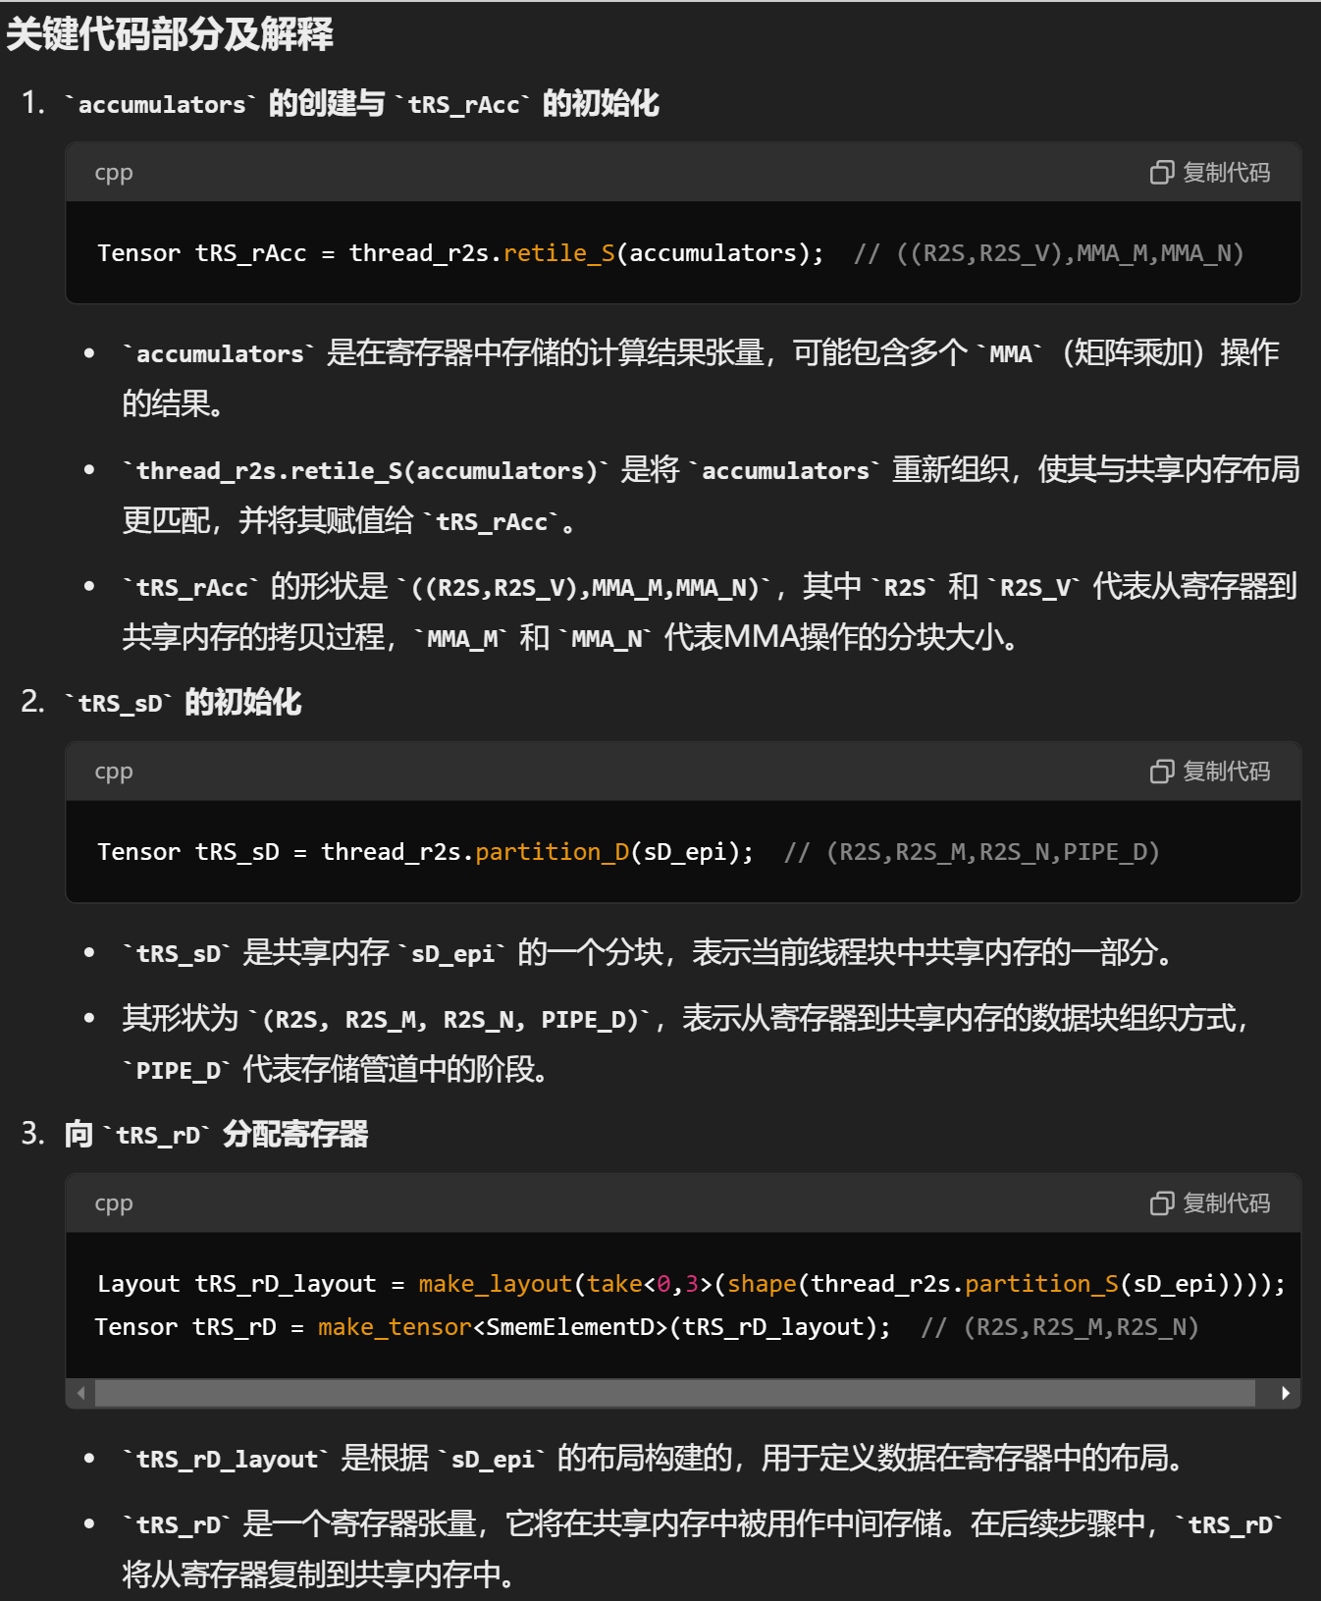

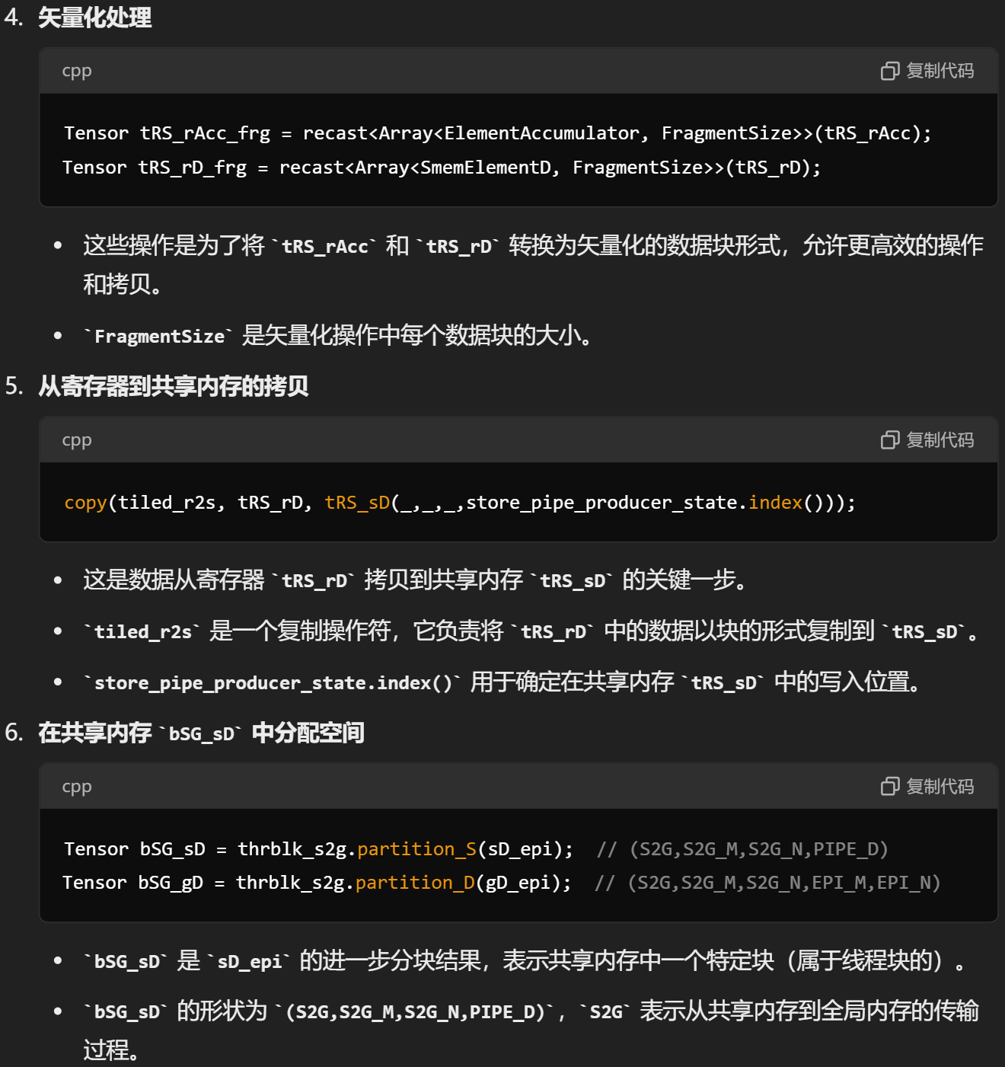

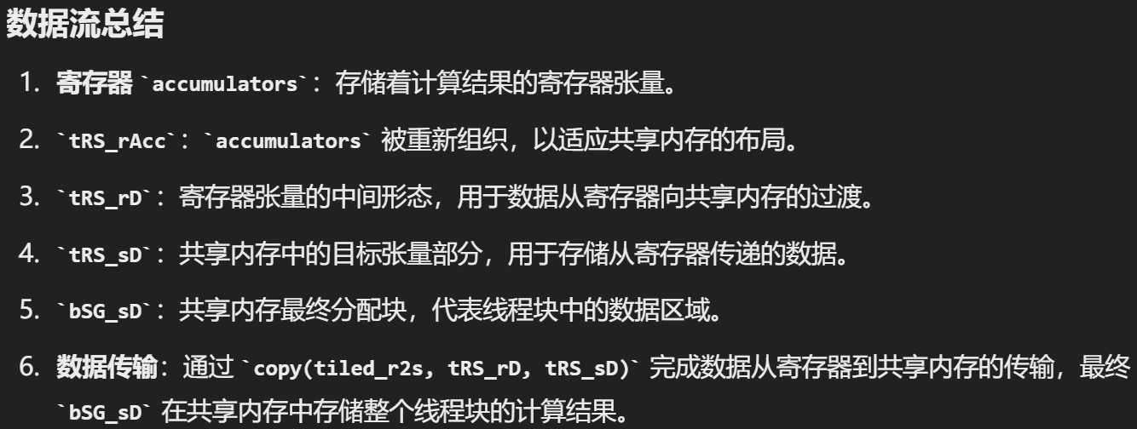

代码内容在：

<https://github.com/NVIDIA/cutlass/blob/4e5a8f6853817e6595189e712a8018e1b71e4380/include/cutlass/epilogue/collective/sm90_epilogue_tma_warpspecialized.hpp#L510-L820>

**1. Tensor Core 计算结果存储在寄存器中**

Tensor Core 计算的结果通常存储在寄存器中，并且在这段代码中使用了 accumulators 表示寄存器中的数据。

<https://github.com/NVIDIA/cutlass/blob/4e5a8f6853817e6595189e712a8018e1b71e4380/include/cutlass/epilogue/collective/sm90_epilogue_tma_warpspecialized.hpp#L574>

    Tensor tRS_rAcc = thread_r2s.retile_S(accumulators); // ((R2S,R2S_V),MMA_M,MMA_N)

这行代码将 accumulators 张量映射到线程级别的 tRS_rAcc，表示每个线程对应的寄存器数据。

**2. 处理寄存器中的数据**

接下来，这段代码创建了一个向量化的视图，以便对寄存器中的数据进行批处理：

<https://github.com/NVIDIA/cutlass/blob/4e5a8f6853817e6595189e712a8018e1b71e4380/include/cutlass/epilogue/collective/sm90_epilogue_tma_warpspecialized.hpp#L586-L589>

    Tensor tRS_rAcc_frg = recast<Array<ElementAccumulator, FragmentSize>>(tRS_rAcc);

    // Vectorized fragment view

    constexpr int FragmentSize = DispatchPolicy::FragmentSize;

    Tensor tRS_rAcc_frg = recast<Array<ElementAccumulator, FragmentSize>>(tRS_rAcc);

    Tensor tRS_rD_frg   = recast<Array<SmemElementD      , FragmentSize>>(tRS_rD);

tRS_rAcc_frg 是寄存器中的向量化片段视图。

tRS_rD_frg 是目标共享内存的向量化片段视图。

**3. 将寄存器中的数据处理并存储到共享内存**

下面这部分代码处理了寄存器中的数据，并将其写入共享内存：

<https://github.com/NVIDIA/cutlass/blob/4e5a8f6853817e6595189e712a8018e1b71e4380/include/cutlass/epilogue/collective/sm90_epilogue_tma_warpspecialized.hpp#L769C1-L771C10>

        Tensor tRS_rAcc_frg_mn = tRS_rAcc_frg(_,mma_m,mma_n);

        CUTLASS_PRAGMA_UNROLL

        for (int epi_v = 0; epi_v < size(tRS_rCompute_frg); ++epi_v) {

          tRS_rCompute_frg(epi_v) = cst_callbacks.visit(tRS_rAcc_frg_mn(r2s_v + epi_v), epi_v, epi_m, epi_n);

        }

tRS_rAcc_frg是tRS_rAcc的切片。要是写入了tRS_rAcc_frg，也就等于tRS_rAcc有了内容。tRS_rAcc_frg_mn又是tRS_rAcc_frg的切片。然后把tRS_rAcc_frg_mn写入到tRS_rCompute_frg。（这都是reg到reg）

<https://github.com/NVIDIA/cutlass/blob/4e5a8f6853817e6595189e712a8018e1b71e4380/include/cutlass/epilogue/collective/sm90_epilogue_tma_warpspecialized.hpp#L787C1-L790C10>

        CUTLASS_PRAGMA_UNROLL

        for (int i = 0; i < size(tRS_rD_frg); ++i) {

          tRS_rD_frg(i) = cutlass::NumericArrayConverter<SmemElementD, RegisterElementD, FragmentSize>{}(tRS_rCompute_frg(i));

        }

然后再从tRS_rCompute_frg写到tRS_rD_frg（这都是reg到reg）

cst_callbacks.visit: 这个回调函数在这里处理了寄存器中的数据，并存储到 tRS_rCompute_frg 中。

tRS_rD_frg(i) = ...: 这一行代码将处理过的结果从 tRS_rCompute_frg 复制到共享内存视图 tRS_rD_frg 中，即将结果写入共享内存的 tRS_rD。

**4. 从共享内存复制到全局内存**

接下来的代码负责将共享内存中的数据存储到全局内存（D 矩阵）中。

<https://github.com/NVIDIA/cutlass/blob/4e5a8f6853817e6595189e712a8018e1b71e4380/include/cutlass/epilogue/collective/sm90_epilogue_tma_warpspecialized.hpp#L792C1-L795C10>

        // Copy tile from register to smem

        if constexpr (is_destination_supported) {

          copy(tiled_r2s, tRS_rD, tRS_sD(_,_,_,store_pipe_producer_state.index()));

        }

上面写来写去，就是写到了tRS_rD，所以就可以写到SMEM里去。

**GPT的总结版本：**

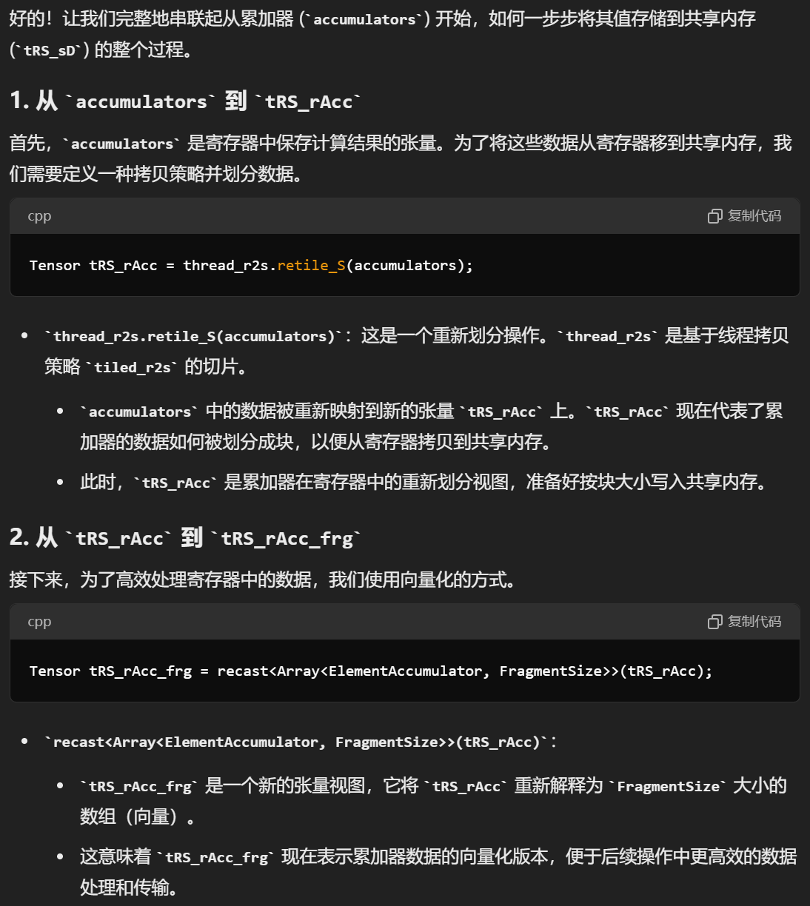

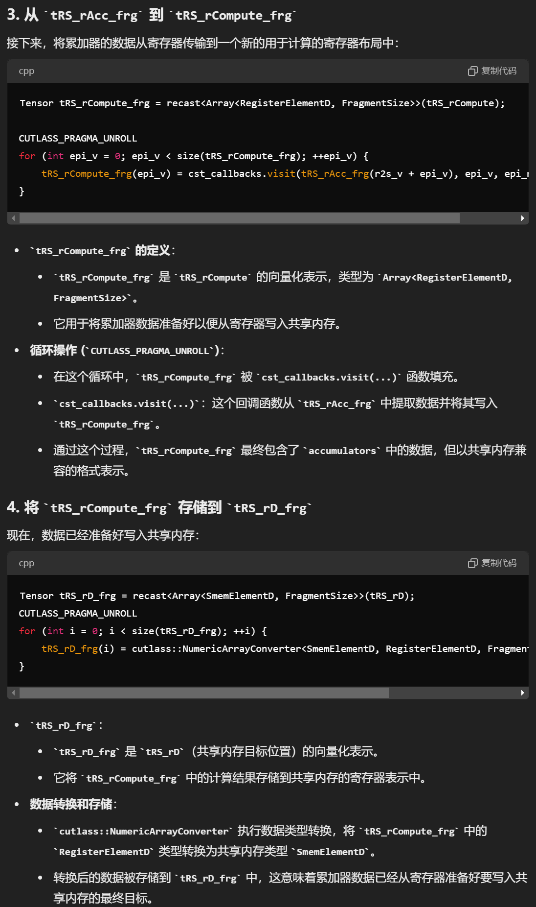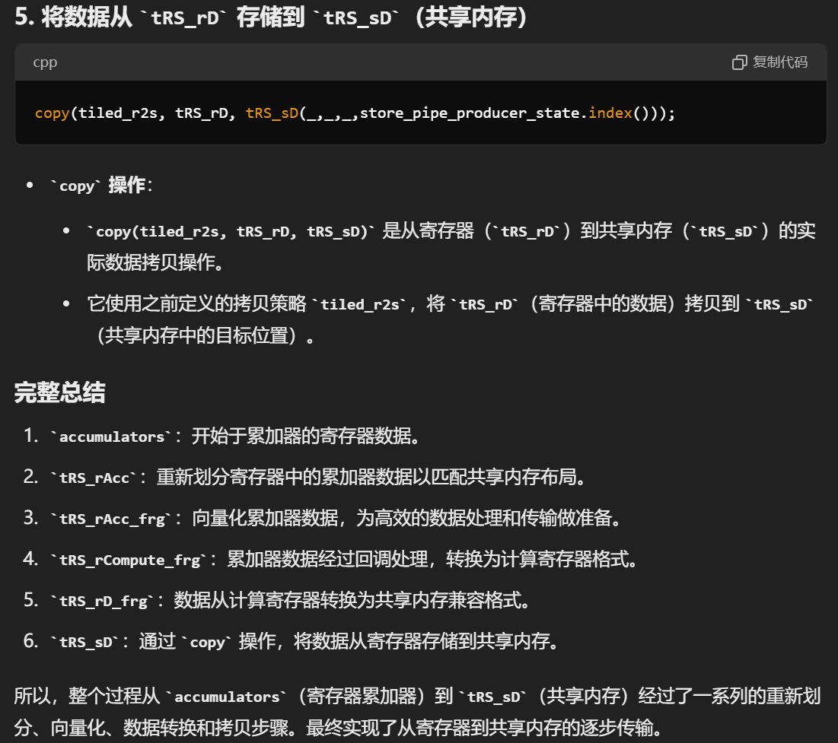

上面是从accumulator到SMEM。下面是SMEM到global。

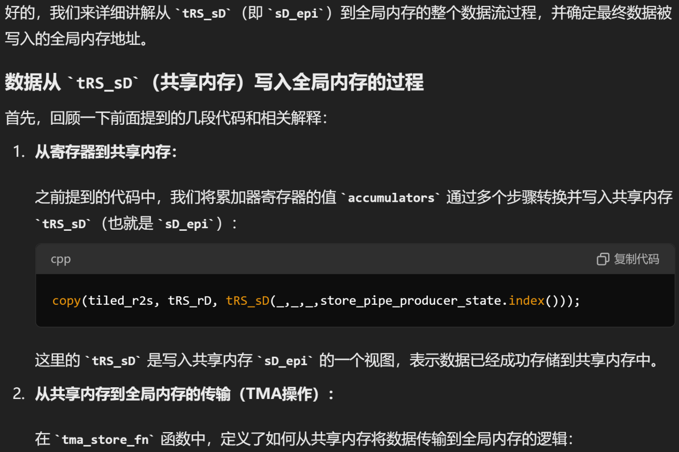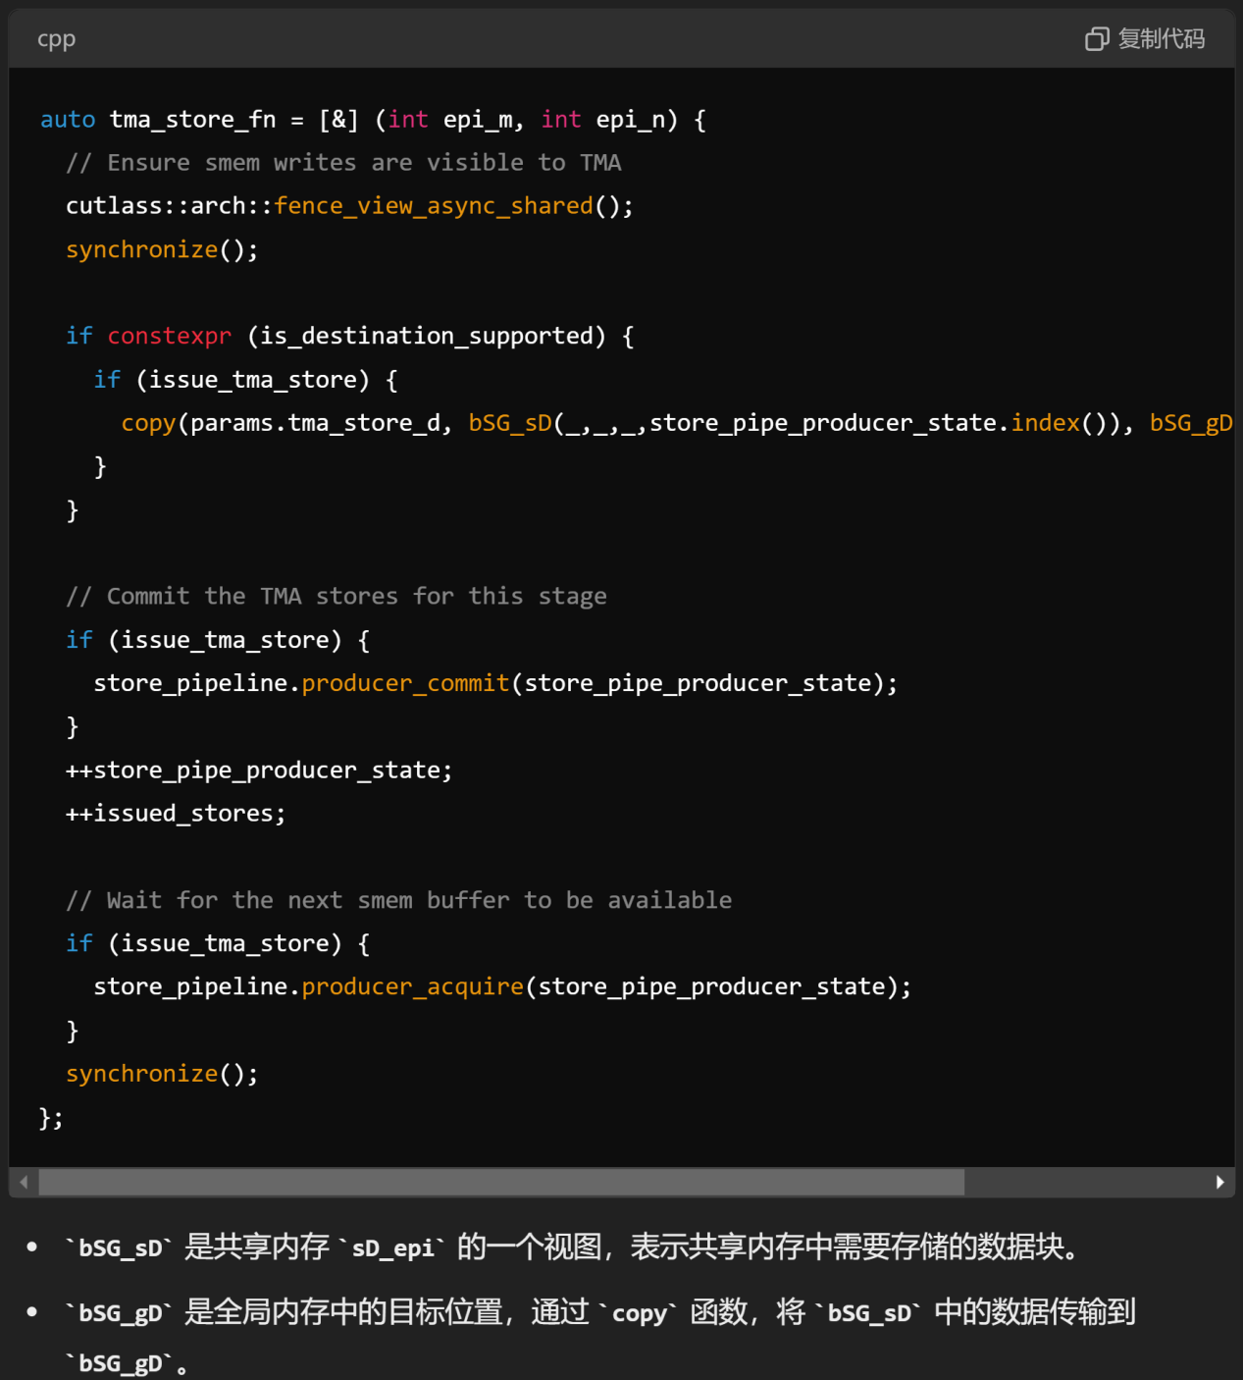

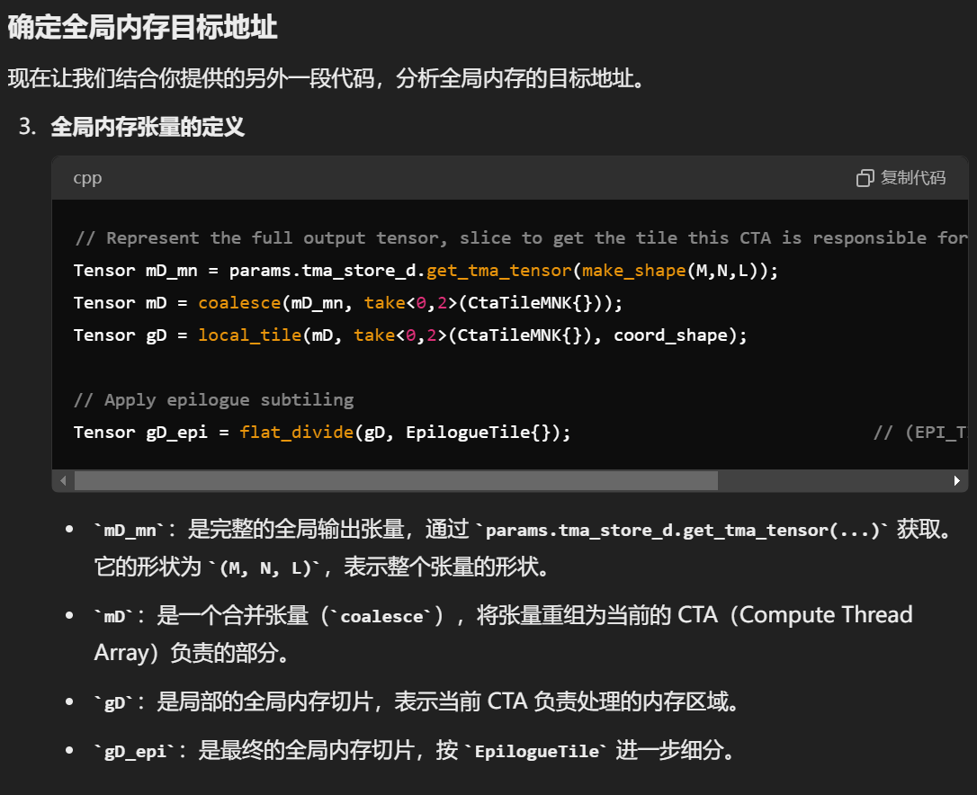

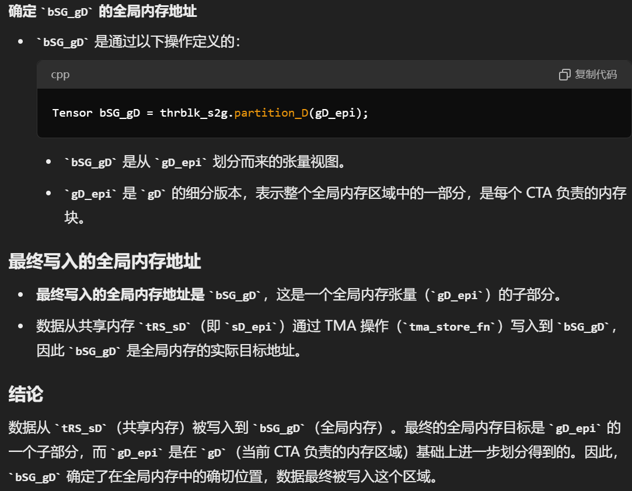

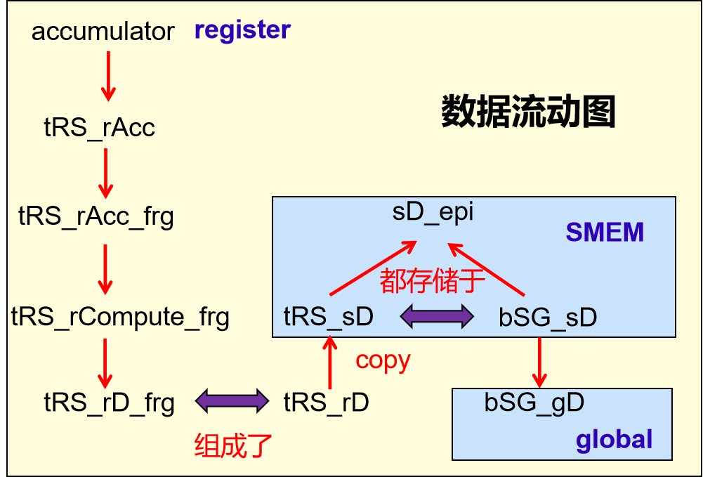

1. **当beta=0，如何避免C矩阵浪费共享内存空间？**

tensor core计算得到的accumulator结果是放在reg的。我需要将其存到SMEM里。但是要注意swizzle，避免bank conflict。但是原先example48存出的策略，是直接从reg到global并且没有用TMA。后来找到example49，使用了TMA，将中间结果存到SMEM，再存出到global。但是问题在于，明明我的beta等于0，但是还是留给C和D各一份共享内存空间，对C来说是完全没用的。仔细寻找之后发现是cutlass的疏漏，修改stagesC=0，节省了C的共享内存空间。

此外，我还修改让reuseC，reuseSMEM为0。（有点强行。。）

1. **Cutlass-sm90里的consumer到底多少线程？**

static const int NumThreadsPerWarp = 32;

static const int NumThreadsPerWarpGroup = 128;

static const int NumWarpsPerWarpGroup = NumThreadsPerWarpGroup / NumThreadsPerWarp;

static const int NumThreadsPerHalfWarp = NumThreadsPerWarp / 2;

static const int NumThreadsPerQuad = 4;

static const int NumThreadsPerQuadPair = NumThreadsPerQuad * 2;

cutlass/include/cutlass/cutlass.h

其实是写死的。

/// Returns a warp-uniform value indicating the canonical warp group index of the calling threads.

/// Threads within the warp must be converged.

CUTLASS_DEVICE

int canonical_warp_group_idx() {

  #if defined(__CUDA_ARCH__)

    return __shfl_sync(0xffffffff, threadIdx.x / NumThreadsPerWarpGroup, 0);

  #else

    return 0;

  #endif

}

同样在cutlass/include/cutlass/cutlass.h下，定义了canonical_warp_group_idx。

而在cutlass/include/cutlass/gemm/kernel/sm90_gemm_tma_warpspecialized_cooperative.hpp的consumer里有：

int consumer_warp_group_idx = canonical_warp_group_idx() - NumLoadWarpGroups;

NumLoadWarpGroups写死是1。因为只有1个warpgroup（128线程）用作producer，那么剩下的256线程就被分别用于两个consumer。并且可以由此确定，每个consumer是128个线程。

1. **如何debug**

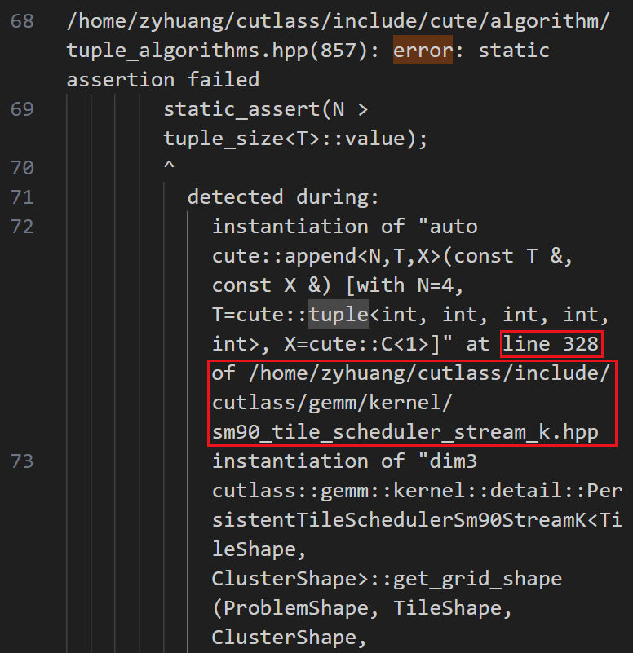

可以利用static_assert来打印出值吗？没法直接打印，这个只能对bool使用。但是可以来两个判断，从上下限来夹逼。

1. **GemmKernel到底在哪？**

  using GemmKernel = cutlass::gemm::kernel::GemmUniversal<

      Shape<int,int,int,int,int>,

      CollectiveMainloop,

      CollectiveEpilogue,

      TileSchedulerType

  >; // 这里增加了Shape后面一个int，为了GEMM1

  using Gemm = cutlass::gemm::device::GemmUniversalAdapter<GemmKernel>;

答案很简单：就在

cutlass/include/cutlass/gemm/kernel/sm90_gemm_tma_warpspecialized_cooperative.hpp

但是也有另一条路线，我一路找到底，但是不明白在什么情况下会用。或许是cutlass3之前的版本会那么走吧：

include/cutlass/gemm/device/gemm_universal.h

template <

    /// Element type for A matrix operand

    typename ElementA_,

.................................

    typename PermuteBLayout_ = layout::NoPermute

>

class GemmUniversal :

  public GemmUniversalBase<

    typename kernel::DefaultGemmUniversal<

      ElementA_,

..............................

      PermuteBLayout_

    >::GemmKernel

  > {

 public:

  using ElementAccumulator = ElementAccumulator_;

...........................

  static ComplexTransform const kTransformB = TransformB;

  using Base = GemmUniversalBase<

    typename kernel::DefaultGemmUniversal<

..........................

      PermuteBLayout_

    >::GemmKernel

  >;

  using Arguments = typename Base::Arguments;

  using GemmKernel = typename Base::GemmKernel;

};

然后去寻找kernel::DefaultGemmUniversal

include/cutlass/gemm/kernel/default_gemm_universal.h

template <

    /// Element type for A matrix operand

    typename ElementA,

.....................................

    /// Permute operand B

    typename PermuteBLayout

>

struct DefaultGemmUniversal<

  ElementA,

...................................

  PermuteBLayout,

  typename platform::enable_if< ! cutlass::is_complex<ElementAccumulator>::value>::type

> {

  using DefaultGemmKernel = typename kernel::DefaultGemm<

    ElementA,

.................................

    PermuteBLayout

  >::GemmKernel;

  /// Universal kernel without StreamkFeature member type

  template <class SwizzleT, class Enable = void>

  class SelectBase :

    public kernel::GemmUniversal<

      typename DefaultGemmKernel::Mma,

      typename DefaultGemmKernel::Epilogue,

      SwizzleT>

  {};

  /// Universal kernel with StreamkFeature member type

  template <class SwizzleT>

  class SelectBase<SwizzleT, typename SwizzleT::StreamkFeature> :

    public kernel::GemmUniversalStreamk<

      typename DefaultGemmKernel::Mma,

      typename DefaultGemmKernel::Epilogue,

      SwizzleT>

  {};

  /// Select kernel by ThreadblockSwizzle's support for StreamkFeature

  using GemmKernel = SelectBase<ThreadblockSwizzle>;

};

也就是说要去找kernel::DefaultGemm

/// Partial specialization for Hopper Architecture

template <

    /// Element type for A matrix operand

    typename ElementA,

    /// Layout type for A matrix operand

...................................

    typename PermuteBLayout

>

struct DefaultGemm<ElementA, LayoutA, kAlignmentA, ElementB, LayoutB, kAlignmentB,

..........................................

PermuteBLayout> {

  /// Define the threadblock-scoped matrix multiply-accumulate

  using Mma = typename cutlass::gemm::threadblock::DefaultMma<

      ElementA, LayoutA, kAlignmentA, ElementB, LayoutB, kAlignmentB,

      ElementAccumulator, layout::RowMajor, arch::OpClassTensorOp, arch::Sm90,

      ThreadblockShape, WarpShape, InstructionShape, Stages,

      Operator, false, SharedMemoryClear, GatherA, GatherB,

      PermuteALayout, PermuteBLayout>::ThreadblockMma;

  static const int kPartitionsK = ThreadblockShape::kK / WarpShape::kK;

  /// Define the epilogue

  using Epilogue =

      typename cutlass::epilogue::threadblock::DefaultEpilogueTensorOp<

          ThreadblockShape, typename Mma::Operator, kPartitionsK, EpilogueOutputOp,

          EpilogueOutputOp::kCount, ScatterD, PermuteDLayout>::Epilogue;

  /// Define the kernel-level GEMM operator.

  using GemmKernel = kernel::Gemm<Mma, Epilogue, ThreadblockSwizzle, SplitKSerial>;

};

也就是说要去找Kernel::Gemm

cutlass/include/cutlass/gemm/kernel/gemm.h

在这里，就很像GemmUniversal的写法。

cute::conditional_t<cute::is_same_v<StageCountType,cutlass::gemm::collective::StageCountAuto>, cutlass::gemm::collective::StageCountAutoCarveout<static_cast<int>(sizeof(typename CollectiveEpilogue::SharedStorage))>, StageCountType>,

1. **重构cutlass-4点**

1. 消除persistent

2. 修改block计算顺序为横向

3. 创建gemm1_weight

4. 修改storage_C

1 2

**1. 消除persistent**

现在是每个CTA只算一个block。然后cluster内进行reduce。所以只需要修改temp_can/cutlass-new/include/cutlass/gemm/kernel/tile_scheduler_params.h里面（注意这里面有三个param，分别是基础，streamK，group）的get_grid_shape：修改block数目为真实problem的数目。以及temp_can/cutlass-new/include/cutlass/gemm/kernel/static_tile_scheduler.hpp里面当前block位置为blockIdx.y和get_current_work_for_linear_idx

有三种。

第一种是每个CTA算完自己block之后就结束。

  CUTLASS_DEVICE explicit StaticPersistentTileScheduler(Params const& params_) : scheduler_params(params_) {

    // MSVC requires protecting use of CUDA-specific nonstandard syntax,

    // like blockIdx and gridDim, with __CUDA_ARCH__.

#if defined(__CUDA_ARCH__)

    if (params_.raster_order_ == RasterOrder::AlongN) {

      // current_work_linear_idx_ = uint64_t(blockIdx.x) + uint64_t(blockIdx.y) * uint64_t(gridDim.x);  // 原先的代码

      current_work_linear_idx_ = uint64_t(blockIdx.y); //1. 消除persistent 2. 修改block计算顺序为横向

  CUTLASS_DEVICE

  WorkTileInfo

  get_current_work_for_linear_idx(uint64_t linear_idx) const {

    if(linear_idx>uint64_t(blockIdx.y)){

      return WorkTileInfo::invalid_work_tile();

    }  //1. 消除persistent 意思是，算一次就退出

  advance_to_next_work(uint32_t advance_count = 1) {

这个其实无所谓。因为反正算完一次就结束了。

第二种是每个CTA（cluster）只算当前行，会向右移动。然后就结束。

  CUTLASS_DEVICE explicit StaticPersistentTileScheduler(Params const& params_) : scheduler_params(params_) {

    // MSVC requires protecting use of CUDA-specific nonstandard syntax,

    // like blockIdx and gridDim, with __CUDA_ARCH__.

#if defined(__CUDA_ARCH__)

    if (params_.raster_order_ == RasterOrder::AlongN) {

      current_work_linear_idx_ = uint64_t(cute::block_id_in_cluster().y) + uint64_t(cute::cluster_id_in_grid().y) * uint64_t(scheduler_params.problem_block_number.y);

  get_current_work_for_linear_idx(uint64_t linear_idx) const {

    if(linear_idx>uint64_t(cute::block_id_in_cluster().y) + uint64_t(cute::cluster_id_in_grid().y+1) * uint64_t(scheduler_params.problem_block_number.y)){

      return WorkTileInfo::invalid_work_tile();

}  // 关键是这里的+1，意思是截止到下一行开始为止。

  advance_to_next_work(uint32_t advance_count = 1) {

    current_work_linear_idx_ += total_cluster_size_ * uint64_t(advance_count);// 向右移动

第三种是cluster个数按照SM个数分配，恰好只有1个wave。会向右，之后还会向上移动。

在第二种的基础上，修改：

（不过下面没有再具体check正确性了）

  get_current_work_for_linear_idx(uint64_t linear_idx) const {

    if (linear_idx >= scheduler_params.blocks_per_problem_) {

      return WorkTileInfo::invalid_work_tile();

    }  // 原先的代码

  advance_to_next_work(uint32_t advance_count = 1) {

    current_work_linear_idx_ += total_cluster_size_ * uint64_t(advance_count);// 向右移动

    if(current_work_linear_idx_ >= (cute::cluster_id_in_grid().y+cluster_jump_count*7+1)*scheduler_params.problem_block_number.y){

      cluster_jump_count += 1;

      current_work_linear_idx_ = uint64_t(cute::block_id_in_cluster().y) + uint64_t(cute::cluster_id_in_grid().y+cluster_jump_count*7) * uint64_t(scheduler_params.problem_block_number.y);// 向上移动

    }

**3. 创建gemm1_weight**

只对

<

cutlass::gemm::KernelTmaWarpSpecializedCooperative,

cutlass::epilogue::TmaWarpSpecializedCooperative,

cutlass::gemm::collective::StageCountAuto,

cutlass::gemm::PersistentScheduler>

可以这样改，其他的还要再琢磨哦！

修改temp_can/cutlass-new/include/cutlass/epilogue/collective/builders/sm90_builder.inl注释“原来的代码”处。就是把reuseC之类的取消掉。设置为0。

不过之前的代码cutlass仍然在static_tile_scheduler里面保留了做persistent的方法，就是一行由一个cluster移动做完，然后cluster整个再跳到下一行去做。

先是修改了49.cu的内容。然后对文档中出现的一些内容进行了批量替换：

cute::append<4> 替换为cute::append<5>

auto [M, N, K, L]替换为auto [M, N, K, L, T]

auto [M,N,K,L]替换为auto [M,N,K,L,T]

auto problem_shape_MNKL = append<4>替换为auto problem_shape_MNKL = append<5>

cute::rank(ProblemShape{})处，只有temp_can/cutlass-new/include/cutlass/gemm/kernel/sm90_gemm_tma_warpspecialized_cooperative.hpp相关。然后替换为4或者5.

static_assert(rank(ProblemShapeMNKL{}) == 4替换为static_assert(rank(ProblemShapeMNKL{}) == 5

修改to_gemm_coord(cute::take<0, 4>(problem_shape_mnkl)),temp_can/cutlass-new/include/cutlass/gemm/kernel/static_tile_scheduler.hpp

然后为了传入gemm1_weight这个参数，就要去修改gemm/collective底下的文件，比如collective_builder类和collective_mma类。以及把不相关的builder和mma都注释掉。

using Element_gemm1_weight = typename CollectiveMainloop::Element_gemm1_weight;

using Stride_gemm1_weight = typename CollectiveMainloop::Stride_gemm1_weight;

要加到temp_can/cutlass-new/include/cutlass/gemm/kernel/sm90_gemm_tma_warpspecialized_cooperative.hpp

using Element_gemm1_weight = typename GemmKernel::Element_gemm1_weight;

加到temp_can/cutlass-new/include/cutlass/gemm/device/gemm_universal_adapter.h

include/cutlass/epilogue/collective/builders/sm90_builder.inl

// Tma warp-specialized builder

template <

class TileShape_MNK,

class ClusterShape_MNK,

class EpilogueTileType,

class ElementAccumulator,

class ElementCompute,

class ElementC,

class GmemLayoutTagC,

int AlignmentC,

class ElementD_,

class GmemLayoutTagD,

int AlignmentD,

class Schedule,

class FusionOperation

>

struct CollectiveBuilder<

arch::Sm90,

arch::OpClassTensorOp,

TileShape_MNK,

ClusterShape_MNK,

EpilogueTileType,

ElementAccumulator,

ElementCompute,

ElementC,

GmemLayoutTagC,

AlignmentC,

ElementD_,

GmemLayoutTagD,

AlignmentD,

Schedule,

FusionOperation,

cute::enable_if_t<cute::is_same_v<Schedule, TmaWarpSpecialized> ||

cute::is_same_v<Schedule, TmaWarpSpecializedCooperative> ||

cute::is_same_v<Schedule, PtrArrayTmaWarpSpecializedCooperative> >> {

根据这里，我判断TmaWarpSpecialized也会使用TMA和SMEM，所以应该是可以用的？

当前是修改了整个库。然后对很多有乱修改和影响其他模板情况的存在。以后要模仿b2b来改改代码布局

矩阵的形状是4096*16384

tile是128*256

所以有32*64个block

当前是第多少个cluster。cute::cluster_id_in_grid().y

总共有scheduler_params.problem_block_number.y*scheduler_params.problem_block_number.x个block。除上cluster_size，就得到有多少个cluster。

一行需要多少个cluster呢？N/cluster_size（默认cluster_m=1）。

cute::cluster_id_in_grid().y / (N/cluster_size)--->得到当前是第多少行。 +

blockIdx.y/scheduler_params.problem_block_number.y *

要确保GEMM0的N除上cluster能整除。

(base) zyhuang@sdzx-h100-1:~/temp_can/cutlass-new/build/examples/49_hopper_gemm_with_collective_builder$ ./49_collective_builder --m=4096 --n=16384 --k=1024 --raster=N

enter temp_can/cutlass-new/include/cutlass/gemm/kernel/sm90_gemm_tma_warpspecialized_cooperative.hpp, bool=1

enter temp_can/cutlass-new/include/cutlass/gemm/kernel/tile_scheduler_params.h 222

launch_grid=(1, 2048), problem_blocks_m=32, problem_blocks_n=64, cluster_shape.m()=1, problem_blocks_total=2048

Automatically-selected schedule and stage count: Passed

Failed to initialize the CUTLASS kernel. Last CUDA error is: no error

Automatically-selected schedule with 5 stages: Failed

TMA schedule with automatically-selected stage count: Passed

Warp-specialized TMA schedule with automatically-selected stage count: Passed

enter temp_can/cutlass-new/include/cutlass/gemm/kernel/tile_scheduler_params.h 222

launch_grid=(1, 2048), problem_blocks_m=32, problem_blocks_n=64, cluster_shape.m()=1, problem_blocks_total=2048

Ping-pong warp-specialized TMA schedule with automatically-selected stage count: Passed

enter temp_can/cutlass-new/include/cutlass/gemm/kernel/tile_scheduler_params.h 444

enter temp_can/cutlass-new/include/cutlass/gemm/kernel/tile_scheduler_params.h 222

launch_grid=(1, 2048), problem_blocks_m=32, problem_blocks_n=64, cluster_shape.m()=1, problem_blocks_total=2048

enter temp_can/cutlass-new/include/cutlass/gemm/kernel/tile_scheduler_params.h 444

enter temp_can/cutlass-new/include/cutlass/gemm/kernel/tile_scheduler_params.h 222

launch_grid=(1, 2048), problem_blocks_m=32, problem_blocks_n=64, cluster_shape.m()=1, problem_blocks_total=2048

enter temp_can/cutlass-new/include/cutlass/gemm/kernel/tile_scheduler_params.h 444

enter temp_can/cutlass-new/include/cutlass/gemm/kernel/tile_scheduler_params.h 222

launch_grid=(1, 2048), problem_blocks_m=32, problem_blocks_n=64, cluster_shape.m()=1, problem_blocks_total=2048

enter temp_can/cutlass-new/include/cutlass/gemm/kernel/tile_scheduler_params.h 444

enter temp_can/cutlass-new/include/cutlass/gemm/kernel/tile_scheduler_params.h 222

launch_grid=(1, 2048), problem_blocks_m=32, problem_blocks_n=64, cluster_shape.m()=1, problem_blocks_total=2048

enter temp_can/cutlass-new/include/cutlass/gemm/kernel/tile_scheduler_params.h 444

enter temp_can/cutlass-new/include/cutlass/gemm/kernel/tile_scheduler_params.h 222

launch_grid=(1, 2048), problem_blocks_m=32, problem_blocks_n=64, cluster_shape.m()=1, problem_blocks_total=2048

enter temp_can/cutlass-new/include/cutlass/gemm/kernel/sm90_gemm_tma_warpspecialized_cooperative.hpp, bool=1

enter temp_can/cutlass-new/include/cutlass/gemm/kernel/tile_scheduler_params.h 444

enter temp_can/cutlass-new/include/cutlass/gemm/kernel/tile_scheduler_params.h 222

launch_grid=(1, 2048), problem_blocks_m=32, problem_blocks_n=64, cluster_shape.m()=1, problem_blocks_total=2048

Cooperative warp-specialized TMA schedule using stream-K with automatically-selected stage count: Passed

enter temp_can/cutlass-new/include/cutlass/gemm/kernel/sm90_gemm_tma_warpspecialized_cooperative.hpp, bool=1

enter temp_can/cutlass-new/include/cutlass/gemm/kernel/tile_scheduler_params.h 222

launch_grid=(1, 2048), problem_blocks_m=32, problem_blocks_n=64, cluster_shape.m()=1, problem_blocks_total=2048

Cooperative warp-specialized TMA schedule using PersistentScheduler with automatically-selected stage count: Passed

enter temp_can/cutlass-new/include/cutlass/gemm/kernel/sm90_gemm_tma_warpspecialized_cooperative.hpp, bool=1

enter temp_can/cutlass-new/include/cutlass/gemm/kernel/tile_scheduler_params.h 222

launch_grid=(1, 2048), problem_blocks_m=32, problem_blocks_n=64, cluster_shape.m()=1, problem_blocks_total=2048

Cooperative warp-specialized TMA schedule using custom epilogue visitor tree with automatically-selected stage count: Passed

观察到streamK有很多次重复，为什么？很奇怪。。不过我的cooperate没有乱就好啦。

**4. 修改storage_C**

使用stages的地方一般写为：

cutlass/include/cutlass/gemm/collective/sm90_mma_tma_gmma_ss_warpspecialized.hpp

如：

  using PipelineState = cutlass::PipelineState<DispatchPolicy::Stages>;

那么就回去寻找DispatchPolicy，得到：

struct CollectiveMma<

    MainloopSm90TmaGmmaWarpSpecialized<Stages, ClusterShape, KernelSchedule>,

进入到：cutlass/include/cutlass/gemm/collective/builders/sm90_gmma_builder.inl

也就是：

  static constexpr int PipelineStages = detail::compute_stage_count_or_override<detail::sm90_smem_capacity_bytes,

      ElementAMma, ElementBMma, TileShape_MNK>(StageCountType{});

  using DispatchPolicy = cute::conditional_t<IsArrayOfPointersGemm,

      MainloopSm90ArrayTmaGmmaWarpSpecialized<PipelineStages, ClusterShape_MNK, KernelScheduleType>,

      /* For FP8 use a separate mainloop compared to other datatypes */

      cute::conditional_t<IsFP8Input,

          MainloopSm90TmaGmmaWarpSpecializedFP8<PipelineStages, ClusterShape_MNK, KernelScheduleType>,

          MainloopSm90TmaGmmaWarpSpecialized<PipelineStages, ClusterShape_MNK, KernelScheduleType>>>;

这里看到函数compute_stage_count_or_override，定义在同一个文件的上方：

// Returns the maximum number of smem tiles that can be used with a given smem capacity, or overrides with manual count.

template<int CapacityBytes, class ElementA, class ElementB, class TileShapeMNK, int stages>

constexpr int

compute_stage_count_or_override(StageCount<stages> stage_count) {

  return stages;

}

// Returns the maximum number of smem tiles that can be used with a given smem capacity, or overrides with manual count.

template<int CapacityBytes, class ElementA, class ElementB, class TileShapeMNK, int stages>

constexpr int

compute_stage_count_or_override(cute::Int<stages> stage_count) {

  return stages;

}

// Returns the maximum number of smem tiles that can be used with a given smem capacity, or overrides with manual count.

template<int CapacityBytes, class ElementA, class ElementB, class TileShapeMNK, int carveout_bytes>

constexpr int

compute_stage_count_or_override(StageCountAutoCarveout<carveout_bytes> stage_count) {

  constexpr auto mainloop_pipeline_bytes = sizeof(typename cutlass::PipelineTmaAsync<1>::SharedStorage);

  constexpr auto a_bits = cute::sizeof_bits_v<ElementA>;

  constexpr auto b_bits = cute::sizeof_bits_v<ElementB>;

  constexpr int stage_bytes =

    cutlass::bits_to_bytes(a_bits * size<0>(TileShapeMNK{}) * size<2>(TileShapeMNK{})) +

    cutlass::bits_to_bytes(b_bits * size<1>(TileShapeMNK{}) * size<2>(TileShapeMNK{})) +

    static_cast<int>(mainloop_pipeline_bytes);

  return (CapacityBytes - carveout_bytes) / stage_bytes;

}

一个问题，这里为什么定义的地方需要五个模板参数，真实使用却只有四个参数？答案是，如果在实参里可以推断出模板参数类型，那么模板参数也可以省略。详细介绍如下：

https://blog.csdn.net/weixin_43971764/article/details/88896885

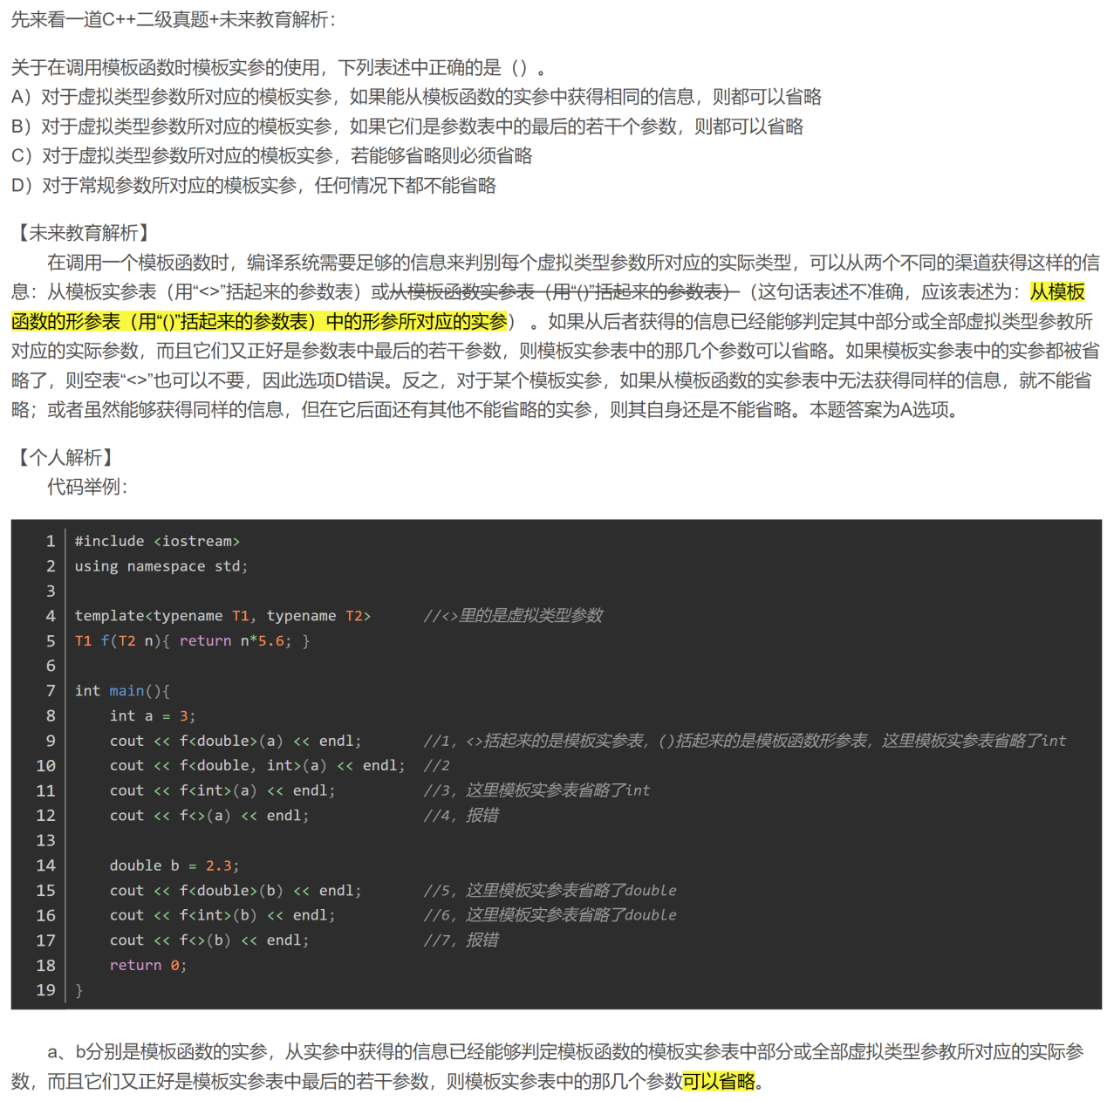

这里的三个overload版本，就是如果手动指定，则按指定的stages来，否则按照计算。如果计算呢，也就是总SMEM量，减去C和D的需求，然后除A+B的需求，看看能读几个A+B，得到的就是stages。我们要改，就是去掉C的需求。

所以方法就是使用StageCountType{}来推断到底使用哪个重载。

  class StageCountType,

  class KernelScheduleType

>

struct CollectiveBuilder<

这样就上溯到了example49的cu文件了：

  using CollectiveEpilogue = typename cutlass::epilogue::collective::CollectiveBuilder<

      cutlass::arch::Sm90, cutlass::arch::OpClassTensorOp,

      TileShape, ClusterShape,

      cutlass::epilogue::collective::EpilogueTileAuto,

      ElementAccumulator, ElementCompute,

      ElementC, LayoutC, AlignmentC,

      ElementD, LayoutD, AlignmentD,

      EpilogueScheduleType,

      cute::conditional_t<UseCustomEVT, CustomEVT, DefaultOperation>

    >::CollectiveOp;

  using CollectiveMainloop = typename cutlass::gemm::collective::CollectiveBuilder<

      cutlass::arch::Sm90, cutlass::arch::OpClassTensorOp,

      ElementA, LayoutA, AlignmentA,

      ElementB, LayoutB, AlignmentB,

      Element_gemm1_weight, Layout_gemm1_weight, Alignment_gemm1_weight,

      ElementAccumulator,

      TileShape, ClusterShape,

      cute::conditional_t<cute::is_same_v<StageCountType,         cutlass::gemm::collective::StageCountAuto>, cutlass::gemm::collective::StageCountAutoCarveout<static_cast<int>(sizeof(typename CollectiveEpilogue::SharedStorage))>, StageCountType>,

      MainloopScheduleType

    >::CollectiveOp;

具体看就是：

cutlass::gemm::collective::StageCountAutoCarveout<static_cast<int>(sizeof(typename CollectiveEpilogue::SharedStorage))>, StageCountType>

然后找到：temp_can/cutlass-new/include/cutlass/gemm/collective/collective_builder_decl.hpp

template<int carveout_bytes>

struct StageCountAutoCarveout {

  static constexpr int bytes = carveout_bytes;

  StageCountAutoCarveout() = default;

  explicit StageCountAutoCarveout(cute::Int<carveout_bytes>) {}

};

Carveout也就是为C和D的保留空间。也就是CollectiveEpilogue::SharedStorage。

然后搜索到collective/epilogue的文件：

temp_can/cutlass-new/include/cutlass/epilogue/collective/builders/sm90_builder.inl

// Tma warp-specialized builder

template <

  class TileShape_MNK,

  class ClusterShape_MNK,

  class EpilogueTileType,

  class ElementAccumulator,

  class ElementCompute,

  class ElementC,

  class GmemLayoutTagC,

  int AlignmentC,

  class ElementD_,

  class GmemLayoutTagD,

  int AlignmentD,

  class Element_gemm1_output_,

  class GmemLayoutTag_gemm1_output_,

  int Alignment_gemm1_output,

  class Schedule,

  class FusionOperation

>

struct CollectiveBuilder<

    arch::Sm90,

    arch::OpClassTensorOp,

    TileShape_MNK,

    ClusterShape_MNK,

    EpilogueTileType,

    ElementAccumulator,

    ElementCompute,

    ElementC,

    GmemLayoutTagC,

    AlignmentC,

    ElementD_,

    GmemLayoutTagD,

    AlignmentD,

    Element_gemm1_output_,

    GmemLayoutTag_gemm1_output_,

    Alignment_gemm1_output,

    Schedule,

    FusionOperation,

    cute::enable_if_t<cute::is_same_v<Schedule, TmaWarpSpecialized> ||

                      cute::is_same_v<Schedule, TmaWarpSpecializedCooperative> ||

                      cute::is_same_v<Schedule, PtrArrayTmaWarpSpecializedCooperative> >> {

private:

  using ElementD = cute::conditional_t<cute::is_void_v<ElementD_>,

                     fusion::get_element_aux_t<FusionOperation>, ElementD_>;

  using Element_gemm1_output = cute::conditional_t<cute::is_void_v<Element_gemm1_output_>,

                     fusion::get_element_aux_t<FusionOperation>, Element_gemm1_output_>;

  // using EpilogueTile_MN =

  //   decltype(detail::sm90_compute_tile_shape_or_override<ElementD, EpilogueTileType, Schedule, TileShape_MNK>());  // 原先的代码

  using EpilogueTile_MN = decltype(take<0,2>(TileShape_MNK{})); // 这里之前肯定是有某种原因，默认判断去复用共享内存了。所以只有我希望的128*256的一半。目前暂时先写死成这样，以后有时间去理解一下原先的判断逻辑，再细改. // 4. 修改storage_C

  using DispatchPolicy =

    decltype(detail::sm90_get_tma_dispatch_policy<TileShape_MNK,EpilogueTile_MN,ElementC,ElementD,Schedule>());

因此对应再修改：

// Returns the parameterized dispatch policy for the TMA epilogue

template<class TileShapeMNK, class EpilogueTileMN, class ElementC, class ElementD, class Schedule>

constexpr auto

sm90_get_tma_dispatch_policy() {

  using namespace cute;

  constexpr int EpiTiles = size(shape_div(take<0,2>(TileShapeMNK{}), EpilogueTileMN{}));

  constexpr int FragmentSize = size(EpilogueTileMN{}) / (detail::sm90_is_cooperative_v<Schedule> ? 256 : 128);

  // 8b residuals load fast and consume little smem, so the perf cost of waiting on stores to finish outweighs the cost of extra allocation

  // constexpr bool ReuseSmem = (sizeof_bits_v<ElementC> == sizeof_bits_v<ElementD>) && (sizeof_bits_v<ElementD> > 8);  // 原先的代码

  constexpr bool ReuseSmem = false; // 4. 修改storage_C

  // TMA store delay performs worse with residual loads and compilicates tensormap updates for Ptr-Array GEMMs

  constexpr bool DelayTmaStore = is_void_v<ElementC> && !detail::sm90_is_tma_ptr_array_v<Schedule>;

  constexpr int StagesD = cute::min(EpiTiles, 2);

  // constexpr int StagesC = ReuseSmem ? cute::max(cute::min(EpiTiles, 4), StagesD+1) : cute::min(EpiTiles, 4);// 原先的代码

  constexpr int StagesC = 0; // 比如beta等于0，这里就可以设为0了。否则会浪费共享内存空间啊！4. 修改storage_C

  return cute::conditional_t<detail::sm90_is_tma_ptr_array_v<Schedule>,

                             Sm90PtrArrayTmaWarpSpecialized<StagesC, StagesD, FragmentSize, ReuseSmem, DelayTmaStore>,

                             Sm90TmaWarpSpecialized<StagesC, StagesD, FragmentSize, ReuseSmem, DelayTmaStore>>{};

}

（额。。。为什么这么改我暂时懒得看，当时是确保正确的哈。）

1. **修改cutlass记录**
2. **理解pipeline**

    typename CollectiveMainloop::PipelineState mainloop_pipe_consumer_state;

我想了解这里的PipelineState到底是怎么写的。因为，我的gemm1会复用gemm0的PipelineState，最好能重新初始化一下，以防造成错误。到底初始化哪里就需要深刻理解了。

先看看到底定义在哪里。这里的CollectiveMainloop是定义在temp_can/cutlass-new/examples/49_hopper_gemm_with_collective_builder/49_collective_builder.cu

  using CollectiveMainloop = typename cutlass::gemm::collective::CollectiveBuilder<

      cutlass::arch::Sm90, cutlass::arch::OpClassTensorOp,

      ElementA, LayoutA, AlignmentA,

      ElementB, LayoutB, AlignmentB,

      Element_gemm1_weight, Layout_gemm1_weight, Alignment_gemm1_weight,

      ElementAccumulator,

      TileShape, ClusterShape,

      cute::conditional_t<cute::is_same_v<StageCountType,         cutlass::gemm::collective::StageCountAuto>, cutlass::gemm::collective::StageCountAutoCarveout<static_cast<int>(sizeof(typename CollectiveEpilogue::SharedStorage))>, StageCountType>,

      MainloopScheduleType

    >::CollectiveOp;

注意这里的::CollectiveOp。也就是要进入CollectiveOp去。在temp_can/cutlass-new/include/cutlass/gemm/collective/sm90_mma_tma_gmma_ss_warpspecialized.hpp里面的

using PipelineState = cutlass::PipelineState<DispatchPolicy::Stages>;

得知具体实例化方法。

// Circular Buffer Index + Associated Phase

// Assumes only one operation possible - i.e., ++

template<uint32_t Stages_>

struct PipelineState {

  static constexpr uint32_t Stages = Stages_;

  int index_ = 0;

  uint32_t phase_ = 0;

  uint32_t count_ = 0;

  CUTLASS_DEVICE

  PipelineState(): index_{}, phase_{}, count_{} {}

  CUTLASS_DEVICE

  PipelineState(int index, uint32_t phase, uint32_t count)

    : index_(index)

    , phase_(phase)

    , count_(count) {}

  CUTLASS_DEVICE

  int index() const {

    return index_;

  }

  CUTLASS_DEVICE

  uint32_t phase() const {

    return phase_;

  }

  CUTLASS_DEVICE

  uint32_t count() const {

    return count_;

  }

  CUTLASS_DEVICE

  void operator++() {

    if constexpr (Stages > 0) {

      ++index_;

      ++count_;

      if (index_ == Stages) {

        index_ = 0;

        phase_ ^= 1;

      }

    }

  }

  CUTLASS_DEVICE

  PipelineState& operator+=(uint32_t num_iterations) {

    return advance(num_iterations);

  }

  CUTLASS_DEVICE

  PipelineState& operator=(PipelineState const& other) {

    index_ = other.index();

    phase_ = other.phase();

    count_ = other.count();

    return *this;

  }

  CUTLASS_DEVICE

  PipelineState& advance(uint32_t num_iterations) {

    if constexpr (Stages > 0) {

      // Number of iterations cross over the stage boundary => flipped phase

      if ((num_iterations < Stages) && (index_ + num_iterations) >= Stages ) {

        phase_ ^= 1;

      }

      // How many times number of iterations cross over the stage boundary and

      // end up on a odd number => flipped phase

      if ((num_iterations >= Stages) && (((index_ + num_iterations) / Stages) % 2) == 1) {

        phase_ ^= 1;

      }

      index_ = (index_ + num_iterations) % Stages;

      count_ += num_iterations;

    }

    return *this;

  }

  CUTLASS_DEVICE

  static PipelineState make_pipeline_state(PipelineState start_state, uint32_t num_iterations) {

    return start_state.advance(num_iterations);

  }

};

仅搜到一处结构体定义。可知，或许可以增加函数来使其中的count/stages/index变为0。

不。还是模仿make_producer_start_state写了一个reset

template<class Pipeline>

CUTLASS_DEVICE

PipelineState<Pipeline::Stages> make_producer_start_state() {

  // Producer starts with an opposite phase as the buffers are initially empty

  constexpr int InitialProducerStage = 0;

  constexpr uint32_t InitialProducerPhase = 1;

  constexpr uint32_t InitialProducerCount = 0;

  return {InitialProducerStage, InitialProducerPhase, InitialProducerCount};

}

最里层是怎么初始化tma_load_b的

temp_can/cutlass-new/include/cutlass/gemm/collective/sm90_mma_tma_gmma_ss_warpspecialized.hpp

这里有：

  template <class ProblemShape>

  static constexpr Params

  to_underlying_arguments(ProblemShape const& problem_shape, Arguments const& args, void* workspace) {

    Tensor tensor_a = make_tensor(ptr_A, make_layout(make_shape(M,K,L), args.dA));

    Tensor tensor_b = make_tensor(ptr_B, make_layout(make_shape(N,K,L), args.dB));

    Tensor tensor_gemm1_output = make_tensor(ptr_gemm1_weight, make_layout(make_shape(N,T,L), args.dB));

    typename Params::TMA_A tma_load_a = make_tma_copy_A_sm90(

        GmemTiledCopyA{},

        tensor_a,

        SmemLayoutA{}(_,_,cute::Int<0>{}),

        TileShape{},

        ClusterShape{});

    typename Params::TMA_B tma_load_b = make_tma_copy_B_sm90(

        GmemTiledCopyB{},

        tensor_b,

        SmemLayoutB{}(_,_,cute::Int<0>{}),

        TileShape{},

        ClusterShape{});

    typename Params::TMA_gemm1_weight tma_load_gemm1_weight = make_tma_copy_B_sm90(

        GmemTiledCopy_gemm1_weight{},

        tensor_b,

        SmemLayoutB{}(_,_,cute::Int<0>{}),

        TileShape{},

        ClusterShape{});

为追踪这里的args.dB，上溯寻找哪里调用的。

1. **to_underlying_arguments函数的调用栈**

因为上面的文件是gemm/collective/，所以去寻找CollectiveMainloop::to_underlying_arguments：得到

temp_can/cutlass-new/include/cutlass/gemm/kernel/sm90_gemm_tma_warpspecialized_cooperative.hpp

template <

  class ProblemShape_,

  class CollectiveMainloop_,

  class CollectiveEpilogue_,

  class TileScheduler_

>

class GemmUniversal<

  ProblemShape_,

  CollectiveMainloop_,

  CollectiveEpilogue_,

  TileScheduler_,

  cute::enable_if_t<cute::is_base_of_v<KernelTmaWarpSpecializedCooperative, typename CollectiveMainloop_::DispatchPolicy::Schedule>>>

  // Convert to underlying arguments. In this case, a simple copy for the aliased type.

  static

  Params

  to_underlying_arguments(Arguments const& args, void* workspace) {

    CUTLASS_TRACE_HOST("to_underlying_arguments():");

.....................

    return {

      args.mode,

      problem_shape,

      CollectiveMainloop::to_underlying_arguments(args.problem_shape, args.mainloop, mainloop_workspace),

      CollectiveEpilogue::to_underlying_arguments(args.problem_shape, args.epilogue, epilogue_workspace),

      hw_info,

      scheduler,

      workspace

    };

  }

于是再上溯去寻找GemmUniversal::to_underlying_arguments

于是找到：

temp_can/cutlass-new/include/cutlass/gemm/device/gemm_universal_adapter.h

  /// Initializes GEMM state from arguments.

  Status

  initialize(

    Arguments const& args,

    void* workspace = nullptr,

    cudaStream_t stream = nullptr,

    CudaHostAdapter* cuda_adapter = nullptr) {

    CUTLASS_TRACE_HOST("GemmUniversal::initialize() - workspace "

      << workspace << ", stream: " << (stream ? "non-null" : "null"));

    // Initialize the workspace

    Status status = GemmKernel::initialize_workspace(args, workspace, stream, cuda_adapter);

    if (status != Status::kSuccess) {

      return status;

    }

    // Initialize the Params structure

    params_ = GemmKernel::to_underlying_arguments(args, workspace);

    // Don't set the function attributes - require the CudaHostAdapter to set it.

    if constexpr (kEnableCudaHostAdapter) {

      CUTLASS_ASSERT(cuda_adapter);

      return Status::kSuccess;

    }

再往上寻找，得到：

temp_can/cutlass-new/examples/49_hopper_gemm_with_collective_builder/49_collective_builder.cu

因为这里的Gemm就是using Gemm = cutlass::gemm::device::GemmUniversalAdapter<GemmKernel>;，和上面的Gemm_universal_adapter是对应的。所以到此结束。

    Gemm gemm_op;

    size_t workspace_size = Gemm::get_workspace_size(arguments);

    cutlass::device_memory::allocation<uint8_t> workspace(workspace_size);

    cutlass::Status status = gemm_op.can_implement(arguments);

    if (status != cutlass::Status::kSuccess) {

      std::cerr << "This kernel is not supported. Last CUDA error is: "

                << cudaGetErrorString(cudaGetLastError()) << std::endl;

      return false;

    }

    status = gemm_op.initialize(arguments, workspace.get());

temp_can/cutlass-new/include/cutlass/gemm/kernel/sm90_gemm_tma_warpspecialized_cooperative.hpp

MainloopPipeline mainloop_pipeline(shared_storage.pipelines.mainloop

, mainloop_pipeline_params, ClusterShape{});

这里对应

temp_can/cutlass-new/include/cutlass/pipeline/sm90_pipeline.hpp

  // Constructor

  template<typename ClusterShape>

  CUTLASS_DEVICE

  PipelineTmaAsync(SharedStorage& storage, Params params, ClusterShape cluster_shape)

      : params_(params)

      , full_barrier_ptr_(&storage.full_barrier_[0])

      , empty_barrier_ptr_(&storage.empty_barrier_[0]) {

这里的storage的定义方式就在sm90_pipeline.hpp的

  struct SharedStorage {

    FullBarrier full_barrier_[Stages];

    EmptyBarrier empty_barrier_[Stages];

  };

解释：

temp_can/cutlass-new/include/cutlass/gemm/kernel/sm90_gemm_tma_warpspecialized_cooperative.hpp

    SharedStorage& shared_storage = *reinterpret_cast<SharedStorage*>(smem_buf);

SharedStorage定义在同一个文件：

  // Kernel level shared memory storage

  struct SharedStorage {

    struct PipelineStorage : cute::aligned_struct<16> {

      using MainloopPipelineStorage = typename CollectiveMainloop::PipelineStorage;

      using EpiLoadPipelineStorage = typename CollectiveEpilogue::PipelineStorage;

      alignas(16) MainloopPipelineStorage mainloop;

      alignas(16) EpiLoadPipelineStorage epi_load;

      alignas(16) typename LoadWarpOrderBarrier::SharedStorage load_order;

    } pipelines;

    struct TensorStorage : cute::aligned_struct<128> {

      using MainloopTensorStorage = typename CollectiveMainloop::TensorStorage;

      using EpilogueTensorStorage = typename CollectiveEpilogue::TensorStorage;

      EpilogueTensorStorage epilogue;

      MainloopTensorStorage mainloop;

    } tensors;

  };

所以.pipelines.mainloop就是

MainloopPipelineStorage

也就是CollectiveMainloop::PipelineStorage

也就是

temp_can/cutlass-new/include/cutlass/gemm/collective/sm90_mma_tma_gmma_ss_warpspecialized.hpp

  struct SharedStorage

  {

    struct TensorStorage : cute::aligned_struct<128> {

      cute::array_aligned<typename TiledMma::ValTypeA, cute::cosize_v<SmemLayoutA>> smem_A;

      cute::array_aligned<typename TiledMma::ValTypeB, cute::cosize_v<SmemLayoutB>> smem_B;

    } tensors;

    using PipelineStorage = typename MainloopPipeline::SharedStorage;

    PipelineStorage pipeline;

  };

  using TensorStorage = typename SharedStorage::TensorStorage;

  using PipelineStorage = typename SharedStorage::PipelineStorage;

也就是MainloopPipeline::SharedStorage

那也就是

  using MainloopPipeline = cutlass::PipelineTmaAsync<DispatchPolicy::Stages>;

去这里面找：SharedStorage

也就是

  struct SharedStorage {

    FullBarrier full_barrier_[Stages];

    EmptyBarrier empty_barrier_[Stages];

  };

1. **变量可见性：花括号内可见**

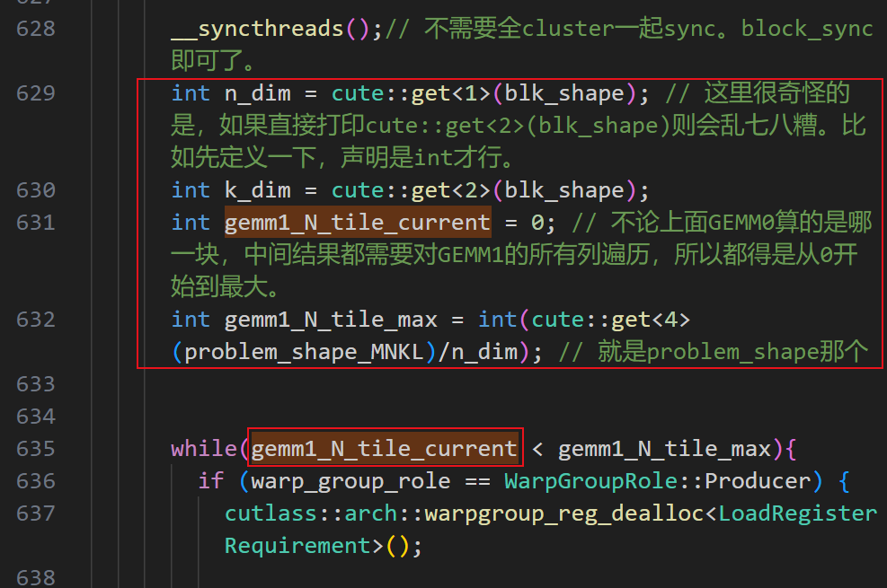

如果红框选中的区域被包到

{

....

}

里面。那么后面的635行就会报错说该变量未定义。其实这个报错不仅出现在这里。。比如在GEMM0的producer里定义的东西，在GEMM1的producer（按理说还是同一个warp啊），就有时候说未定义。比如下面这几个变量。

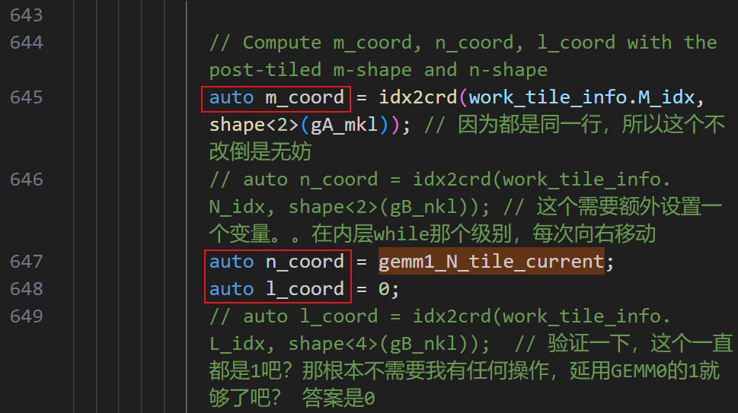

为什么呢？

----->**解决了**。原来变量的生命周期就是在花括号内部的。这是正常的。

1. **理解epilogue/collective/store的存储策略**

这里有复杂的数据逻辑如下：



去确切的理解每个张量的含义，以及其转换方式是复杂的。为了抓住主要矛盾，我们直接去研究bSG_sD的底层排布，从指针级来有序打印其值。并且打印kernel外部保存到global的结果。进行对比。

那么第一步就是去对数据排布进行控制。也就是要对A/B的初始化进行自定义控制。这里遇到的困难是总是发现Segmentation fault (core dumped)。

深入研究之后发现，是因为数据创建的方式，直接返回的指针就已经在GPU上了。Cutlass的原生数据初始化就是在GPU上用kernel的方式。这导致，print数据/初始化数据，都需要使用kernel来执行。

另一个问题是，数据到底是row还是col的major。我的代码经过层层修改，如果现在将A B D都改为row major，会报错。经检测，在没有经过修改的cutlass版本上，这样是不会报错的。不过我暂时不管了。在：print数据/初始化数据，这两个情况下，要格外小心数据排布。

现在发现，bSG_sD的尺寸是((64,256),2),1,1,1)。我们令：

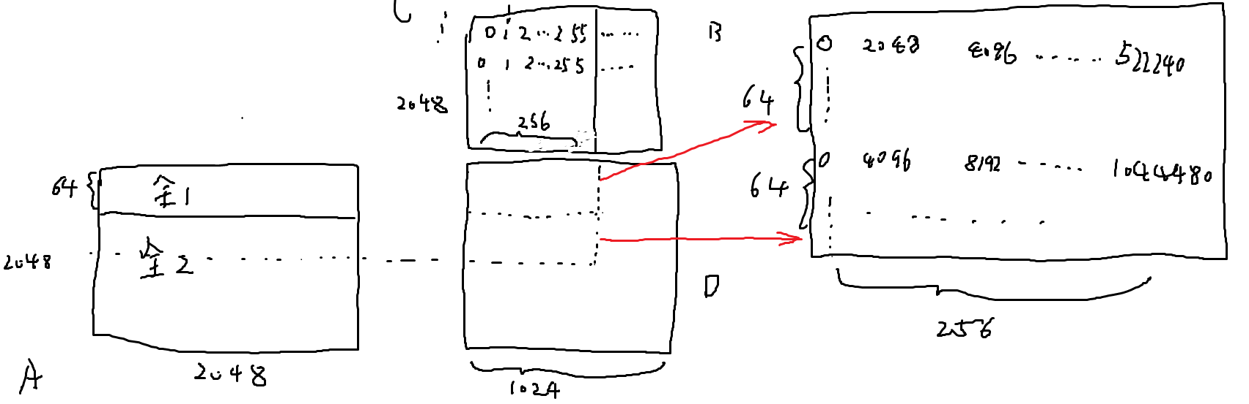

数据按照上述方式进行初始化。（打印出来的值放置在：C:\文件备份\dataflow_code\weekly_report\0905的results.txt）

然后在store函数里依此打印出bSG_sD后的128*256个值。发现数值顺序如下。

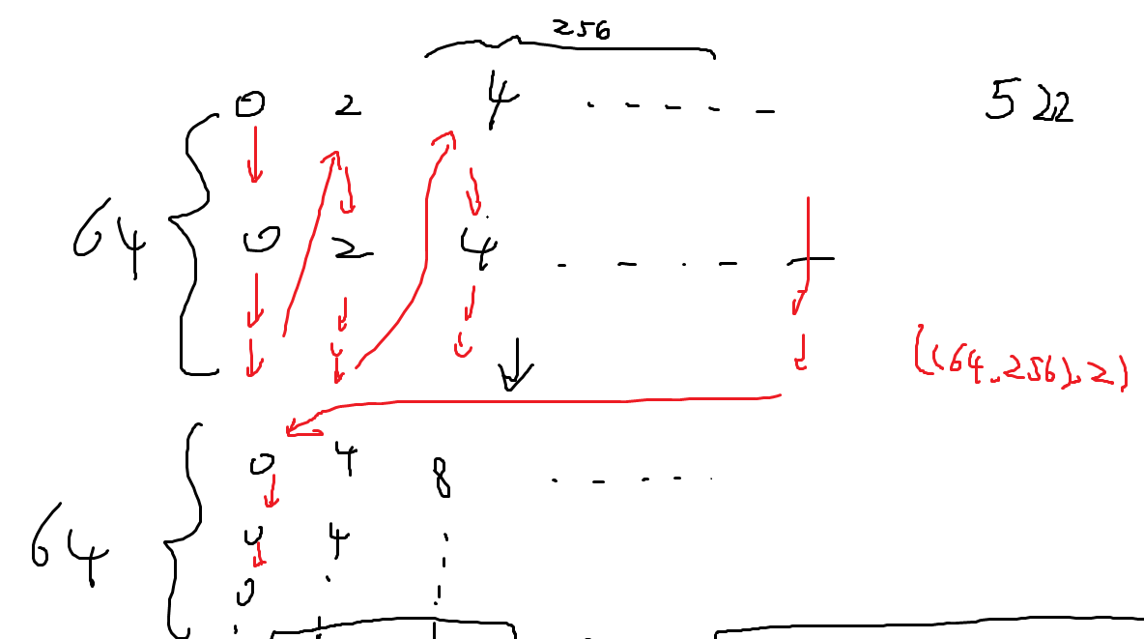

所以最后可以用如下方法，分别获取到上下两端值的初始指针：

      int M=128;

      int N=256;

      auto shape = cute::make_shape(M/2, N);        // 张量的形状为 (128, 256)

      auto stride = cute::make_stride(1, M/2);      // 列主序布局的步幅为 (1, M)

      // 使用形状和步幅创建布局

      auto layout = cute::make_layout(shape, stride);

      // 创建张量，使用指针和布局

      Tensor bSG_sD_col = cute::make_tensor(bSG_sD.data(), layout);  // 非拥有的张量

      print(bSG_sD_col);

      printf("\n");

      // 打印指定范围的张量

      for (int i = 0; i < M/2; ++i) {

          for (int j = 0; j < N; ++j) {

            printf("%*.5f    ", 10, float(bSG_sD_col(i, j)));

          }

          printf("\n");

      }

      printf("\n print bSG_sD_col_lower\n");

      auto base_ptr = bSG_sD.data();  // 保持为smem_ptr类型

      // 偏移指针到中间位置（M*N/2）

      auto offset_ptr = base_ptr + int(M * N / 2);  // 偏移位置----这里要减一是非常奇怪的。。

      // 使用偏移后的指针创建一个新的张量

      Tensor bSG_sD_col_lower = cute::make_tensor(offset_ptr, layout);  // 非拥有的张量

1. **理解gemm/epilogue/load的读取策略**

值的初始指针

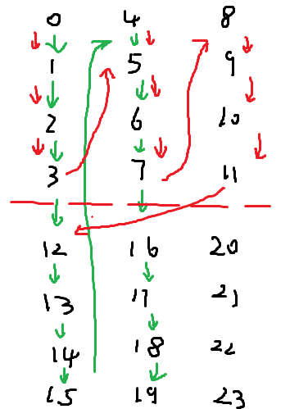

图中绿色箭头为内存排布。红色箭头为张量顺序排布。打印代码区别为：

     int *A = new int[64*2*64*3];  // 修改为指针，指向内存

    for (int i = 0; i < 64*2*64*3; ++i) {

        A[i] = i;

    }

    Layout L0 = Layout<Shape <Shape <_64,_2>,_64, _3>,Stride<Stride<_1,_4096>,_64, _8192>>{};

    Tensor B = make_tensor(A, L0);  // 确保传递指针

    printf("Tensor B-指针:\n");

    for (int i = 0; i < 128*64*3; ++i) {

        printf("%*d    ", 6, int(B.data()[i]));

    }  // 这样会出现绿色箭头顺序，是真正内存里的顺序

    printf("A-指针:\n");

    for (int i = 0; i < 128*64*3; ++i) {

        printf("%*d    ", 6, int(B(i)));

    }  // 这样是红色箭头。顺序是张量访问顺序。

吓得我又返回去验证了一下store出去的内存排布。好在确实还是从内存上分成两段的。

我开始研究example13，因为这个是b2b GEMM的融合。好处是帮我实现了存入共享内存，然后直接利用。坏处是需要我手动加入cluster。以后最好再加上TMA，WASP等功能。

先研究调用栈顺序。

为了跑通，首先需要修改：

temp_can/new_cutlass_0828-1053/cutlass-main/examples/13_two_tensor_op_fusion/test_run.h

  if (!(props.major == arch_major && props.minor == arch_minor)) {

    std::cout << "Device architecture does not match the required architecture." << std::endl;

    supported = false;

    supported = true; // 为了在h100上跑，强行让它通过试试看吧。

  } else {

    std::cout << "Device architecture matches the required architecture." << std::endl;

  }

其实改完也是能跑的。。而且结果是：

o_tensor_op_fusion$ ./13_fused_two_gemms_f16_sm80_shmem

Checking for Ampere or newer architecture...

Supported CUDA version for Ampere.

Device architecture does not match the required architecture.

Device: NVIDIA H100 80GB HBM3

Arch: SM80

Test: gemm f16 shmem staging

Running Non-fused back-to-back FP16 TN GEMMs...

gemm 0 time 0.0479171 ms

gemm 1 time 0.0284538 ms

Non-fusion time 0.0763709 ms

Pass

Running Fused back-to-back FP16 TN GEMMs with shared memory staging...

Fusion time 0.0748704 ms

Pass

All tests passed.

从最外层的文件：

temp_can/new_cutlass_0828-1053/cutlass-main/examples/13_two_tensor_op_fusion/fused_two_gemms_f16_sm80_shmem.cu

开始。这里使用的是

  B2bFusedGemmRun<B2bGemm> fusedGemm;

那么检查B2bFusedGemmRun之后得知，运行的其实是B2bGemm。也就是：

  using B2bGemm = cutlass::gemm::device::B2bGemm<

    cutlass::half_t,

    cutlass::layout::RowMajor,

    cutlass::half_t,

    cutlass::layout::ColumnMajor,

    ElementOutput,

    cutlass::layout::RowMajor,

    ElementAccumulator,

    cutlass::arch::OpClassTensorOp,

    cutlass::arch::Sm80,

    ThreadblockShape0,

    ThreadblockShape1,

    WarpShape0,

    WarpShape1,

    InstructionShape,

    EpilogueOutputOp0,

    EpilogueOutputOp1,

    cutlass::gemm::threadblock::GemmIdentityThreadblockSwizzle<1>,

    3,

    SmemAccumulator

  >;

那么进入到device文件夹里：

temp_can/new_cutlass_0828-1053/cutlass-main/examples/13_two_tensor_op_fusion/**device/b2b_gemm.h**

  using B2bGemmKernel = typename kernel::DefaultB2bGemm<

    ElementA,

    LayoutA,

    kAlignmentA,

    ElementB,

    LayoutB,

    kAlignmentB,

    ElementC,

    LayoutC,

    ElementAccumulator,

    OperatorClass,

    ArchTag,

    ThreadblockShape0,

    ThreadblockShape1,

    WarpShape0,

    WarpShape1,

    InstructionShape,

    EpilogueOutputOp0,

    EpilogueOutputOp1,

    ThreadblockSwizzle,

    kStages,

    Operator,

    SmemAccumulator

  >::B2bGemmKernel;

然后进入kernel文件夹：

temp_can/new_cutlass_0828-1053/cutlass-main/examples/13_two_tensor_op_fusion/kernel/default_b2b_gemm.h

或者：

temp_can/new_cutlass_0828-1053/cutlass-main/examples/13_two_tensor_op_fusion/kernel/default_b2b_gemm_smem_accumulator.h

这俩有什么区别呢？就看模板对应：

这里面定义了一堆模板。分别对应ampere/Turing；grouped/integer等。因为我们这里最开始是硬写成sm80输入进去的，所以肯定会走ampere，如下：

/// Partial specialization for Ampere Architecture

template <

    /// Element type for A matrix operand

    typename ElementA,

    /// Layout type for A matrix operand

    typename LayoutA,

    /// Access granularity of A matrix in units of elements

    int kAlignmentA,

    /// Element type for B matrix operand

    typename ElementB,

    /// Layout type for B matrix operand

    typename LayoutB,

    /// Access granularity of A matrix in units of elements

    int kAlignmentB,

    /// Element type for C and D matrix operands

    typename ElementC,

    /// Element type for internal accumulation

    typename ElementAccumulator,

    /// Threadblock-level tile size (concept: GemmShape)

    typename ThreadblockShape0,

    /// Threadblock-level tile size (concept: GemmShape)

    typename ThreadblockShape1,

    /// Warp-level tile size (concept: GemmShape)

    typename WarpShape0,

    /// Warp-level tile size (concept: GemmShape)

    typename WarpShape1,

    /// Warp-level tile size (concept: GemmShape)

    typename InstructionShape,

    /// Epilogue output operator

    typename EpilogueOutputOp0,

    /// Epilogue output operator

    typename EpilogueOutputOp1,

    /// Threadblock-level swizzling operator

    typename ThreadblockSwizzle,

    /// Number of stages used in the pipelined mainloop

    int Stages,

    /// Operation performed by GEMM

    typename Operator>

struct DefaultB2bGemm<ElementA, LayoutA, kAlignmentA, ElementB, LayoutB, kAlignmentB, ElementC,

                   layout::RowMajor, ElementAccumulator, arch::OpClassTensorOp,

                   arch::Sm80, ThreadblockShape0, ThreadblockShape1,

                   WarpShape0, WarpShape1, InstructionShape,

                   EpilogueOutputOp0, EpilogueOutputOp1, ThreadblockSwizzle, Stages,

                   Operator, false, typename platform::enable_if<!IsGroupedSwizzle<ThreadblockSwizzle>::value>::type> {

这一堆东西，最后的typename enable_if什么的不对应实际的东西，只是看上面已经给了的参数是否满足某个条件。实际上对应关系是：

DefaultB2bGemm<ElementA, LayoutA, kAlignmentA, ElementB, LayoutB, kAlignmentB, ElementC, layout::RowMajor, ElementAccumulator, arch::OpClassTensorOp, arch::Sm80, ThreadblockShape0, ThreadblockShape1, WarpShape0, WarpShape1, InstructionShape, EpilogueOutputOp0, EpilogueOutputOp1, ThreadblockSwizzle, Stages, Operator, false

对应：

DefaultB2bGemm<

    ElementA,

    LayoutA,

    kAlignmentA,

    ElementB,

    LayoutB,

    kAlignmentB,

    ElementC,

    LayoutC,

    ElementAccumulator,

    OperatorClass,

    ArchTag,

    ThreadblockShape0,

    ThreadblockShape1,

    WarpShape0,

    WarpShape1,

    InstructionShape,

    EpilogueOutputOp0,

    EpilogueOutputOp1,

    ThreadblockSwizzle,

    kStages,

    Operator,

    SmemAccumulator

  >

而SmemAccumulator我们能找到，咱们这定义的就是bool，是true。经过检查可知，kernel文件夹下面的这俩文件：

default_b2b_gemm.h------>SmemAccumulator都是false

default_b2b_gemm_smem_accumulator.h------>SmemAccumulator都是true

temp_can/new_cutlass_0828-1053/cutlass-main/examples/13_two_tensor_op_fusion/**kernel/default_b2b_gemm_smem_accumulator.h**

所以我们最后进入default_b2b_gemm_smem_accumulator.h的这里：

/// Partial specialization for Ampere Architecture

template <

    /// Element type for A matrix operand

    typename ElementA,

    /// Layout type for A matrix operand

    typename LayoutA,

    /// Access granularity of A matrix in units of elements

    int kAlignmentA,

    /// Element type for B matrix operand

    typename ElementB,

    /// Layout type for B matrix operand

    typename LayoutB,

    /// Access granularity of A matrix in units of elements

    int kAlignmentB,

    /// Element type for C and D matrix operands

    typename ElementC,

    /// Element type for internal accumulation

    typename ElementAccumulator,

    /// Threadblock-level tile size (concept: GemmShape)

    typename ThreadblockShape0,

    /// Threadblock-level tile size (concept: GemmShape)

    typename ThreadblockShape1,

    /// Warp-level tile size (concept: GemmShape)

    typename WarpShape0,

    /// Warp-level tile size (concept: GemmShape)

    typename WarpShape1,

    /// Warp-level tile size (concept: GemmShape)

    typename InstructionShape,

    /// Epilogue output operator

    typename EpilogueOutputOp0,

    /// Epilogue output operator

    typename EpilogueOutputOp1,

    /// Threadblock-level swizzling operator

    typename ThreadblockSwizzle,

    /// Number of stages used in the pipelined mainloop

    int Stages,

    /// Operation performed by GEMM

    typename Operator>

struct DefaultB2bGemm<ElementA, LayoutA, kAlignmentA, ElementB, LayoutB, kAlignmentB, ElementC,

                   layout::RowMajor, ElementAccumulator, arch::OpClassTensorOp,

                   arch::Sm80, ThreadblockShape0, ThreadblockShape1,

                   WarpShape0, WarpShape1, InstructionShape,

                   EpilogueOutputOp0, EpilogueOutputOp1, ThreadblockSwizzle, Stages,

                   Operator, true> {

  /// Define the threadblock-scoped matrix multiply-accumulate

  using B2bMma = typename cutlass::gemm::threadblock::DefaultB2bMma<

      ElementA, LayoutA, kAlignmentA, ElementB, LayoutB, kAlignmentB,

      ElementAccumulator, layout::RowMajor, arch::OpClassTensorOp, arch::Sm80,

      ThreadblockShape0, ThreadblockShape1, WarpShape0, WarpShape1,

      InstructionShape, Stages, Operator, EpilogueOutputOp0, false, true>::ThreadblockB2bMma;

  static const int kPartitionsK1 = ThreadblockShape1::kK / WarpShape1::kK;

  /// Define the epilogue

  using Epilogue =

      typename cutlass::epilogue::threadblock::DefaultEpilogueTensorOp<

          ThreadblockShape1, typename B2bMma::Operator1, kPartitionsK1, EpilogueOutputOp1,

          EpilogueOutputOp1::kCount>::Epilogue;

  /// Define the kernel-level GEMM operator.

  using B2bGemmKernel = kernel::B2bGemm<B2bMma, Epilogue, ThreadblockSwizzle>;

};

注意上一层是要来找B2bGemmKernel的，也就是说我们找到了kernel::B2bGemm<B2bMma, Epilogue, ThreadblockSwizzle>

只有一个选择：

temp_can/new_cutlass_0828-1053/cutlass-main/examples/**13_two_tensor_op_fusion/kernel/b2b_gemm.h**

在这里面我们注意到operator中间出现了：

    if(blockIdx.x==0&&blockIdx.y==0&&threadIdx.x==0&&threadIdx.y==0){

      printf("enter 1\n");

    }

    // Compute threadblock-scoped matrix multiply-add

    b2bMma(gemm_k_iterations_0, accumulators, iterator_A0, iterator_B0,

      iterator_Scale0, iterator_Bias0, iterator_B1, src_accum, output_op_0);

    if(blockIdx.x==0&&blockIdx.y==0&&threadIdx.x==0&&threadIdx.y==0){

      printf("enter 3\n");

    }

也就是说，kernel就是这里的operator了，不过中间的mma的细节要进去b2bMma再找。这里的b2bMma就是刚才我们传进来的B2bMma，定义为：

  /// Define the threadblock-scoped matrix multiply-accumulate

  using B2bMma = typename cutlass::gemm::threadblock::DefaultB2bMma<

      ElementA, LayoutA, kAlignmentA, ElementB, LayoutB, kAlignmentB,

      ElementAccumulator, layout::RowMajor, arch::OpClassTensorOp, arch::Sm80,

      ThreadblockShape0, ThreadblockShape1, WarpShape0, WarpShape1,

      InstructionShape, Stages, Operator, EpilogueOutputOp0, false, true>::ThreadblockB2bMma;

这里的cutlass::gemm::threadblock::DefaultB2bMma我们再次看到有

default_b2b_mma_smem_accumulator.h---->这里是允许smem的，选这个

default_b2b_mma.h---->这个不要

temp_can/new_cutlass_0828-1053/cutlass-main/examples/13_two_tensor_op_fusion/**threadblock/b2b_mma_multistage_smem_accumulator.h**

这里看到又对multi-stage还是double-stage进行了区分：

/// Specialization for row-major output with 2-stage pipeline

/// Accumulator will be staged in shared memory.

template <

    /// Element type for A matrix operand

    typename ElementA,

    /// Layout type for A matrix operand

    typename LayoutA,

    /// Access granularity of A matrix in units of elements

    int kAlignmentA,

    /// Element type for B matrix operand

    typename ElementB,

    /// Layout type for B matrix operand

    typename LayoutB,

    /// Access granularity of B matrix in units of elements

    int kAlignmentB,

    /// Element type for internal accumulation

    typename ElementAccumulator,

    /// Tag indicating architecture to tune for

    typename ArchTag,

    /// Threadblock-level tile size (concept: GemmShape)

    typename ThreadblockShape0,

    /// Threadblock-level tile size (concept: GemmShape)

    typename ThreadblockShape1,

    /// Warp-level tile size (concept: GemmShape)

    typename WarpShape0,

    /// Warp-level tile size (concept: GemmShape)

    typename WarpShape1,

    /// Instruction-level tile size (concept: GemmShape)

    typename InstructionShape,

    /// Operation performed by GEMM

    typename Operator,

    /// Epilogue output operator

    typename EpilogueOutputOp>

struct DefaultB2bMma<ElementA, LayoutA, kAlignmentA, ElementB, LayoutB,

                  kAlignmentB, ElementAccumulator, layout::RowMajor,

                  arch::OpClassTensorOp, ArchTag,

                  ThreadblockShape0, ThreadblockShape1,

                  WarpShape0, WarpShape1,

                  InstructionShape, 2, Operator, EpilogueOutputOp, false, true> {

参看这里最后的参数有一个2，如果是multi-stage，就是stages的参量。我们回到最外层的fused_two_gemms_f16_sm80_shmem.cu看到stages数目是3。

所以我们的模板特化为：

////////////////////////////////////////////////////////////////////////////////

/// Specialization for row-major output for multi-stage

/// Accumulator will be staged in shared memory.

template <

    /// Element type for A matrix operand

    typename ElementA,

    /// Layout type for A matrix operand

    typename LayoutA,

    /// Access granularity of A matrix in units of elements

    int kAlignmentA,

    /// Element type for B matrix operand

    typename ElementB,

    /// Layout type for B matrix operand

    typename LayoutB,

    /// Access granularity of B matrix in units of elements

    int kAlignmentB,

    /// Element type for internal accumulation

    typename ElementAccumulator,

    /// Tag indicating architecture to tune for

    typename ArchTag,

    /// Threadblock-level tile size (concept: GemmShape)

    typename ThreadblockShape0,

    /// Threadblock-level tile size (concept: GemmShape)

    typename ThreadblockShape1,

    /// Warp-level tile size (concept: GemmShape)

    typename WarpShape0,

    /// Warp-level tile size (concept: GemmShape)

    typename WarpShape1,

    /// Instruction-level tile size (concept: GemmShape)

    typename InstructionShape,

    /// Number of stages used in the multistage mainloop

    int Stages,

    /// Operation performed by GEMM

    typename Operator,

    /// Epilogue output operator

    typename EpilogueOutputOp>

struct DefaultB2bMma<ElementA, LayoutA, kAlignmentA, ElementB, LayoutB,

                  kAlignmentB, ElementAccumulator, layout::RowMajor,

                  arch::OpClassTensorOp, ArchTag,

                  ThreadblockShape0, ThreadblockShape1,

                  WarpShape0, WarpShape1,

                  InstructionShape, Stages, Operator, EpilogueOutputOp, false, true> {

  static cutlass::arch::CacheOperation::Kind const CacheOpA =

      ((sizeof_bits<ElementA>::value * kAlignmentA) == 128)

          ? cutlass::arch::CacheOperation::Global

          : cutlass::arch::CacheOperation::Always;

  static cutlass::arch::CacheOperation::Kind const CacheOpB =

      ((sizeof_bits<ElementB>::value * kAlignmentB) == 128)

          ? cutlass::arch::CacheOperation::Global

          : cutlass::arch::CacheOperation::Always;

  // Define the MmaCore components

  using MmaCore0 = typename cutlass::gemm::threadblock::DefaultMmaCore<

      ThreadblockShape0, WarpShape0, InstructionShape, ElementA, LayoutA,

      ElementB, LayoutB, ElementAccumulator, layout::RowMajor, arch::OpClassTensorOp,

      Stages, Operator, false, CacheOpA, CacheOpB>;

  using MmaCore1 = typename cutlass::gemm::threadblock::DefaultMmaCore<

      ThreadblockShape1, WarpShape1, InstructionShape, ElementA, LayoutA,

      ElementB, LayoutB, ElementAccumulator, layout::RowMajor, arch::OpClassTensorOp,

      Stages, Operator, false, CacheOpA, CacheOpB>;

  // Define iterators over tiles from the A operand

  using ThreadMapA0 = typename MmaCore0::IteratorThreadMapA;

  using AccessTypeA0 = cutlass::Array<ElementA, kAlignmentA>;

  using IteratorA0 =

      cutlass::transform::threadblock::PredicatedTileAccessIterator<

          cutlass::MatrixShape<ThreadblockShape0::kM, ThreadblockShape0::kK>,

          ElementA, LayoutA, 1, ThreadMapA0, AccessTypeA0>;

  // Define iterators over tiles from the B operand

  using ThreadMapB0 = typename MmaCore0::IteratorThreadMapB;

  using AccessTypeB0 = cutlass::Array<ElementB, kAlignmentB>;

  using IteratorB0 =

      cutlass::transform::threadblock::PredicatedTileAccessIterator<

          cutlass::MatrixShape<ThreadblockShape0::kK, ThreadblockShape0::kN>,

          ElementB, LayoutB, 0, ThreadMapB0, AccessTypeB0>;

  // Define iterators over tiles from the B operand

  using ThreadMapB1 = typename MmaCore1::IteratorThreadMapB;

  using AccessTypeB1 = cutlass::Array<ElementB, kAlignmentB>;

  using IteratorB1 =

      cutlass::transform::threadblock::PredicatedTileAccessIterator<

          cutlass::MatrixShape<ThreadblockShape1::kK, ThreadblockShape1::kN>,

          ElementB, LayoutB, 0, ThreadMapB1, AccessTypeB1>;

  // Warp-level GEMM components

  using WarpMmaTensorOp0 = typename MmaCore0::MmaTensorOp;

  using WarpMmaTensorOp1 = typename MmaCore1::MmaTensorOp;

  // Use fragment iterator for the accumulator

  using SmemAccumulatorLayout = cutlass::layout::RowMajor;

  using FragmentIteratorAccumulator = cutlass::epilogue::warp::FragmentIteratorTensorOp<

          WarpShape0, InstructionShape,

          ElementAccumulator,

          typename WarpMmaTensorOp0::Policy::Operator::FragmentC,

          SmemAccumulatorLayout

        >;

  /// Define iterators over tiles from scale/bias vectors

  using ElementScaleBias = typename EpilogueOutputOp::ElementCompute;

  using LayoutScaleBias = layout::RowMajor; //vector layout doesn't really matter

  static int const kElementsPerAccess = 2;

  using IteratorAccumulatorScaleBias =

    cutlass::transform::threadblock::VectorIterator<

      cutlass::transform::threadblock::PredicatedVectorAccessIterator<

          cutlass::MatrixShape<ThreadblockShape0::kM, ThreadblockShape0::kN>,

          cutlass::MatrixShape<WarpShape0::kM, WarpShape0::kN>,

          ElementScaleBias, LayoutScaleBias, kElementsPerAccess>

    >;

  // Store Accumulator tiles to Shared Memory

  using SmemIteratorD0 =

      cutlass::epilogue::warp::TileIteratorTensorOp<

          WarpShape0,

          InstructionShape,

          typename EpilogueOutputOp::ElementOutput,

          SmemAccumulatorLayout

        >;

  static int const kThreadCount = 32;

  // load warp tile from Shared Memory accumulator

  using WarpIteratorA1 = cutlass::gemm::warp::MmaTensorOpMultiplicandTileAccessIterator<

    MatrixShape<WarpShape1::kM, WarpShape1::kK>, cutlass::gemm::Operand::kA,

    ElementA, SmemAccumulatorLayout,

    MatrixShape<InstructionShape::kM, InstructionShape::kK>,

    WarpMmaTensorOp1::Policy::OpDelta::kRow, kThreadCount, true>;

  // Define the threadblock-scoped pipelined matrix multiply

  using ThreadblockB2bMma = cutlass::gemm::threadblock::B2bMmaMultistageSmemAccumulator<

      typename MmaCore0::Shape, IteratorA0, typename MmaCore0::SmemIteratorA,

      MmaCore0::kCacheOpA,

      IteratorB0, typename MmaCore0::SmemIteratorB, MmaCore0::kCacheOpB,

      IteratorAccumulatorScaleBias,

      FragmentIteratorAccumulator, SmemIteratorD0,

      typename MmaCore1::Shape, WarpIteratorA1,

      IteratorB1, typename MmaCore1::SmemIteratorB, MmaCore1::kCacheOpB,

      ElementAccumulator, layout::RowMajor,

      EpilogueOutputOp,

      typename MmaCore0::MmaPolicy, typename MmaCore1::MmaPolicy, Stages>;

};

据此指引，我们最后来到了

temp_can/new_cutlass_0828-1053/cutlass-main/examples/13_two_tensor_op_fusion/threadblock/b2b_mma_multistage_smem_accumulator.h

这里面藏着如何将GEMM0-result存入SMEM，然后给GEMM1利用的方法。

1. 找到load store分别定义在哪里？一来为了后续我对D矩阵的再次读取。二来为了有可能我回去修改自己sm90的版本。

是有专门的iterator来实现。不过似乎是

using IteratorA0 =

cutlass::transform::threadblock::PredicatedTileAccessIterator<

cutlass::MatrixShape<ThreadblockShape0::kM, ThreadblockShape0::kK>,

ElementA, LayoutA, 1, ThreadMapA0, AccessTypeA0>;

/// Shared memory iterator to A operand

using SmemIteratorA = transform::threadblock::RegularTileAccessIterator<

MatrixShape<Shape::kM, Shape::kK>, ElementA, SmemLayoutA, 1,

IteratorThreadMapA>;

这种。感觉比较复杂。好在还比较清晰。

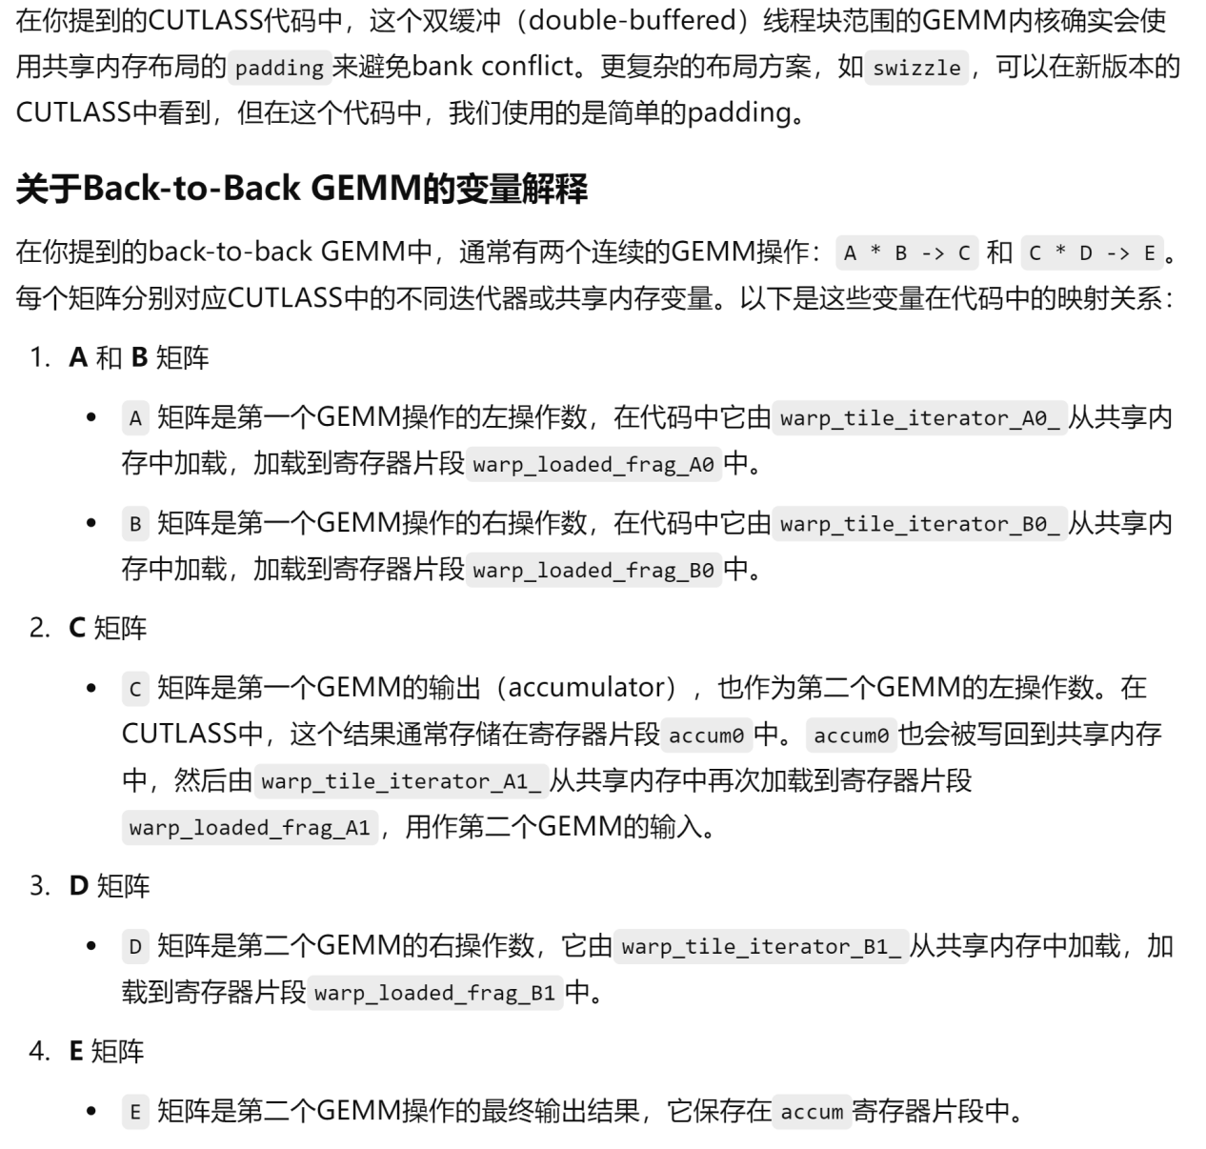

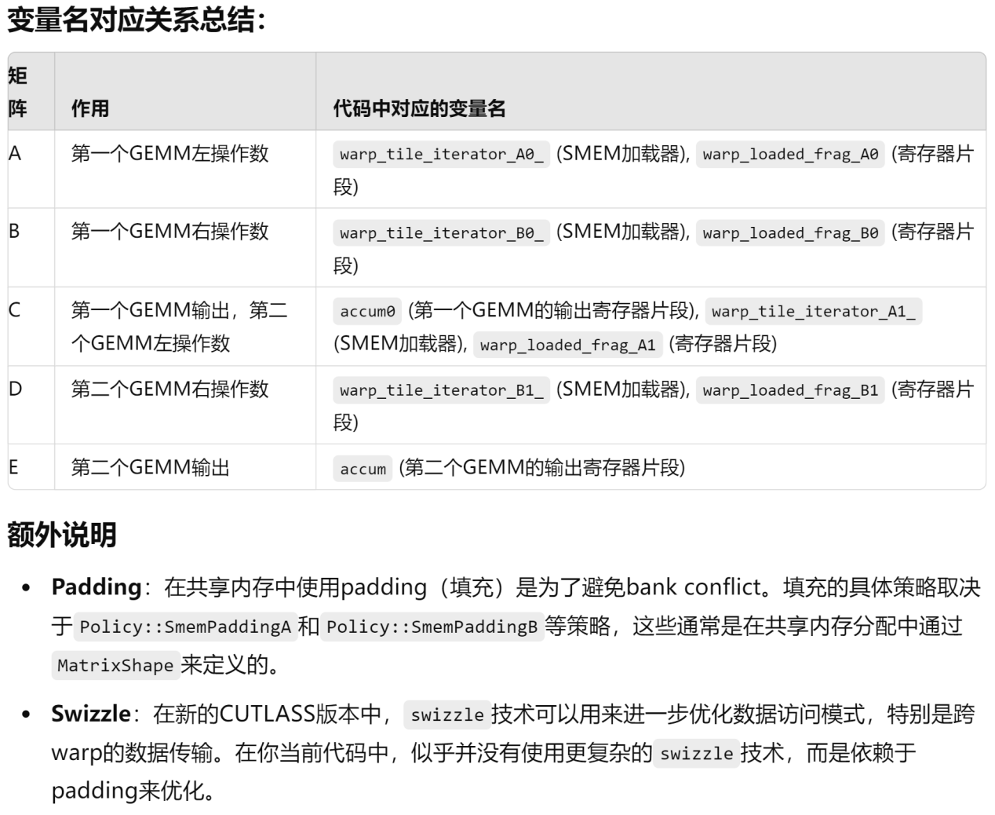

temp_can/new_cutlass_0828-1053/cutlass-main/examples/13_two_tensor_op_fusion/kernel/b2b_gemm.h

  /// Shared memory storage structure

  union SharedStorage {

    typename B2bMma::B2bMmaSharedStorage main_loop;

    typename Epilogue::SharedStorage epilogue;

  };

执行顺序是怎样的？用example49来跑是下面这样：

temp_can/new_cutlass_0828-1053/cutlass-main/include/cutlass/gemm/device/gemm_universal_adapter.h

    Status launch_result{ Status::kSuccess };

    // Use extended launch API only for mainloops that use it

    if constexpr (GemmKernel::ArchTag::kMinComputeCapability >= 90) {

      printf("enter 1\n");

      constexpr bool is_static_1x1x1 = cute::is_static_v<typename GemmKernel::DispatchPolicy::ClusterShape> and

                                       cute::size(typename GemmKernel::DispatchPolicy::ClusterShape{}) == 1;

      dim3 cluster(cute::size<0>(typename GemmKernel::DispatchPolicy::ClusterShape{}),

                   cute::size<1>(typename GemmKernel::DispatchPolicy::ClusterShape{}),

                   cute::size<2>(typename GemmKernel::DispatchPolicy::ClusterShape{}));

      void* kernel_params[] = {&params};

      if constexpr (kEnableCudaHostAdapter) {

        printf("enter 2\n");

        //

        // Use the cuda host adapter

        //

        CUTLASS_ASSERT(cuda_adapter);

        if (cuda_adapter) {

          if (launch_with_pdl) {

            CUTLASS_TRACE_HOST(

              "GemmUniversal::run() does not support launching with PDL and a custom cuda adapter.");

            return Status::kErrorInternal;

          }

          launch_result = cuda_adapter->launch(grid,

                                               cluster,

                                               block,

                                               smem_size,

                                               stream,

                                               kernel_params,

                                               0);

        }

        else {

          return Status::kErrorInternal;

        }

      }

      else {

        printf("enter 3\n");

        CUTLASS_ASSERT(cuda_adapter == nullptr);

        void const* kernel = (void const*) device_kernel<GemmKernel>;

        if constexpr (GemmKernel::ArchTag::kMinComputeCapability == 90) {

          if (is_static_1x1x1 && not launch_with_pdl) {

            device_kernel<GemmKernel><<<grid, block, smem_size, stream>>>(params);

          }

          else {

            printf("enter 4, launch_with_pdl=%d\n", launch_with_pdl);

            launch_result = ClusterLauncher::launch(

              grid, cluster, block, smem_size, stream, kernel, kernel_params, launch_with_pdl);

          }

enter 1

enter 3

enter 4, launch_with_pdl=0

证明cluster排布是按照blockIdx.x来的

grid=(2, 4, 1)

BlockIdx in Grid: (1, 2), ClusterIdx in Grid: (1, 1), BlockIdx in Cluster: (0, 0)

BlockIdx in Grid: (0, 0), ClusterIdx in Grid: (0, 0), BlockIdx in Cluster: (0, 0)

BlockIdx in Grid: (1, 3), ClusterIdx in Grid: (1, 1), BlockIdx in Cluster: (0, 1)

BlockIdx in Grid: (0, 1), ClusterIdx in Grid: (0, 0), BlockIdx in Cluster: (0, 1)

BlockIdx in Grid: (1, 0), ClusterIdx in Grid: (1, 0), BlockIdx in Cluster: (0, 0)

BlockIdx in Grid: (1, 1), ClusterIdx in Grid: (1, 0), BlockIdx in Cluster: (0, 1)

BlockIdx in Grid: (0, 2), ClusterIdx in Grid: (0, 1), BlockIdx in Cluster: (0, 0)

BlockIdx in Grid: (0, 3), ClusterIdx in Grid: (0, 1), BlockIdx in Cluster: (0, 1)

BlockIdx in Grid: (0, 0), ClusterIdx in Grid: (0, 0), BlockIdx in Cluster: (0, 0)

BlockIdx in Grid: (0, 1), ClusterIdx in Grid: (0, 0), BlockIdx in Cluster: (0, 1)

BlockIdx in Grid: (1, 2), ClusterIdx in Grid: (1, 1), BlockIdx in Cluster: (0, 0)

BlockIdx in Grid: (1, 3), ClusterIdx in Grid: (1, 1), BlockIdx in Cluster: (0, 1)

BlockIdx in Grid: (1, 0), ClusterIdx in Grid: (1, 0), BlockIdx in Cluster: (0, 0)

BlockIdx in Grid: (1, 1), ClusterIdx in Grid: (1, 0), BlockIdx in Cluster: (0, 1)

BlockIdx in Grid: (0, 2), ClusterIdx in Grid: (0, 1), BlockIdx in Cluster: (0, 0)

BlockIdx in Grid: (0, 3), ClusterIdx in Grid: (0, 1), BlockIdx in Cluster: (0, 1)

temp_can/new_cutlass_0828-1053/cutlass-main/examples/13_two_tensor_op_fusion/kernel/b2b_gemm.h

    epilogue(output_op_1, iterator_D1, accumulators, iterator_C1);

然后进入：

temp_can/new_cutlass_0828-1053/cutlass-main/include/cutlass/epilogue/threadblock/default_epilogue_tensor_op.h

struct DefaultEpilogueTensorOp {

然后进入：

temp_can/new_cutlass_0828-1053/cutlass-main/include/cutlass/epilogue/threadblock/epilogue.h

    #pragma unroll(IterationsUnroll ? OutputTileIterator::kIterations : 1)

    for (int iter = 0; iter < OutputTileIterator::kIterations; ++iter)

    {

这里是把计算结果逐次累加到SMEM里。但是不是全部。比如128*128的M*N尺寸，每次存进去1/8的内容。如何控制这里的OutputTileIterator::kIterations呢？向上找OutputTileIterator的过程很困难。不知道学长是否熟悉这方面？

我目前的打算是先不改这里，每次都对这里执行常规的累加。但是这没有充分利用SMEM资源（尤其是H100的SMEM很大），可能是一个性能损失。（不过相比于我这里的baseline，增加了DSM之后也会有性能提升）